**Top Interview Questions - Eazy**

Introduction

This is LeetCode's official curated list of Top classic interview questions to help you land your dream job. Our top interview questions are divided into the following series:

1. [Easy Collection](https://leetcode.com/explore/interview/card/top-interview-questions-easy/)
2. [Medium Collection](https://leetcode.com/explore/interview/card/top-interview-questions-medium/)
3. [Hard Collection](https://leetcode.com/explore/interview/card/top-interview-questions-hard/)

to help you master Data Structure & Algorithms and improve your coding skills.

Just like any other skills, coding interview is one area where you can greatly improve with [deliberate practice](https://en.wikipedia.org/wiki/Practice_(learning_method)#Deliberate_practice).

Most of the classic interview questions have multiple solution approaches. For the best practice result, we strongly advise you to go through this list at least a second time, or even better - a *third time*.

By the second attempt, you may discover some new tricks or new methods. By the third time, you should find that your code appear to be more concise compared to your first attempt. If so, congratulations!

**Remember:** Deliberate practice does not mean looking for answers and memorizing it. You won't go very far with that approach. The more you are able to solve a problem yourself without any reference to answers, the more you will improve.

## Array

Array type of questions were asked in interviews frequently. You will most likely encounter one during your interviews.

We recommend: Single Number, Rotate Array, Intersection of Two Arrays II and Two Sum.

 Remove Duplicates from Sorted Array

 Best Time to Buy and Sell Stock II

 Rotate Array

 Contains Duplicate

 Single Number

 Intersection of Two Arrays II

 Plus One

 Move Zeroes

 Two Sum

 Valid Sudoku

 Rotate Image

## Array

Array type of questions were asked in interviews frequently. You will most likely encounter one during your interviews.

We recommend: Single Number, Rotate Array, Intersection of Two Arrays II and Two Sum.

**Remove Duplicates from Sorted Array**

Given a sorted array nums, remove the duplicates [**in-place**](https://en.wikipedia.org/wiki/In-place_algorithm) such that each element appears only once and returns the new length.

Do not allocate extra space for another array, you must do this by **modifying the input array**[**in-place**](https://en.wikipedia.org/wiki/In-place_algorithm) with O(1) extra memory.

**Clarification:**

Confused why the returned value is an integer but your answer is an array?

Note that the input array is passed in by **reference**, which means a modification to the input array will be known to the caller as well.

Internally you can think of this:

// **nums** is passed in by reference. (i.e., without making a copy)

int len = removeDuplicates(nums);

// any modification to **nums** in your function would be known by the caller.

// using the length returned by your function, it prints the first **len** elements.

for (int i = 0; i < len; i++) {

    print(nums[i]);

}

**Example 1:**

**Input:** nums = [1,1,2]

**Output:** 2, nums = [1,2]

**Explanation:** Your function should return length = **2**, with the first two elements of *nums* being **1** and **2** respectively. It doesn't matter what you leave beyond the returned length.

**Example 2:**

**Input:** nums = [0,0,1,1,1,2,2,3,3,4]

**Output:** 5, nums = [0,1,2,3,4]

**Explanation:** Your function should return length = **5**, with the first five elements of *nums* being modified to **0**, **1**, **2**, **3**, and **4** respectively. It doesn't matter what values are set beyond the returned length.

**Constraints:**

* 0 <= nums.length <= 3 \* 104
* -104 <= nums[i] <= 104
* nums is sorted in ascending order.

   Hide Hint #1

In this problem, the key point to focus on is the input array being sorted. As far as duplicate elements are concerned, what is their positioning in the array when the given array is sorted? Look at the image above for the answer. If we know the position of one of the elements, do we also know the positioning of all the duplicate elements?  
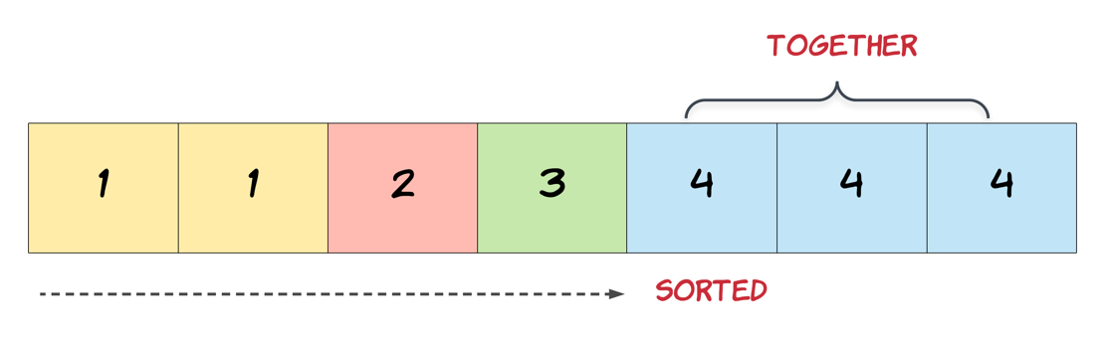

   Hide Hint #2

We need to modify the array in-place and the size of the final array would potentially be smaller than the size of the input array. So, we ought to use a two-pointer approach here. One, that would keep track of the current element in the original array and another one for just the unique elements.

   Hide Hint #3

Essentially, once an element is encountered, you simply need to **bypass** its duplicates and move on to the next unique element.

**Best Time to Buy and Sell Stock II**

Say you have an array prices for which the *i*th element is the price of a given stock on day *i*.

Design an algorithm to find the maximum profit. You may complete as many transactions as you like (i.e., buy one and sell one share of the stock multiple times).

**Note:** You may not engage in multiple transactions at the same time (i.e., you must sell the stock before you buy again).

**Example 1:**

**Input:** [7,1,5,3,6,4]

**Output:** 7

**Explanation:** Buy on day 2 (price = 1) and sell on day 3 (price = 5), profit = 5-1 = 4.

  Then buy on day 4 (price = 3) and sell on day 5 (price = 6), profit = 6-3 = 3.

**Example 2:**

**Input:** [1,2,3,4,5]

**Output:** 4

**Explanation:** Buy on day 1 (price = 1) and sell on day 5 (price = 5), profit = 5-1 = 4.

  Note that you cannot buy on day 1, buy on day 2 and sell them later, as you are

  engaging multiple transactions at the same time. You must sell before buying again.

**Example 3:**

**Input:** [7,6,4,3,1]

**Output:** 0

**Explanation:** In this case, no transaction is done, i.e. max profit = 0.

**Constraints:**

* 1 <= prices.length <= 3 \* 10 ^ 4
* 0 <= prices[i] <= 10 ^ 4

## Summary

We have to determine the maximum profit that can be obtained by making the transactions (no limit on the number of transactions done). For this we need to find out those sets of buying and selling prices which together lead to the maximization of profit.

## Solution

#### **Approach 1: Brute Force**

In this case, we simply calculate the profit corresponding to all the possible sets of transactions and find out the maximum profit out of them.

|  |
| --- |
| class Solution {  public int maxProfit(int[] prices) {  return calculate(prices, 0);  }  public int calculate(int prices[], int s) {  if (s >= prices.length)  return 0;  int max = 0;  for (int start = s; start < prices.length; start++) {  int maxprofit = 0;  for (int i = start + 1; i < prices.length; i++) {  if (prices[start] < prices[i]) {  int profit = calculate(prices, i + 1) + prices[i] - prices[start];  if (profit > maxprofit)  maxprofit = profit;  }  }  if (maxprofit > max)  max = maxprofit;  }  return max;  }  } |

**Complexity Analysis**

* Time complexity : O(n^n). Recursive function is called n^ntimes.
* Space complexity : *O*(*n*). Depth of recursion is *n*.

#### **Approach 2: Peak Valley Approach**

**Algorithm**

Say the given array is:

[7, 1, 5, 3, 6, 4].

If we plot the numbers of the given array on a graph, we get:

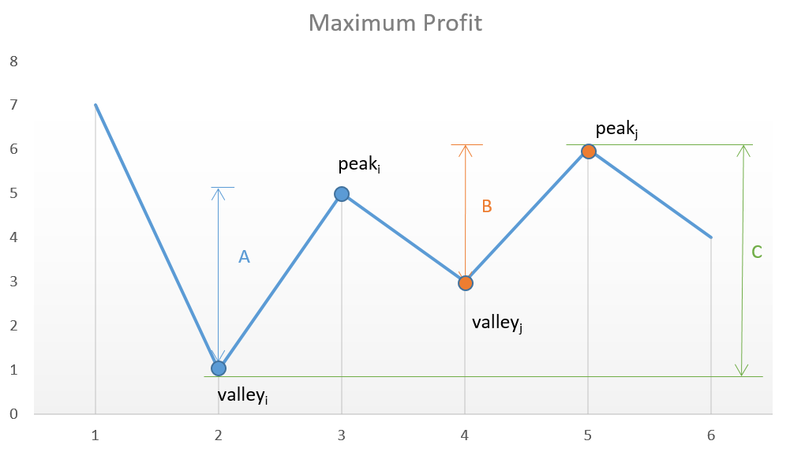

If we analyze the graph, we notice that the points of interest are the consecutive valleys and peaks.

Mathematically speaking: 

The key point is we need to consider every peak immediately following a valley to maximize the profit. In case we skip one of the peaks (trying to obtain more profit), we will end up losing the profit over one of the transactions leading to an overall lesser profit.

For example, in the above case, if we skip *peaki*​ and *valleyj*​ trying to obtain more profit by considering points with more difference in heights, the net profit obtained will always be lesser than the one obtained by including them, since *C* will always be lesser than *A*+*B*.

|  |
| --- |
| class Solution {  public int maxProfit(int[] prices) {  int i = 0;  int valley = prices[0];  int peak = prices[0];  int maxprofit = 0;  while (i < prices.length - 1) {  while (i < prices.length - 1 && prices[i] >= prices[i + 1])  i++;  valley = prices[i];  while (i < prices.length - 1 && prices[i] <= prices[i + 1])  i++;  peak = prices[i];  maxprofit += peak - valley;  }  return maxprofit;  }  } |

**Complexity Analysis**

* Time complexity : *O*(*n*). Single pass.
* Space complexity : *O*(1). Constant space required.

#### **Approach 3: Simple One Pass**

**Algorithm**

This solution follows the logic used in [Approach 2](https://leetcode.com/problems/best-time-to-buy-and-sell-stock-ii/solution/#approach-2-peak-valley-approach) itself, but with only a slight variation. In this case, instead of looking for every peak following a valley, we can simply go on crawling over the slope and keep on adding the profit obtained from every consecutive transaction. In the end,we will be using the peaks and valleys effectively, but we need not track the costs corresponding to the peaks and valleys along with the maximum profit, but we can directly keep on adding the difference between the consecutive numbers of the array if the second number is larger than the first one, and at the total sum we obtain will be the maximum profit. This approach will simplify the solution. This can be made clearer by taking this example:

[1, 7, 2, 3, 6, 7, 6, 7]

The graph corresponding to this array is:

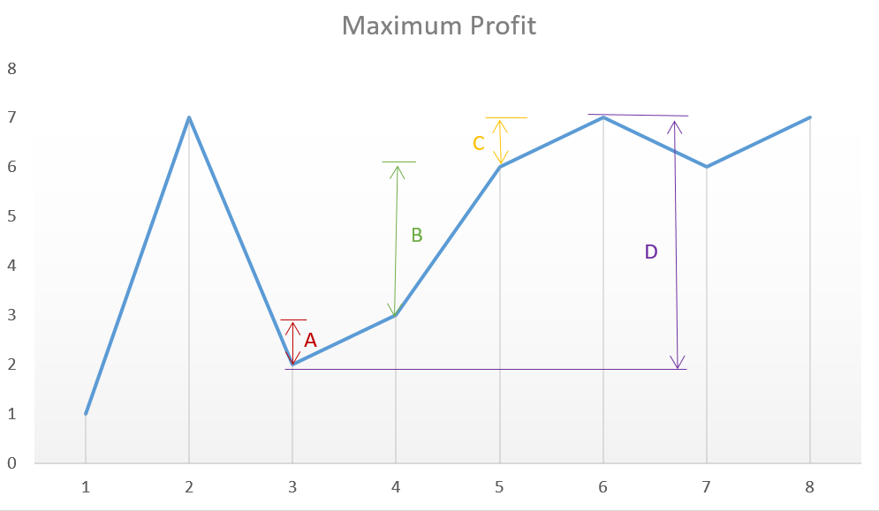

From the above graph, we can observe that the sum *A*+*B*+*C* is equal to the difference *D* corresponding to the difference between the heights of the consecutive peak and valley.

|  |
| --- |
| class Solution {  public int maxProfit(int[] prices) {  int maxprofit = 0;  for (int i = 1; i < prices.length; i++) {  if (prices[i] > prices[i - 1])  maxprofit += prices[i] - prices[i - 1];  }  return maxprofit;  }  } |

**Complexity Analysis**

* Time complexity : *O*(*n*). Single pass.
* Space complexity: *O*(1). Constant space needed.

**Rotate Array**

Given an array, rotate the array to the right by *k* steps, where *k* is non-negative.

**Follow up:**

* Try to come up as many solutions as you can, there are at least 3 different ways to solve this problem.
* Could you do it in-place with O(1) extra space?

**Example 1:**

**Input:** nums = [1,2,3,4,5,6,7], k = 3

**Output:** [5,6,7,1,2,3,4]

**Explanation:**

rotate 1 steps to the right: [7,1,2,3,4,5,6]

rotate 2 steps to the right: [6,7,1,2,3,4,5]

rotate 3 steps to the right: [5,6,7,1,2,3,4]

**Example 2:**

**Input:** nums = [-1,-100,3,99], k = 2

**Output:** [3,99,-1,-100]

**Explanation:**

rotate 1 steps to the right: [99,-1,-100,3]

rotate 2 steps to the right: [3,99,-1,-100]

**Constraints:**

* 1 <= nums.length <= 2 \* 104
* -231 <= nums[i] <= 231 - 1
* 0 <= k <= 105

   Hide Hint #1

The easiest solution would use additional memory and that is perfectly fine.

   Hide Hint #2

The actual trick comes when trying to solve this problem without using any additional memory. This means you need to use the original array somehow to move the elements around. Now, we can place each element in its original location and shift all the elements around it to adjust as that would be too costly and most likely will time out on larger input arrays.

   Hide Hint #3

One line of thought is based on reversing the array (or parts of it) to obtain the desired result. Think about how reversal might potentially help us out by using an example.

   Hide Hint #4

The other line of thought is a tad bit complicated but essentially it builds on the idea of placing each element in its original position while keeping track of the element originally in that position. Basically, at every step, we place an element in its rightful position and keep track of the element already there or the one being overwritten in an additional variable. We can't do this in one linear pass and the idea here is based on **cyclic-dependencies** between elements.

**Contains Duplicate**

Given an array of integers, find if the array contains any duplicates.

Your function should return true if any value appears at least twice in the array, and it should return false if every element is distinct.

**Example 1:**

**Input:** [1,2,3,1]

**Output:** true

**Example 2:**

**Input:** [1,2,3,4]

**Output:** false

**Example 3:**

**Input:** [1,1,1,3,3,4,3,2,4,2]

**Output:** true

**Single Number**

Given a **non-empty** array of integers nums, every element appears *twice* except for one. Find that single one.

**Follow up:** Could you implement a solution with a linear runtime complexity and without using extra memory?

**Example 1:**

**Input:** nums = [2,2,1]

**Output:** 1

**Example 2:**

**Input:** nums = [4,1,2,1,2]

**Output:** 4

**Example 3:**

**Input:** nums = [1]

**Output:** 1

**Constraints:**

* 1 <= nums.length <= 3 \* 104
* -3 \* 104 <= nums[i] <= 3 \* 104
* Each element in the array appears twice except for one element which appears only once.

## Solution

#### **Approach 1: List operation**

**Algorithm**

1. Iterate over all the elements in nums
2. If some number in nums is new to array, append it
3. If some number is already in the array, remove it

|  |
| --- |
| class Solution {  public int singleNumber(int[] nums) {  List<Integer> no\_duplicate\_list = new ArrayList<>();  for (int i : nums) {  if (!no\_duplicate\_list.contains(i)) {  no\_duplicate\_list.add(i);  } else {  no\_duplicate\_list.remove(new Integer(i));  }  }  return no\_duplicate\_list.get(0);  }  } |

**Complexity Analysis**

* Time complexity : O(n^2). We iterate through nums, taking *O*(*n*) time. We search the whole list to find whether there is duplicate number, taking *O*(*n*) time. Because search is in the for loop, so we have to multiply both time complexities which is O(n^2).
* Space complexity : *O*(*n*). We need a list of size *n* to contain elements in nums.

#### **Approach 2: Hash Table**

**Algorithm**

We use hash table to avoid the O(n)*O*(*n*) time required for searching the elements.

1. Iterate through all elements in nums and set up key/value pair.
2. Return the element which appeared only once.

|  |
| --- |
| class Solution {  public int singleNumber(int[] nums) {  HashMap<Integer, Integer> hash\_table = new HashMap<>();  for (int i : nums) {  hash\_table.put(i, hash\_table.getOrDefault(i, 0) + 1);  }  for (int i : nums) {  if (hash\_table.get(i) == 1) {  return i;  }  }  return 0;  }  } |

**Complexity Analysis**

* Time complexity : *O*(*n*⋅1)=*O*(*n*). Time complexity of for loop is *O*(*n*). Time complexity of hash table(dictionary in python) operation pop is *O*(1).
* Space complexity : *O*(*n*). The space required by hash\\_table*hash*\_*table* is equal to the number of elements in nums.

#### **Approach 3: Math**

**Concept**

2 \* (a + b + c) - (a + a + b + b + c) = c

|  |
| --- |
| class Solution {  public int singleNumber(int[] nums) {  int sumOfSet = 0, sumOfNums = 0;  Set<Integer> set = new HashSet();  for (int num : nums) {  if (!set.contains(num)) {  set.add(num);  sumOfSet += num;  }  sumOfNums += num;  }  return 2 \* sumOfSet - sumOfNums;  }  } |

**Complexity Analysis**

* Time complexity : *O*(*n*+*n*)=*O*(*n*). sum will call next to iterate through nums. We can see it as sum(list(i, for i in nums)) which means the time complexity is O(n)*O*(*n*) because of the number of elements(*n*) in nums.
* Space complexity : *O*(*n*+*n*)=*O*(*n*). set needs space for the elements in nums

#### **Approach 4: Bit Manipulation**

**Concept**

* If we take XOR of zero and some bit, it will return that bit
  + *a*⊕0=*a*
* If we take XOR of two same bits, it will return 0
  + *a*⊕*a*=0
* *a*⊕*b*⊕*a*=(*a*⊕*a*)⊕*b*=0⊕*b*=*b*

So we can XOR all bits together to find the unique number.

|  |
| --- |
| class Solution {  public int singleNumber(int[] nums) {  int a = 0;  for (int i : nums) {  a ^= i;  }  return a;  }  } |

**Complexity Analysis**

* Time complexity : *O*(*n*). We only iterate through nums, so the time complexity is the number of elements in nums.
* Space complexity : *O*(1).

**Intersection of Two Arrays II**

Given two arrays, write a function to compute their intersection.

**Example 1:**

**Input:** nums1 = [1,2,2,1], nums2 = [2,2]

**Output:** [2,2]

**Example 2:**

**Input:** nums1 = [4,9,5], nums2 = [9,4,9,8,4]

**Output:** [4,9]

**Note:**

* Each element in the result should appear as many times as it shows in both arrays.
* The result can be in any order.

**Follow up:**

* What if the given array is already sorted? How would you optimize your algorithm?
* What if *nums1*'s size is small compared to *nums2*'s size? Which algorithm is better?
* What if elements of *nums2* are stored on disk, and the memory is limited such that you cannot load all elements into the memory at once?

## Solution

If an interviewer gives you this problem, your first question should be - how should I handle duplicates? Your second question, perhaps, can be about the order of inputs and outputs. Such questions manifest your problem-solving skills, and help you steer to the right solution.

The [solution](https://leetcode.com/problems/intersection-of-two-arrays/solution/) for the previous problem, [349. Intersection of Two Arrays](https://leetcode.com/problems/intersection-of-two-arrays/), talks about approaches when each number in the output must be unique. For this problem, we need to adapt those approaches so that numbers in the result appear as many times as they do in both arrays.

#### **Approach 1: Hash Map**

For the previous problem, we used a hash set to achieve a linear time complexity. Here, we need to use a hash map to track the count for each number.

We collect numbers and their counts from one of the arrays into a hash map. Then, we iterate along the second array, and check if the number exists in the hash map and its count is positive. If so - add the number to the result and decrease its count in the hash map.

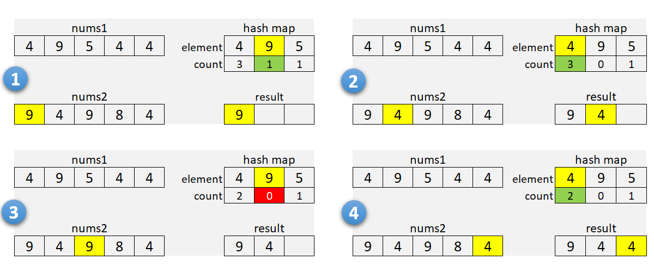

It's a good idea to check array sizes and use a hash map for the smaller array. It will reduce memory usage when one of the arrays is very large.

**Algorithm**

1. If nums1 is larger than nums2, swap the arrays.
2. For each element in nums1:
   * Add it to the hash map m.
     + Increment the count if the element is already there.
3. Initialize the insertion pointer (k) with zero.
4. Iterate along nums2:
   * If the current number is in the hash map and count is positive:
     + Copy the number into nums1[k], and increment k.
     + Decrement the count in the hash map.
5. Return first k elements of nums1.

For our solutions here, we use one of the arrays to store the result. As we find common numbers, we copy them to the first array starting from the beginning. This idea is from [this solution](https://leetcode.com/problems/intersection-of-two-arrays-ii/discuss/82405/Simple-Java-Solution) by [sankitgupta](https://leetcode.com/sankitgupta/).

|  |
| --- |
| public int[] intersect(int[] nums1, int[] nums2) {  if (nums1.length > nums2.length) {  return intersect(nums2, nums1);  }  HashMap<Integer, Integer> m = new HashMap<>();  for (int n : nums1) {  m.put(n, m.getOrDefault(n, 0) + 1);  }  int k = 0;  for (int n : nums2) {  int cnt = m.getOrDefault(n, 0);  if (cnt > 0) {  nums1[k++] = n;  m.put(n, cnt - 1);  }  }  return Arrays.copyOfRange(nums1, 0, k);  } |

**Complexity Analysis**

* Time Complexity: O(*n*+*m*), where *n* and m*m* are the lengths of the arrays. We iterate through the first, and then through the second array; insert and lookup operations in the hash map take a constant time.
* Space Complexity: O(min(*n*,*m*)). We use hash map to store numbers (and their counts) from the smaller array.

#### **Approach 2: Sort**

You can recommend this method when the input is sorted, or when the output needs to be sorted. Here, we sort both arrays (assuming they are not sorted) and use two pointers to find common numbers in a single scan.

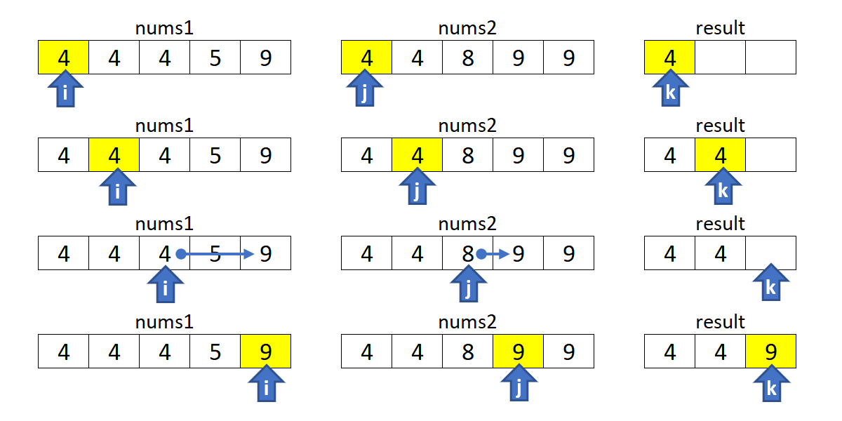

**Algorithm**

1. Sort nums1 and nums2.
2. Initialize i, j and k with zero.
3. Move indices i along nums1, and j through nums2:
   * Increment i if nums1[i] is smaller.
   * Increment j if nums2[j] is smaller.
   * If numbers are the same, copy the number into nums1[k], and increment i, j and k.
4. Return first k elements of nums1.

|  |
| --- |
| public int[] intersect(int[] nums1, int[] nums2) {  Arrays.sort(nums1);  Arrays.sort(nums2);  int i = 0, j = 0, k = 0;  while (i < nums1.length && j < nums2.length) {  if (nums1[i] < nums2[j]) {  ++i;  } else if (nums1[i] > nums2[j]) {  ++j;  } else {  nums1[k++] = nums1[i++];  ++j;  }  }  return Arrays.copyOfRange(nums1, 0, k);  } |

**Complexity Analysis**

* Time Complexity:  O(*n*log*n*+*m*log*m*), where *n* and *m* are the lengths of the arrays. We sort two arrays independently, and then do a linear scan.
* Space Complexity: from  O(log*n*+log*m*) to  O(*n*+*m*), depending on the implementation of the sorting algorithm. For the complexity analysis purposes, we ignore the memory required by inputs and outputs.

#### **Approach 3: Built-in Intersection**

This is similar to [Approach 2](https://leetcode.com/problems/intersection-of-two-arrays-ii/solution/#approach-2-sort). Instead of iterating with two pointers, we use a built-in function to find common elements. In C++, we can use set\_intersection for sorted arrays (or multisets).

The [retainAll](https://docs.oracle.com/javase/8/docs/api/java/util/AbstractCollection.html" \l "retainAll-java.util.Collection-) method in Java, unfortunately, does not care how many times an element occurs in the other collection. You can use the [retainOccurrences](https://guava.dev/releases/23.0/api/docs/com/google/common/collect/Multisets.html" \l "retainOccurrences-com.google.common.collect.Multiset-com.google.common.collect.Multiset-) method of the multiset implementation in [Guava](https://guava.dev/releases/16.0/api/docs/com/google/common/collect/Multiset.html).

**Algorithm**

Note that set\_intersection returns the position past the end of the produced range, so it can be used as an input for the erase function. The idea is from [this solution](https://leetcode.com/problems/intersection-of-two-arrays-ii/discuss/82269/Short-Python-C%2B%2B) by [StefanPochmann](https://leetcode.com/stefanpochmann/).

|  |
| --- |
| vector<int> intersect(vector<int>& nums1, vector<int>& nums2) {  sort(begin(nums1), end(nums1));  sort(begin(nums2), end(nums2));  nums1.erase(set\_intersection(begin(nums1), end(nums1),  begin(nums2), end(nums2), begin(nums1)), end(nums1));  return nums1;  } |

**Complexity Analysis**

* Same as for [approach 2](https://leetcode.com/problems/intersection-of-two-arrays-ii/solution/#approach2complexity) above.

#### **Follow-up Questions**

1. What if the given array is already sorted? How would you optimize your algorithm?
   * We can use either [Approach 2](https://leetcode.com/problems/intersection-of-two-arrays-ii/solution/#approach-2-sort) or [Approach 3](https://leetcode.com/problems/intersection-of-two-arrays-ii/solution/#approach-3-built-in-intersection), dropping the sort of course. It will give us linear time and constant memory complexity.
2. What if nums1's size is small compared to nums2's size? Which algorithm is better?
   * [Approach 1](https://leetcode.com/problems/intersection-of-two-arrays-ii/solution/#approach-1-hash-map) is a good choice here as we use a hash map for the smaller array.
3. What if elements of nums2 are stored on disk, and the memory is limited such that you cannot load all elements into the memory at once?
   * If nums1 fits into the memory, we can use [Approach 1](https://leetcode.com/problems/intersection-of-two-arrays-ii/solution/#approach-1-hash-map) to collect counts for nums1 into a hash map. Then, we can sequentially load and process nums2.
   * If neither of the arrays fit into the memory, we can apply some partial processing strategies:
     + Split the numeric range into subranges that fits into the memory. Modify [Approach 1](https://leetcode.com/problems/intersection-of-two-arrays-ii/solution/#approach-1-hash-map) to collect counts only within a given subrange, and call the method multiple times (for each subrange).
     + Use an external sort for both arrays. Modify [Approach 2](https://leetcode.com/problems/intersection-of-two-arrays-ii/solution/#approach-2-sort) to load and process arrays sequentially.

**Plus One**

Given a **non-empty** array of decimal digits representing a non-negative integer, increment one to the integer.

The digits are stored such that the most significant digit is at the head of the list, and each element in the array contains a single digit.

You may assume the integer does not contain any leading zero, except the number 0 itself.

**Example 1:**

**Input:** digits = [1,2,3]

**Output:** [1,2,4]

**Explanation:** The array represents the integer 123.

**Example 2:**

**Input:** digits = [4,3,2,1]

**Output:** [4,3,2,2]

**Explanation:** The array represents the integer 4321.

**Example 3:**

**Input:** digits = [0]

**Output:** [1]

**Constraints:**

* 1 <= digits.length <= 100
* 0 <= digits[i] <= 9

**Move Zeroes**

Given an array nums, write a function to move all 0's to the end of it while maintaining the relative order of the non-zero elements.

**Example:**

**Input:** [0,1,0,3,12]

**Output:** [1,3,12,0,0]

**Note**:

1. You must do this **in-place** without making a copy of the array.
2. Minimize the total number of operations.

  Hide Hint #1

**In-place** means we should not be allocating any space for extra array. But we are allowed to modify the existing array. However, as a first step, try coming up with a solution that makes use of additional space. For this problem as well, first apply the idea discussed using an additional array and the in-place solution will pop up eventually.

   Hide Hint #2

A **two-pointer** approach could be helpful here. The idea would be to have one pointer for iterating the array and another pointer that just works on the non-zero elements of the array.

**Two Sum**

Given an array of integers nums and an integer target, return *indices of the two numbers such that they add up to target*.

You may assume that each input would have ***exactly* one solution**, and you may not use the *same* element twice.

You can return the answer in any order.

**Example 1:**

**Input:** nums = [2,7,11,15], target = 9

**Output:** [0,1]

**Output:** Because nums[0] + nums[1] == 9, we return [0, 1].

**Example 2:**

**Input:** nums = [3,2,4], target = 6

**Output:** [1,2]

**Example 3:**

**Input:** nums = [3,3], target = 6

**Output:** [0,1]

**Constraints:**

* 2 <= nums.length <= 103
* -109 <= nums[i] <= 109
* -109 <= target <= 109
* **Only one valid answer exists.**

   Hide Hint #1

A really brute force way would be to search for all possible pairs of numbers but that would be too slow. Again, it's best to try out brute force solutions for just for completeness. It is from these brute force solutions that you can come up with optimizations.

   Hide Hint #2

So, if we fix one of the numbers, say

x

, we have to scan the entire array to find the next number

y

which is

value - x

where value is the input parameter. Can we change our array somehow so that this search becomes faster?

   Hide Hint #3

The second train of thought is, without changing the array, can we use additional space somehow? Like maybe a hash map to speed up the search?

**Valid Sudoku**

Determine if a 9 x 9 Sudoku board is valid. Only the filled cells need to be validated **according to the following rules**:

1. Each row must contain the digits 1-9 without repetition.
2. Each column must contain the digits 1-9 without repetition.
3. Each of the nine 3 x 3 sub-boxes of the grid must contain the digits 1-9 without repetition.

**Note:**

* A Sudoku board (partially filled) could be valid but is not necessarily solvable.
* Only the filled cells need to be validated according to the mentioned rules.

**Example 1:**

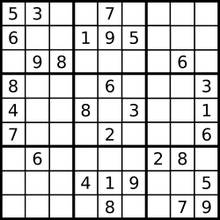

**Input:** board =

[["5","3",".",".","7",".",".",".","."]

,["6",".",".","1","9","5",".",".","."]

,[".","9","8",".",".",".",".","6","."]

,["8",".",".",".","6",".",".",".","3"]

,["4",".",".","8",".","3",".",".","1"]

,["7",".",".",".","2",".",".",".","6"]

,[".","6",".",".",".",".","2","8","."]

,[".",".",".","4","1","9",".",".","5"]

,[".",".",".",".","8",".",".","7","9"]]

**Output:** true

**Example 2:**

**Input:** board =

[["8","3",".",".","7",".",".",".","."]

,["6",".",".","1","9","5",".",".","."]

,[".","9","8",".",".",".",".","6","."]

,["8",".",".",".","6",".",".",".","3"]

,["4",".",".","8",".","3",".",".","1"]

,["7",".",".",".","2",".",".",".","6"]

,[".","6",".",".",".",".","2","8","."]

,[".",".",".","4","1","9",".",".","5"]

,[".",".",".",".","8",".",".","7","9"]]

**Output:** false

**Explanation:** Same as Example 1, except with the **5** in the top left corner being modified to **8**. Since there are two 8's in the top left 3x3 sub-box, it is invalid.

**Constraints:**

* board.length == 9
* board[i].length == 9
* board[i][j] is a digit or '.'.

## Solution

#### **Intuition**

The naive solution would be to iterate three times over the board to ensure that :

* There is no rows with duplicates.
* There is no columns with duplicates.
* There is no sub-boxes with duplicates.

Actually, all this could be done in just one iteration.

#### **Approach 1: One iteration**

Let's first discuss two questions.

* How to enumerate sub-boxes?

One could use box\_index = (row / 3) \* 3 + col / 3 where / is an integer division, row is a row number, and col is a column number.

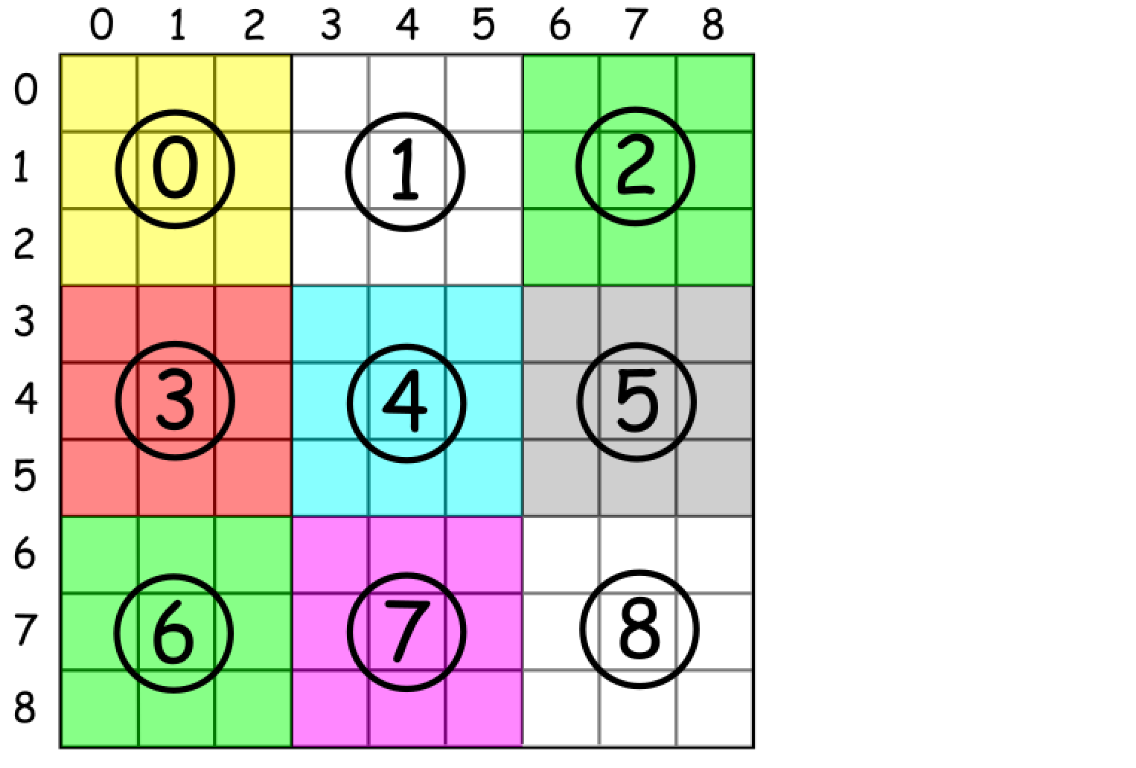

* How to ensure that there is no duplicates in a row / column / box?

One could just track all values which were already encountered in a hash map value -> count.

Now everything is ready for the overall algorithm :

* Move along the board.
  + Check for each cell value if it was seen already in the current row / column / box :
    - Return false if yes.
    - Keep this value for a further tracking if no.
* Return true.

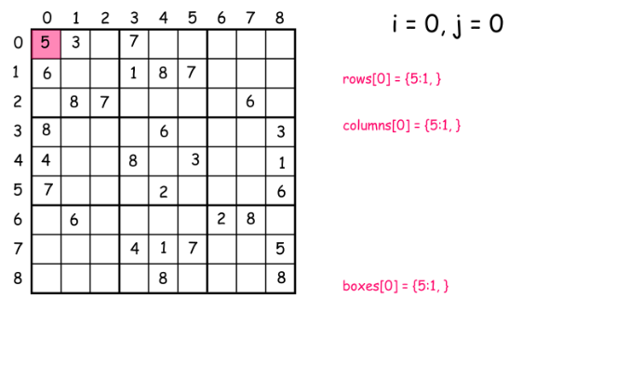

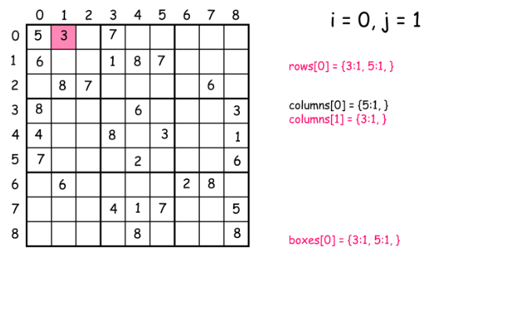

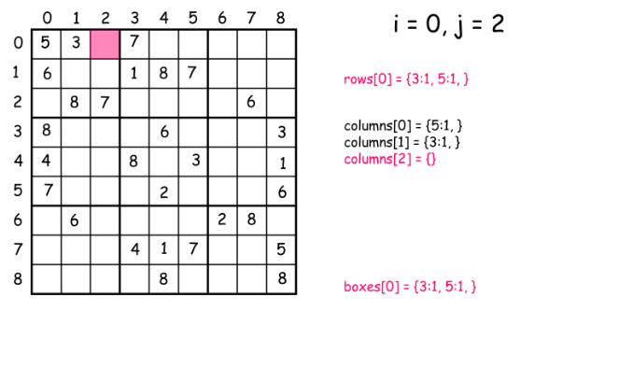

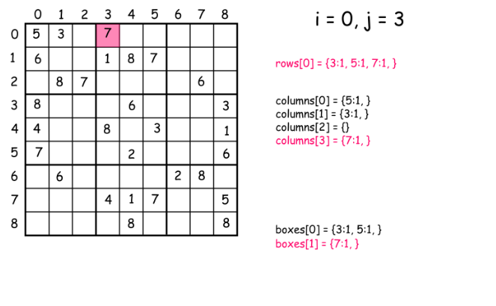

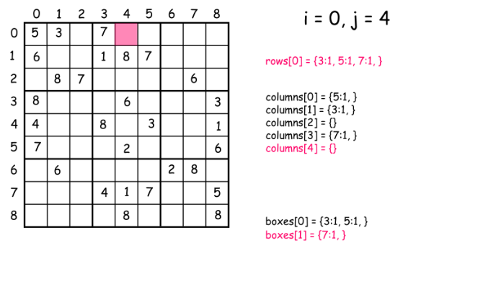

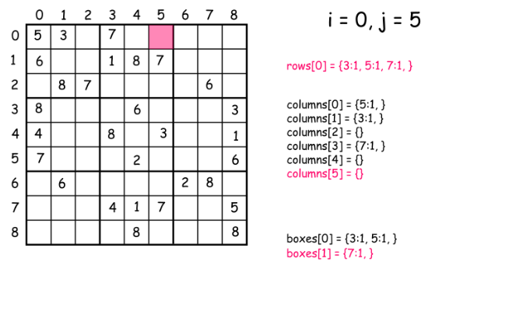

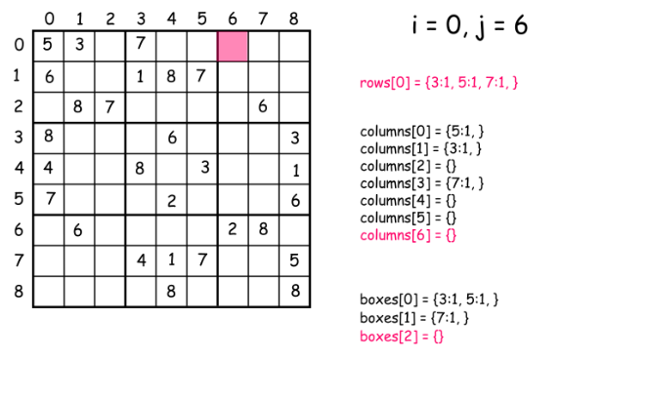

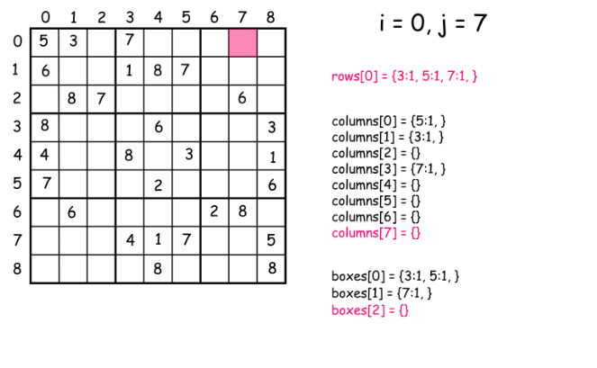

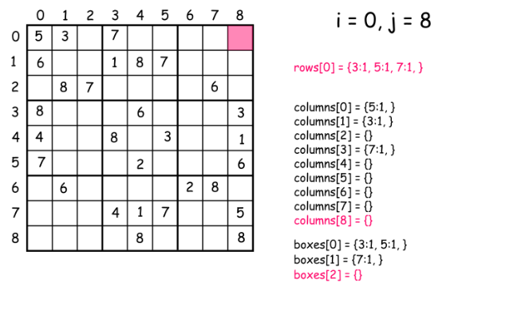

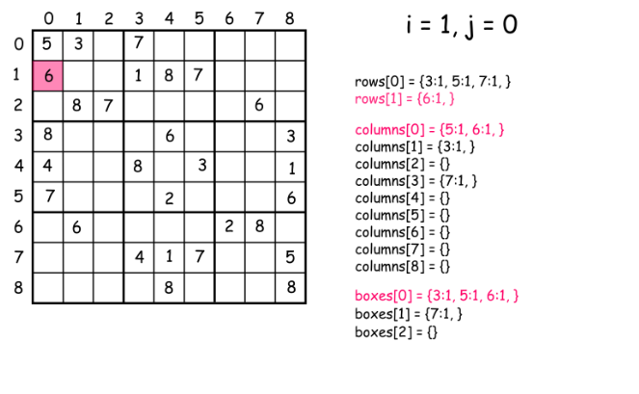

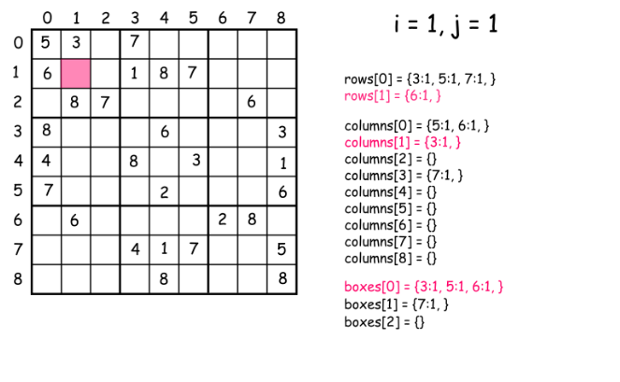

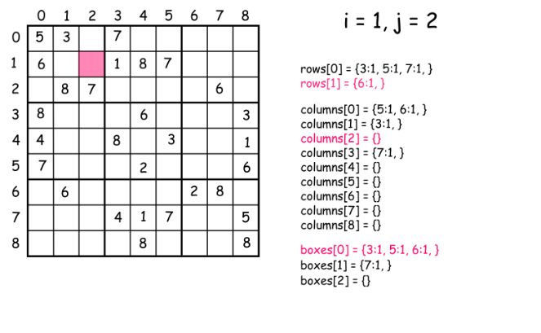

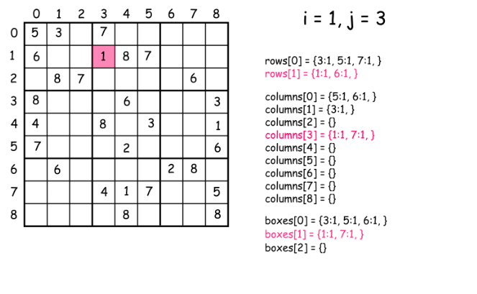

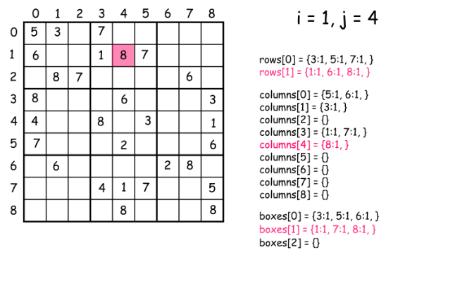

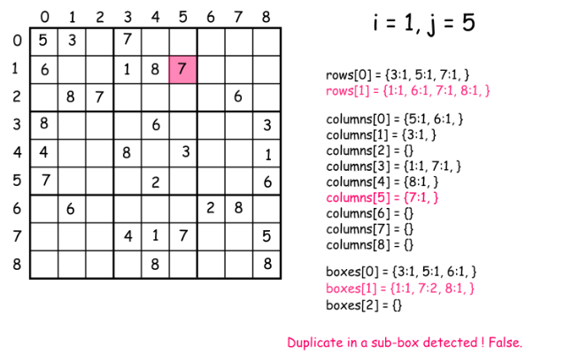

|  |
| --- |
| class Solution {  public boolean isValidSudoku(char[][] board) {  // init data  HashMap<Integer, Integer> [] rows = new HashMap[9];  HashMap<Integer, Integer> [] columns = new HashMap[9];  HashMap<Integer, Integer> [] boxes = new HashMap[9];  for (int i = 0; i < 9; i++) {  rows[i] = new HashMap<Integer, Integer>();  columns[i] = new HashMap<Integer, Integer>();  boxes[i] = new HashMap<Integer, Integer>();  }  // validate a board  for (int i = 0; i < 9; i++) {  for (int j = 0; j < 9; j++) {  char num = board[i][j];  if (num != '.') {  int n = (int)num;  int box\_index = (i / 3 ) \* 3 + j / 3;  // keep the current cell value  rows[i].put(n, rows[i].getOrDefault(n, 0) + 1);  columns[j].put(n, columns[j].getOrDefault(n, 0) + 1);  boxes[box\_index].put(n, boxes[box\_index].getOrDefault(n, 0) + 1);  // check if this value has been already seen before  if (rows[i].get(n) > 1 || columns[j].get(n) > 1 || boxes[box\_index].get(n) > 1)  return false;  }  }  }  return true;  }  } |

**Complexity Analysis**

* Time complexity : O(1) since all we do here is just one iteration over the board with 81 cells.
* Space complexity : O(1).

**Rotate Image**

You are given an *n* x *n* 2D matrix representing an image, rotate the image by 90 degrees (clockwise).

You have to rotate the image [**in-place**](https://en.wikipedia.org/wiki/In-place_algorithm), which means you have to modify the input 2D matrix directly. **DO NOT** allocate another 2D matrix and do the rotation.

**Example 1:**

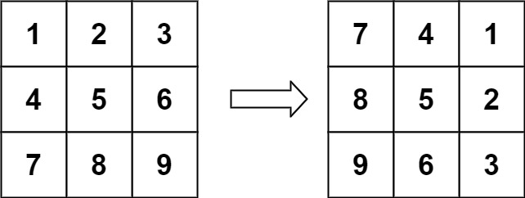

**Input:** matrix = [[1,2,3],[4,5,6],[7,8,9]]

**Output:** [[7,4,1],[8,5,2],[9,6,3]]

**Example 2:**

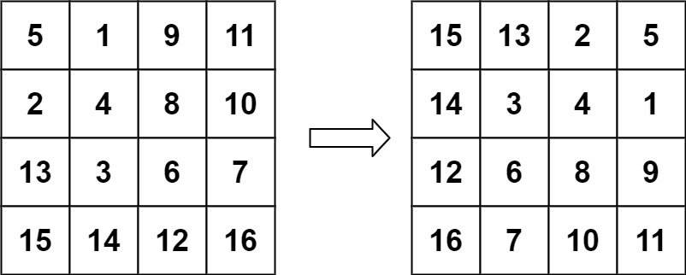

**Input:** matrix = [[5,1,9,11],[2,4,8,10],[13,3,6,7],[15,14,12,16]]

**Output:** [[15,13,2,5],[14,3,4,1],[12,6,8,9],[16,7,10,11]]

**Example 3:**

**Input:** matrix = [[1]]

**Output:** [[1]]

**Example 4:**

**Input:** matrix = [[1,2],[3,4]]

**Output:** [[3,1],[4,2]]

**Constraints:**

* matrix.length == n
* matrix[i].length == n
* 1 <= n <= 20
* -1000 <= matrix[i][j] <= 1000

## Solution

#### **Approach 1: Rotate Groups of Four Cells**

**Intuition**

Observe how the cells move in groups when we rotate the image.

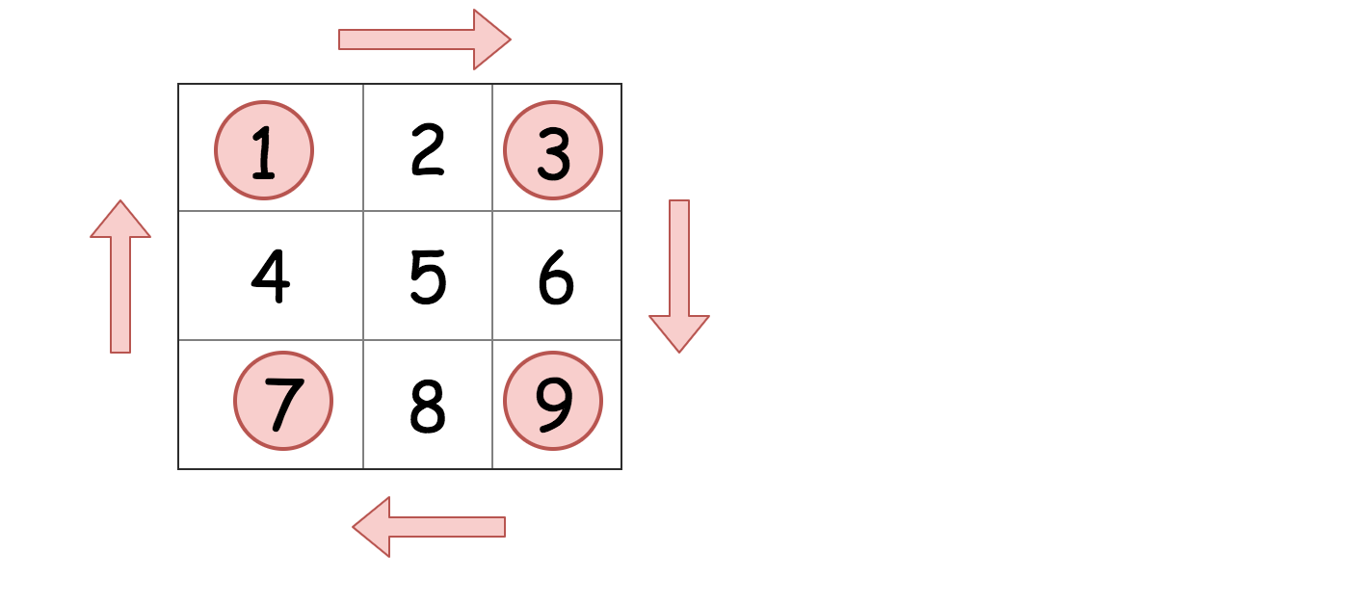

We can iterate over each group of four cells and rotate them.

**Implementation**

Here is a visualization of the algorithm in action.

|  |
| --- |
| class Solution {  public void rotate(int[][] matrix) {  int n = matrix.length;  for (int i = 0; i < (n + 1) / 2; i ++) {  for (int j = 0; j < n / 2; j++) {  int temp = matrix[n - 1 - j][i];  matrix[n - 1 - j][i] = matrix[n - 1 - i][n - j - 1];  matrix[n - 1 - i][n - j - 1] = matrix[j][n - 1 -i];  matrix[j][n - 1 - i] = matrix[i][j];  matrix[i][j] = temp;  }  }  }  } |

**Complexity Analysis**

Let M*M* be the number of cells in the matrix.

* Time complexity : \mathcal{O}(M)O(*M*), as each cell is getting read once and written once.
* Space complexity : \mathcal{O}(1)O(1) because we do not use any other additional data structures.

#### **Approach 2: Reverse on Diagonal and then Reverse Left to Right**

**Intuition**

The most elegant solution for rotating the matrix is to firstly reverse the matrix around the main diagonal, and then reverse it from left to right. These operations are called **transpose** and **reflect** in linear algebra.

Here is a visualization to help you see why this works.

**Bonus Question:** What would happen if you reflect and then transpose? Would you still get the correct answer?

Even though this approach does twice as many reads and writes as approach 1, most people would consider it a better approach because the code is simpler, and it is built with standard matrix operations that can be found in any matrix library.

**Implementation**

|  |
| --- |
| class Solution {  public void rotate(int[][] matrix) {  transpose(matrix);  reflect(matrix);  }    public void transpose(int[][] matrix) {  int n = matrix.length;  for (int i = 0; i < n; i++) {  for (int j = i; j < n; j++) {  int tmp = matrix[j][i];  matrix[j][i] = matrix[i][j];  matrix[i][j] = tmp;  }  }  }    public void reflect(int[][] matrix) {  int n = matrix.length;  for (int i = 0; i < n; i++) {  for (int j = 0; j < n / 2; j++) {  int tmp = matrix[i][j];  matrix[i][j] = matrix[i][n - j - 1];  matrix[i][n - j - 1] = tmp;  }  }  }  } |

**Complexity Analysis.** Let *M* be the number of cells in the grid.

* Time complexity : O(*M*). We perform two steps; transposing the matrix, and then reversing each row. Transposing the matrix has a cost of O(*M*) because we're moving the value of each cell once. Reversing each row also has a cost of O(*M*), because again we're moving the value of each cell once.
* Space complexity : O(1) because we do not use any other additional data structures.

**Bonus Question:** If you're not too confident with matrices and linear algebra, get some more practice by also coding a method that transposes the matrix on the *other* diagonal, and another that reflects from top to bottom. You can test your functions by printing out the matrix before and after each operation. Finally, use your functions to find *three more solutions to this problem*. Each solution uses two matrix operations.

**Interview Tip**: Terrified of being asked this question in an interview? Many people are: it can be intimidating due to the fiddly logic. Unfortunately, if you do a lot of interviewing, the probability of seeing it at least once is high, and some people have claimed to have seen it multiple times! This is one of the few questions where I recommend practicing until you can confidently code it and explain it without thinking too much.

## Strings

String type of questions were asked in interviews frequently. You will most likely encounter one during your interviews.

We recommend: Reverse String, First Unique Character in a String, String to Integer (atoi) and Implement strStr().

 Reverse String

 Reverse Integer

 First Unique Character in a String

 Valid Anagram

 Valid Palindrome

 String to Integer (atoi)

 Implement strStr()

 Count and Say

 Longest Common Prefix

**Reverse String**

Write a function that reverses a string. The input string is given as an array of characters char[].

Do not allocate extra space for another array, you must do this by **modifying the input array**[**in-place**](https://en.wikipedia.org/wiki/In-place_algorithm) with O(1) extra memory.

You may assume all the characters consist of [printable ascii characters](https://en.wikipedia.org/wiki/ASCII#Printable_characters).

**Example 1:**

**Input:** ["h","e","l","l","o"]

**Output:** ["o","l","l","e","h"]

**Example 2:**

**Input:** ["H","a","n","n","a","h"]

**Output:** ["h","a","n","n","a","H"]

   Hide Hint #1

The entire logic for reversing a string is based on using the opposite directional two-pointer approach!

**Reverse Integer**

Given a signed 32-bit integer x, return x*with its digits reversed*. If reversing x causes the value to go outside the signed 32-bit integer range [-231, 231 - 1], then return 0.

**Assume the environment does not allow you to store 64-bit integers (signed or unsigned).**

**Example 1:**

**Input:** x = 123

**Output:** 321

**Example 2:**

**Input:** x = -123

**Output:** -321

**Example 3:**

**Input:** x = 120

**Output:** 21

**Example 4:**

**Input:** x = 0

**Output:** 0

**Constraints:**

* -231 <= x <= 231 - 1

## Solution

#### **Approach 1: Pop and Push Digits & Check before Overflow**

**Intuition**

We can build up the reverse integer one digit at a time. While doing so, we can check beforehand whether or not appending another digit would cause overflow.

**Algorithm**

Reversing an integer can be done similarly to reversing a string.

We want to repeatedly "pop" the last digit off of x*x* and "push" it to the back of the rev. In the end, rev will be the reverse of the x*x*.

To "pop" and "push" digits without the help of some auxiliary stack/array, we can use math.

//pop operation:

pop = x % 10;

x /= 10;

//push operation:

temp = rev \* 10 + pop;

rev = temp;

However, this approach is dangerous, because the statement  temp=rev⋅10+pop can cause overflow.

Luckily, it is easy to check beforehand whether or this statement would cause an overflow.

To explain, lets assume that rev is positive.

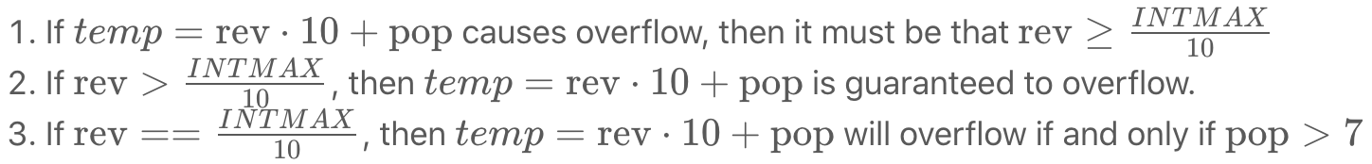

Similar logic can be applied when rev is negative.

|  |
| --- |
| class Solution {  public int reverse(int x) {  int rev = 0;  while (x != 0) {  int pop = x % 10;  x /= 10;  if (rev > Integer.MAX\_VALUE/10 || (rev == Integer.MAX\_VALUE / 10 && pop > 7)) return 0;  if (rev < Integer.MIN\_VALUE/10 || (rev == Integer.MIN\_VALUE / 10 && pop < -8)) return 0;  rev = rev \* 10 + pop;  }  return rev;  }  } |

**Complexity Analysis**

* Time Complexity: *O*(log(*x*)). There are roughly log10​(*x*) digits in x*x*.
* Space Complexity: *O*(1).

**First Unique Character in a String**

Given a string, find the first non-repeating character in it and return its index. If it doesn't exist, return -1.

**Examples:**

s = "leetcode"

return 0.

s = "loveleetcode"

return 2.

**Note:** You may assume the string contains only lowercase English letters.

## Solution

#### **Approach 1: Linear time solution**

The best possible solution here could be of a linear time because to ensure that the character is unique you have to check the whole string anyway.

The idea is to go through the string and save in a hash map the number of times each character appears in the string. That would take O(*N*) time, where N is a number of characters in the string.

And then we go through the string the second time, this time we use the hash map as a reference to check if a character is unique or not.  
If the character is unique, one could just return its index. The complexity of the second iteration is O(*N*) as well.

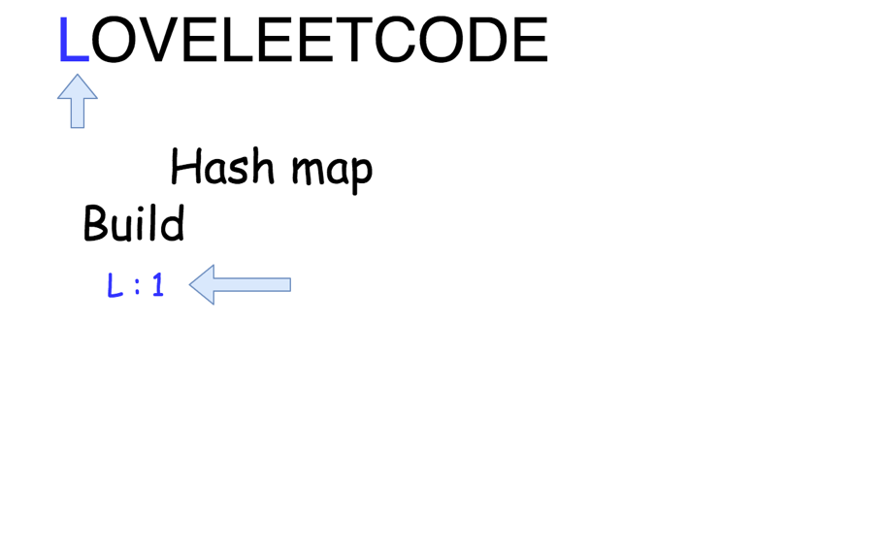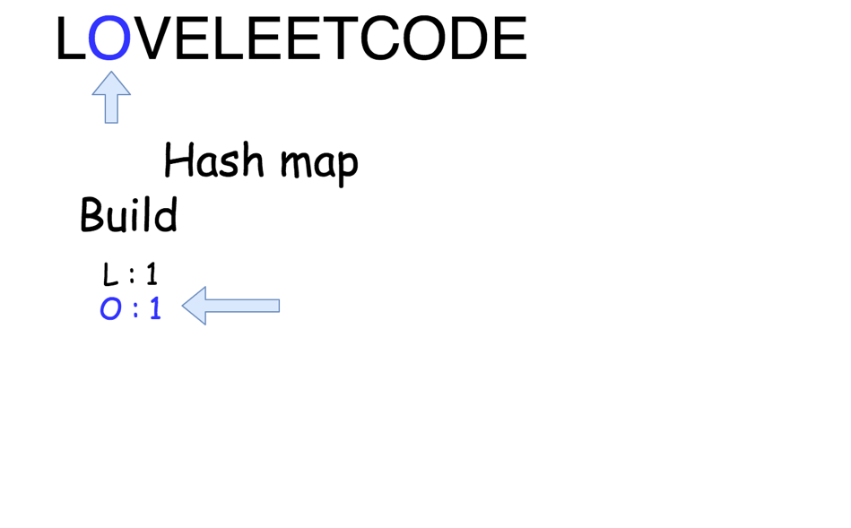

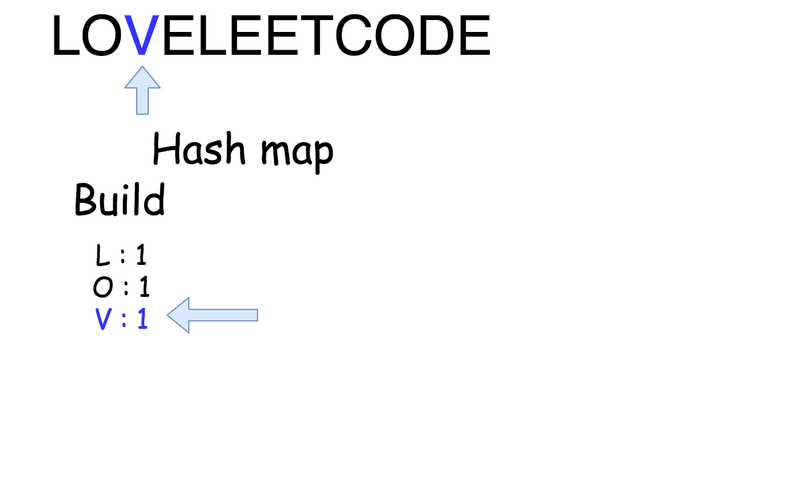

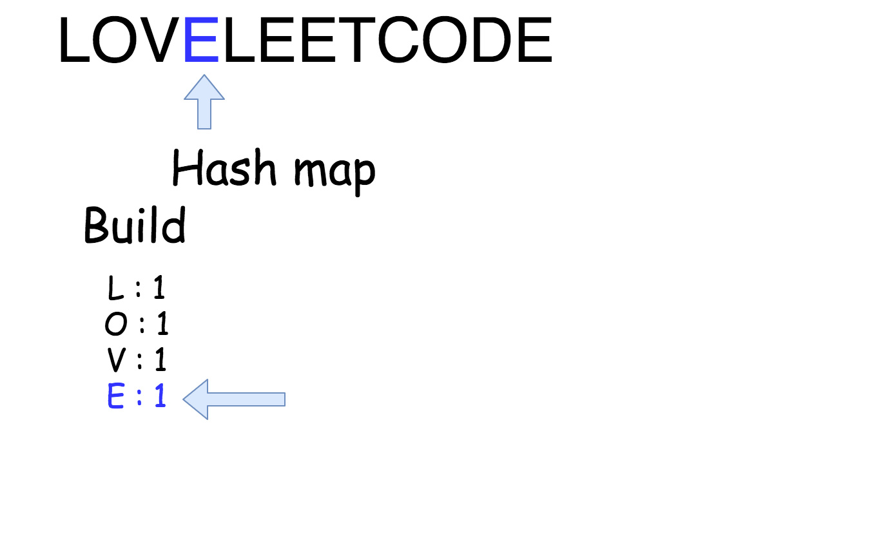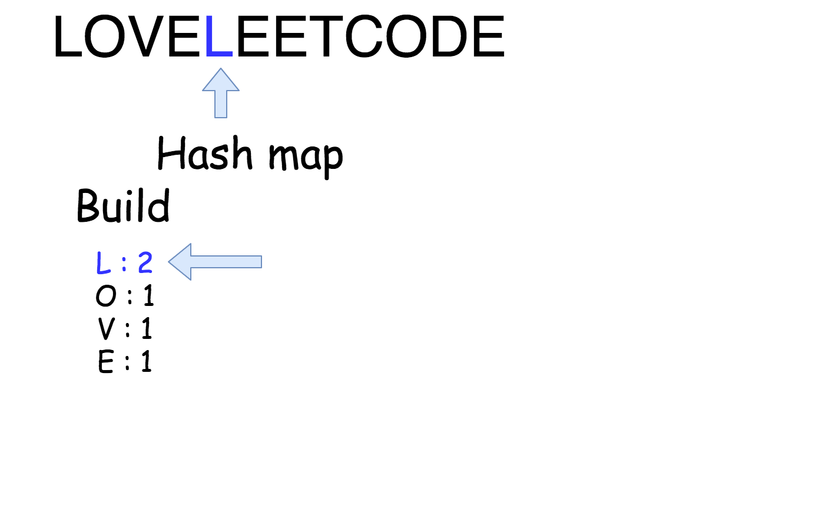

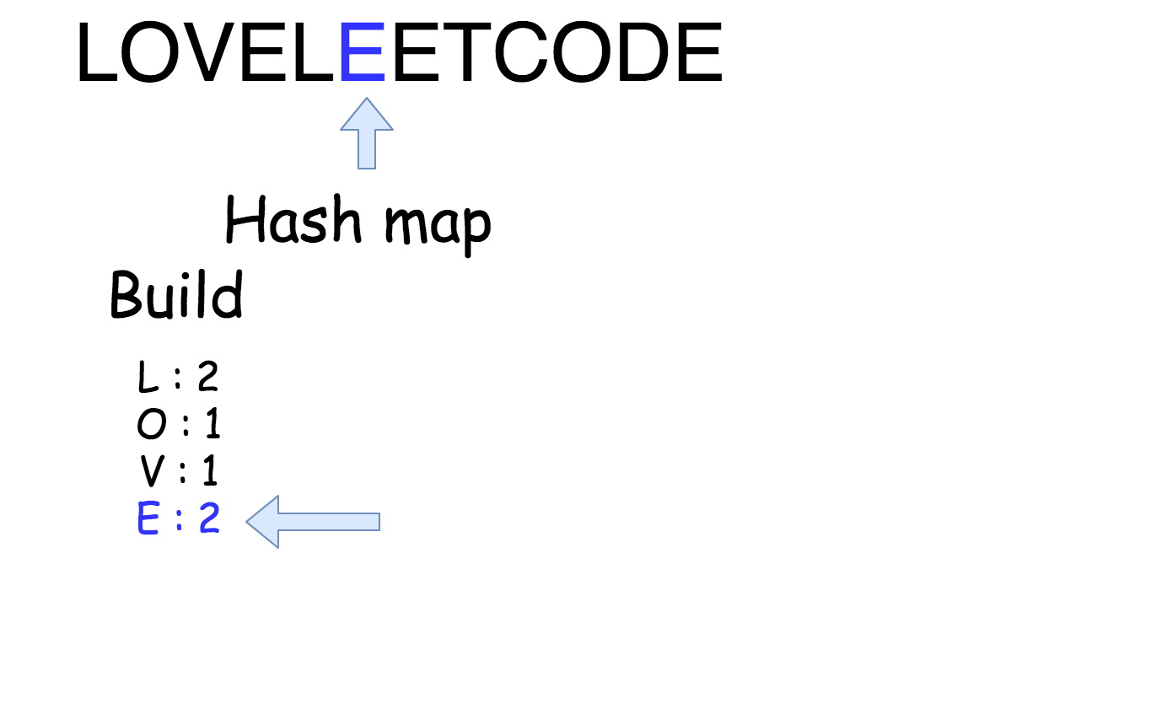

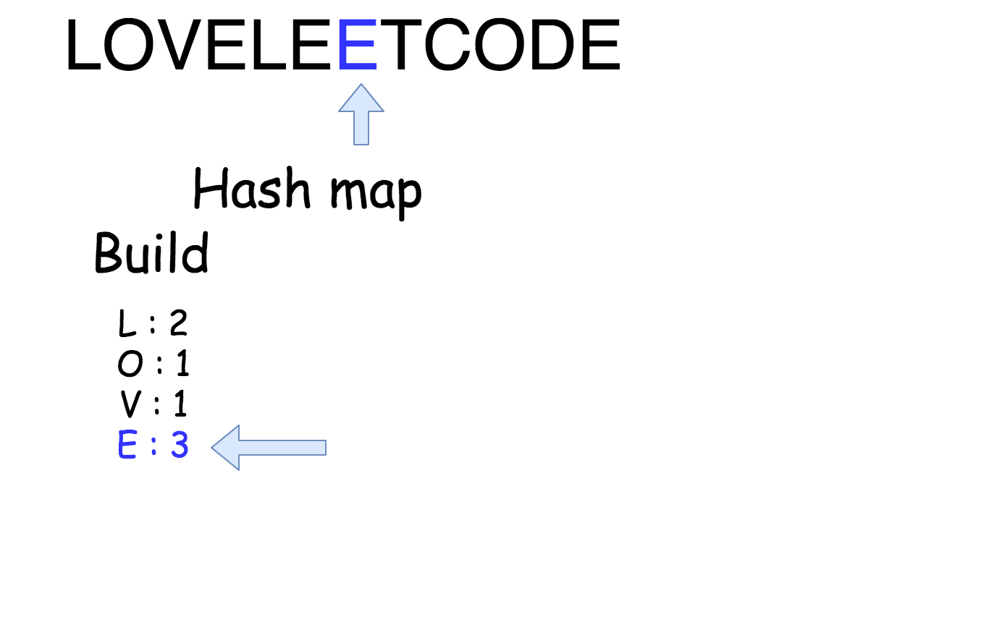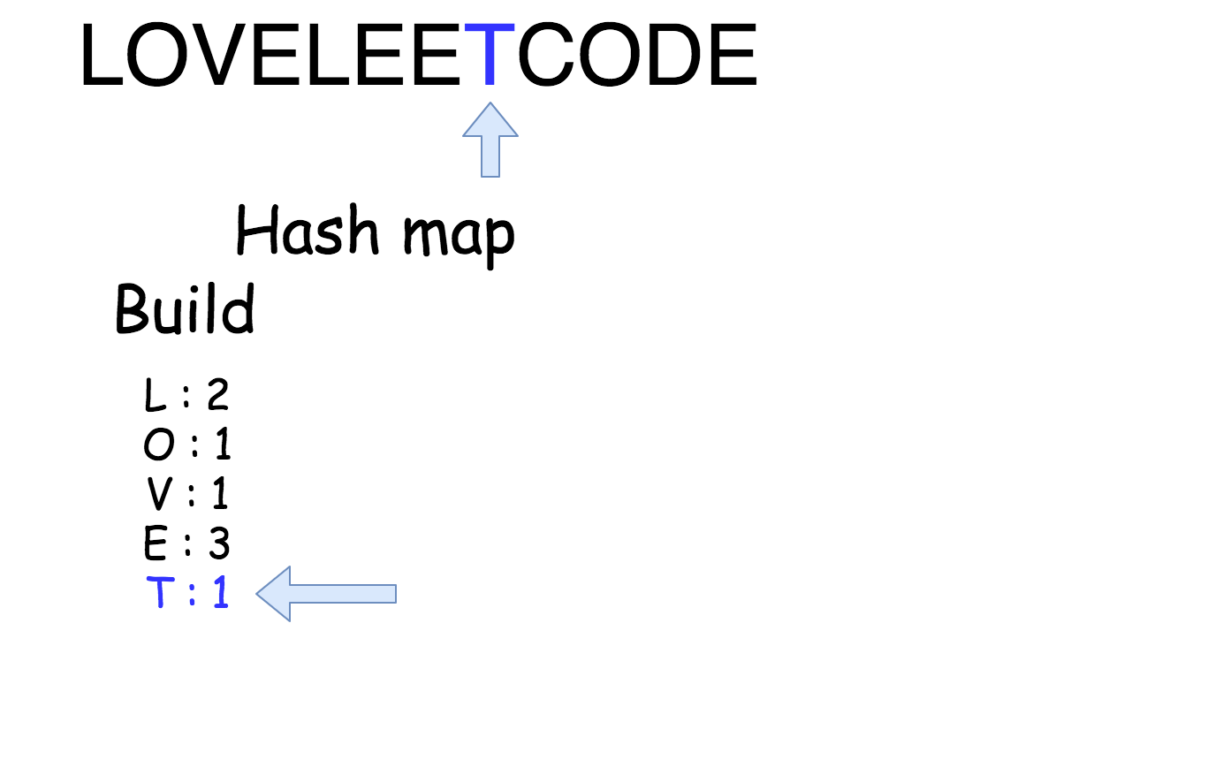

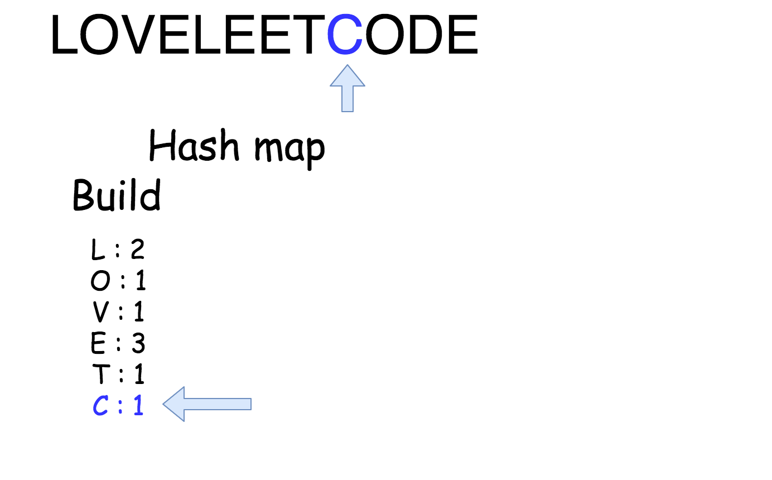

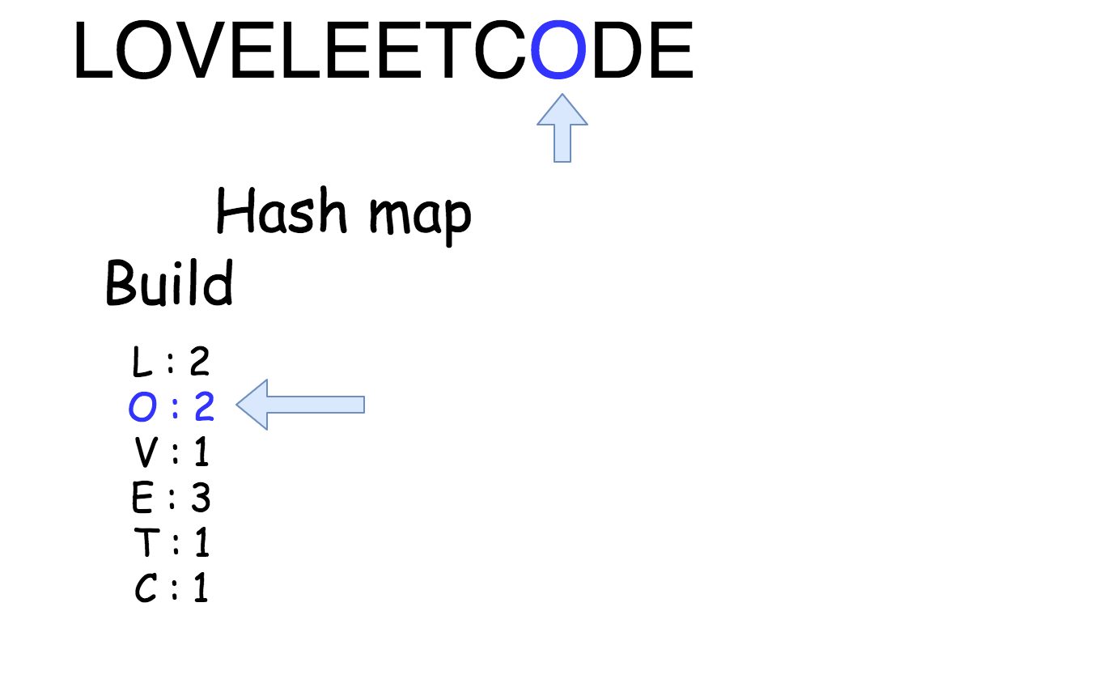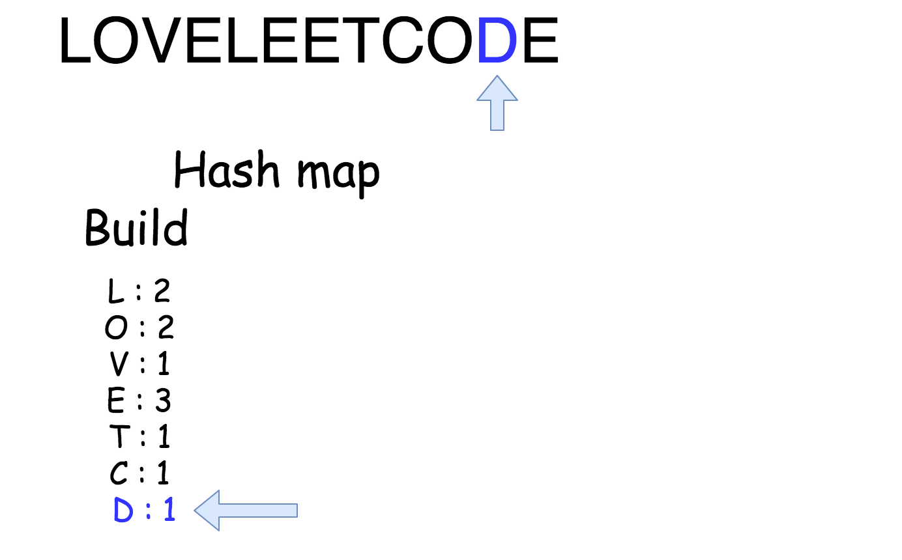

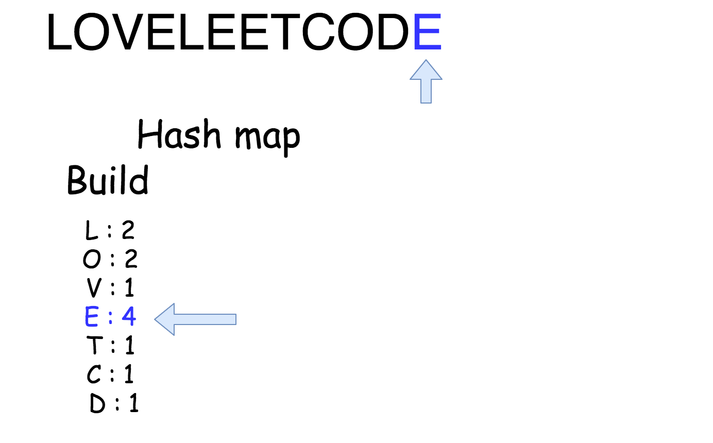

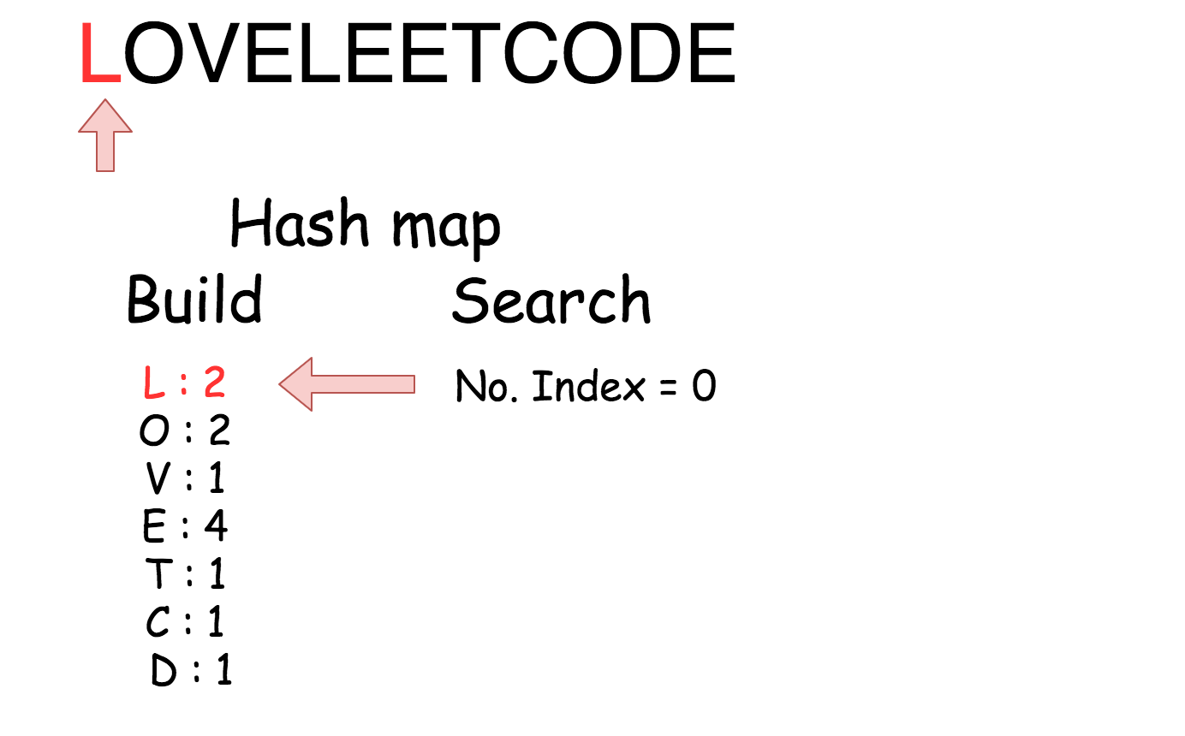

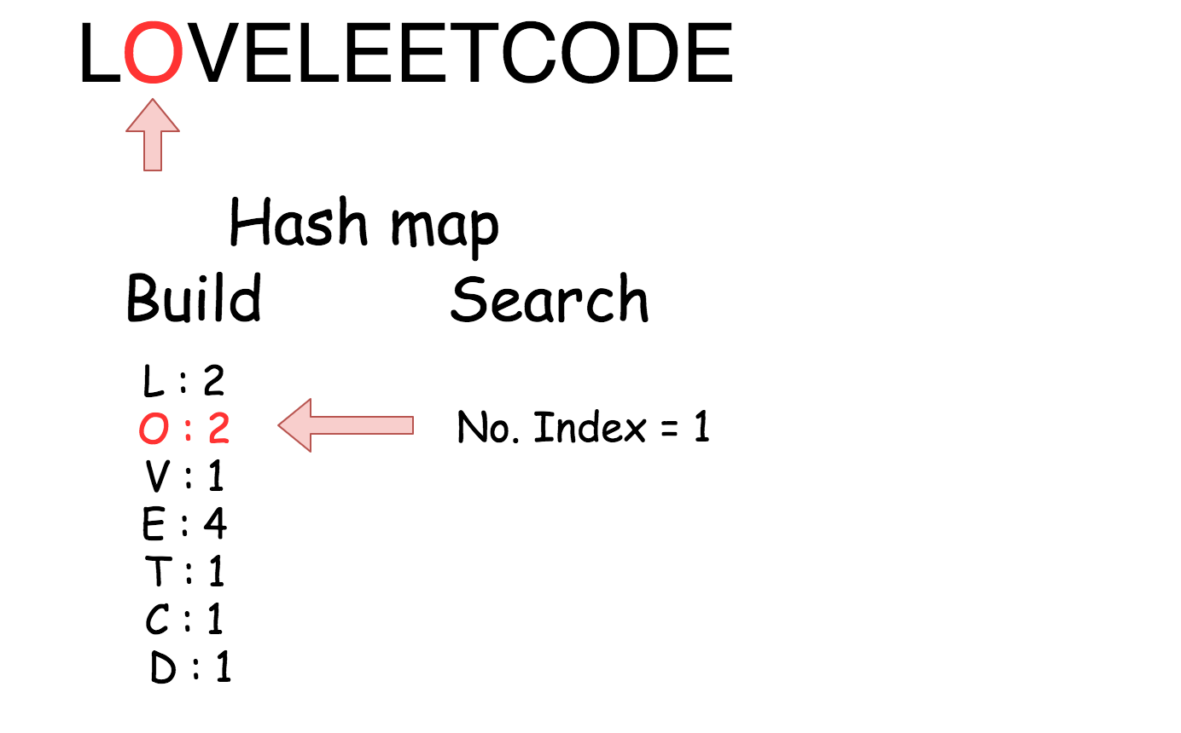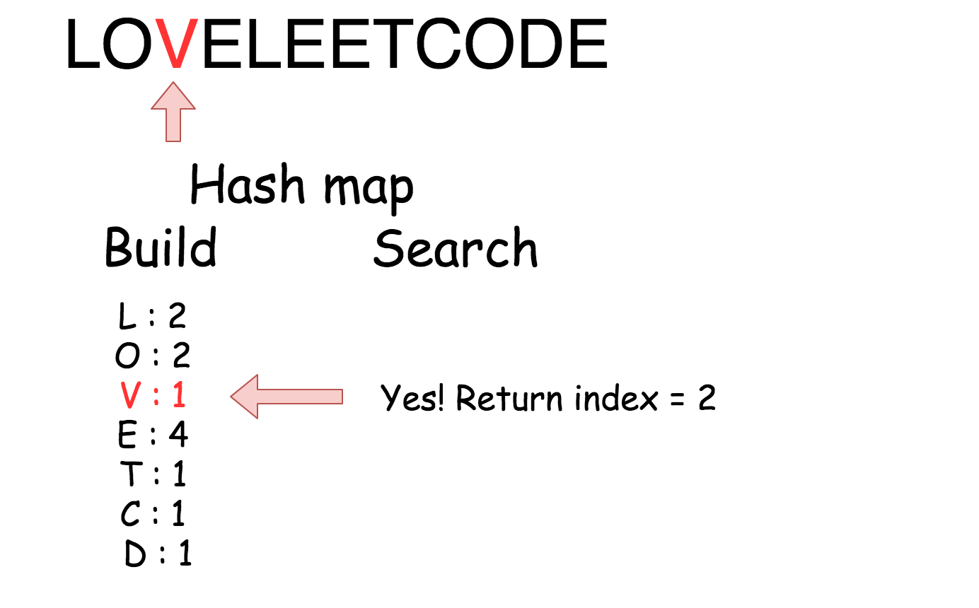

|  |
| --- |
| class Solution {  public int firstUniqChar(String s) {  HashMap<Character, Integer> count = new HashMap<Character, Integer>();  int n = s.length();  // build hash map : character and how often it appears  for (int i = 0; i < n; i++) {  char c = s.charAt(i);  count.put(c, count.getOrDefault(c, 0) + 1);  }    // find the index  for (int i = 0; i < n; i++) {  if (count.get(s.charAt(i)) == 1)  return i;  }  return -1;  }  } |

**Complexity Analysis**

* Time complexity : O(*N*) since we go through the string of length N two times.
* Space complexity : O(1) because English alphabet contains 26 letters.

Since we can assume only lowercase letters.  
Using a fixed array instead of a HashMap is a lot faster.

|  |
| --- |
| class Solution {  public int firstUniqChar(String s) {  int[] count = new int[26];  int n = s.length();  // build char count bucket : <charIndex, count>  for (int i = 0; i < n; i++) {  int index = s.charAt(i) - 'a';  count[index]++;  }    // find the index  for (int i = 0; i < n; i++) {  int index = s.charAt(i) - 'a';  if (count[index] == 1) {  return i;  }    }  return -1;  }  } |

**Valid Anagram**

Given two strings *s* and *t*, write a function to determine if *t* is an anagram of *s*.

**Example 1:**

**Input:** *s* = "anagram", *t* = "nagaram"

**Output:** true

**Example 2:**

**Input:** *s* = "rat", *t* = "car"

**Output:** false

**Note:**  
You may assume the string contains only lowercase alphabets.

**Follow up:**  
What if the inputs contain unicode characters? How would you adapt your solution to such case?

## Solution

#### **Approach #1 (Sorting) [Accepted]**

**Algorithm**

An anagram is produced by rearranging the letters of s*s* into *t*. Therefore, if *t* is an anagram of s*s*, sorting both strings will result in two identical strings. Furthermore, if s*s* and *t* have different lengths, *t* must not be an anagram of s*s* and we can return early.

|  |
| --- |
| public boolean isAnagram(String s, String t) {  if (s.length() != t.length()) {  return false;  }  char[] str1 = s.toCharArray();  char[] str2 = t.toCharArray();  Arrays.sort(str1);  Arrays.sort(str2);  return Arrays.equals(str1, str2);  } |

**Complexity analysis**

* Time complexity : *O*(*n*log*n*). Assume that n*n* is the length of s*s*, sorting costs *O*(*n*log*n*) and comparing two strings costs *O*(*n*). Sorting time dominates and the overall time complexity is *O*(*n*log*n*).
* Space complexity : *O*(1). Space depends on the sorting implementation which, usually, costs *O*(1) auxiliary space if heapsort is used. Note that in Java, toCharArray() makes a copy of the string so it costs *O*(*n*) extra space, but we ignore this for complexity analysis because:
  + It is a language dependent detail.
  + It depends on how the function is designed. For example, the function parameter types can be changed to char[].

#### **Approach #2 (Hash Table) [Accepted]**

**Algorithm**

To examine if *t* is a rearrangement of s*s*, we can count occurrences of each letter in the two strings and compare them. Since both s*s* and *t* contain only letters from *a*−*z*, a simple counter table of size 26 is suffice.

Do we need two counter tables for comparison? Actually no, because we could increment the counter for each letter in s*s* and decrement the counter for each letter in *t*, then check if the counter reaches back to zero.

|  |
| --- |
| public boolean isAnagram(String s, String t) {  if (s.length() != t.length()) {  return false;  }  int[] counter = new int[26];  for (int i = 0; i < s.length(); i++) {  counter[s.charAt(i) - 'a']++;  counter[t.charAt(i) - 'a']--;  }  for (int count : counter) {  if (count != 0) {  return false;  }  }  return true;  } |

Or we could first increment the counter for s*s*, then decrement the counter for *t*. If at any point the counter drops below zero, we know that *t* contains an extra letter not in s*s* and return false immediately.

|  |
| --- |
| public boolean isAnagram(String s, String t) {  if (s.length() != t.length()) {  return false;  }  int[] table = new int[26];  for (int i = 0; i < s.length(); i++) {  table[s.charAt(i) - 'a']++;  }  for (int i = 0; i < t.length(); i++) {  table[t.charAt(i) - 'a']--;  if (table[t.charAt(i) - 'a'] < 0) {  return false;  }  }  return true;  } |

**Complexity analysis**

* Time complexity : *O*(*n*). Time complexity is *O*(*n*) because accessing the counter table is a constant time operation.
* Space complexity : *O*(1). Although we do use extra space, the space complexity is *O*(1) because the table's size stays constant no matter how large *n* is.

**Follow up**

What if the inputs contain unicode characters? How would you adapt your solution to such case?

**Answer**

Use a hash table instead of a fixed size counter. Imagine allocating a large size array to fit the entire range of unicode characters, which could go up to [more than 1 million](http://stackoverflow.com/a/5928054/490463). A hash table is a more generic solution and could adapt to any range of characters.

**Valid Palindrome**

Given a string, determine if it is a palindrome, considering only alphanumeric characters and ignoring cases.

**Note:** For the purpose of this problem, we define empty string as valid palindrome.

**Example 1:**

**Input:** "A man, a plan, a canal: Panama"

**Output:** true

**Example 2:**

**Input:** "race a car"

**Output:** false

**Constraints:**

* s consists only of printable ASCII characters.

## Solution

#### **Approach 1: Compare with Reverse**

**Intuition**

A palindrome is a word, phrase, or sequence that reads the same backwards as forwards. e.g. madam

A palindrome, and its reverse, are identical to each other.

**Algorithm**

We'll reverse the given string and compare it with the original. If those are equivalent, it's a palindrome.

Since only alphanumeric characters are considered, we'll filter out all other types of characters before we apply our algorithm.

Additionally, because we're treating letters as case-insensitive, we'll convert the remaining letters to lower case. The digits will be left the same.

|  |
| --- |
| class Solution {  public boolean isPalindrome(String s) {  StringBuilder builder = new StringBuilder();  for (char ch : s.toCharArray()) {  if (Character.isLetterOrDigit(ch)) {  builder.append(Character.toLowerCase(ch));  }  }  String filteredString = builder.toString();  String reversedString = builder.reverse().toString();  return filteredString.equals(reversedString);  }  /\*\* An alternate solution using Java 8 Streams \*/  public boolean isPalindromeUsingStreams(String s) {  StringBuilder builder = new StringBuilder();  s.chars()  .filter(c -> Character.isLetterOrDigit(c))  .mapToObj(c -> Character.toLowerCase((char) c))  .forEach(builder::append);  return builder.toString().equals(builder.reverse().toString());  }  } |

**Complexity Analysis**

* Time complexity : *O*(*n*), in length *n* of the string.

We need to iterate thrice through the string:

* 1. When we filter out non-alphanumeric characters, and convert the remaining characters to lower-case.
  2. When we reverse the string.
  3. When we compare the original and the reversed strings.

Each iteration runs linear in time (since each character operation completes in constant time). Thus, the effective run-time complexity is linear.

* Space complexity : *O*(*n*), in length *n* of the string. We need *O*(*n*) additional space to stored the filtered string and the reversed string.

#### **Approach 2: Two Pointers**

**Intuition**

If you take any ordinary string, and concatenate its reverse to it, you'll get a palindrome. This leads to an interesting insight about the converse: every palindrome half is reverse of the other half.

Simply speaking, if one were to start in the middle of a palindrome, and traverse outwards, they'd encounter the same characters, in the exact same order, in both halves!

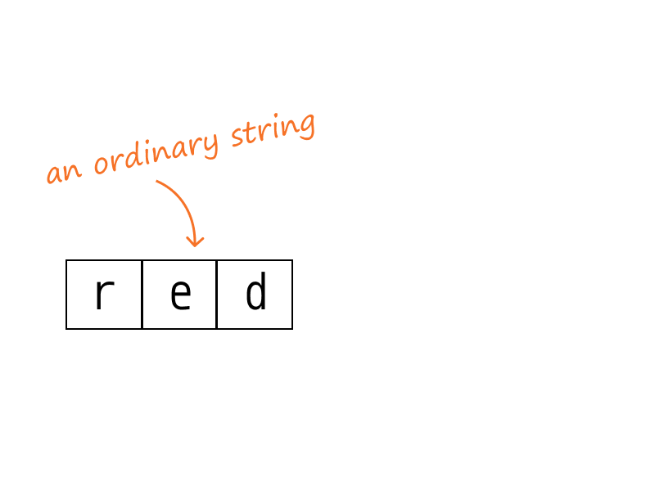 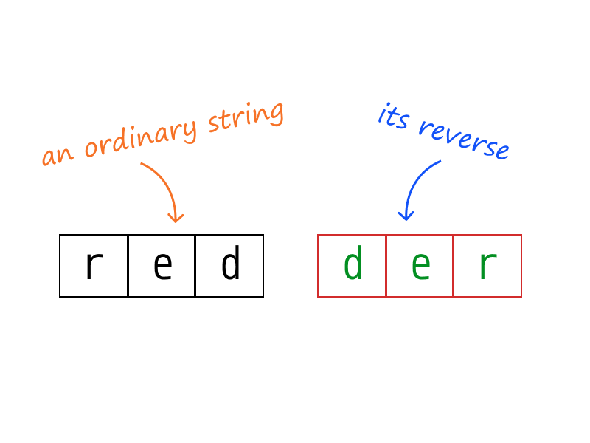

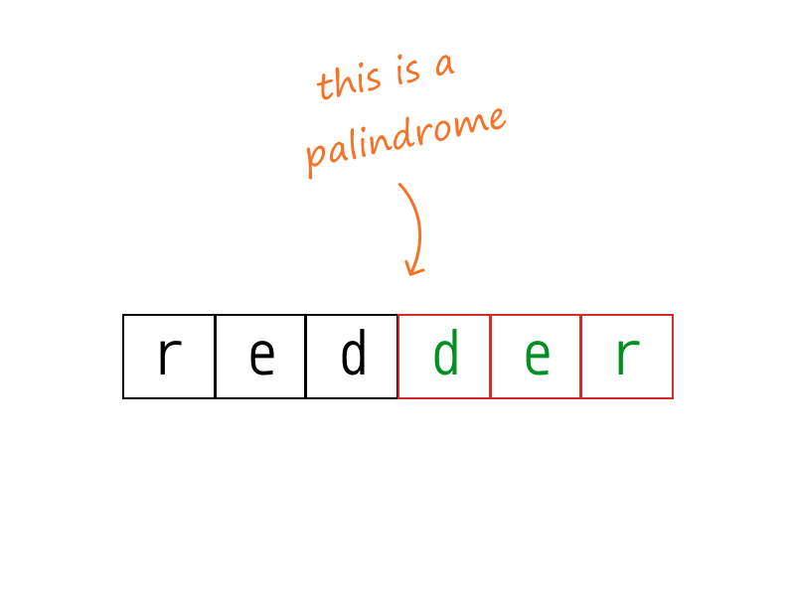

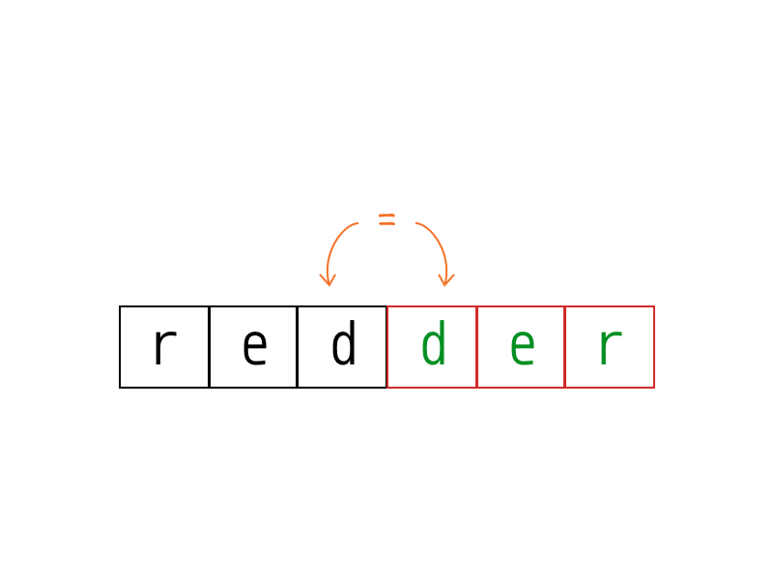

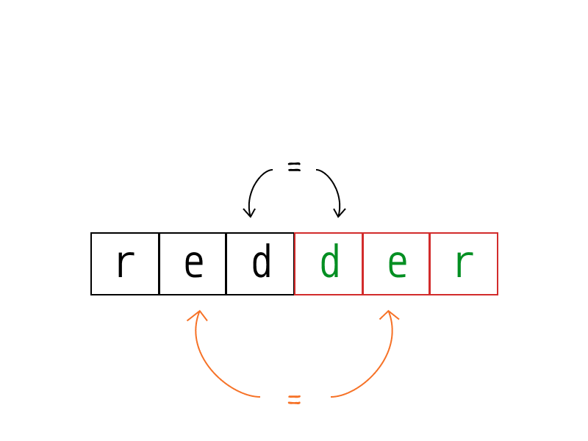

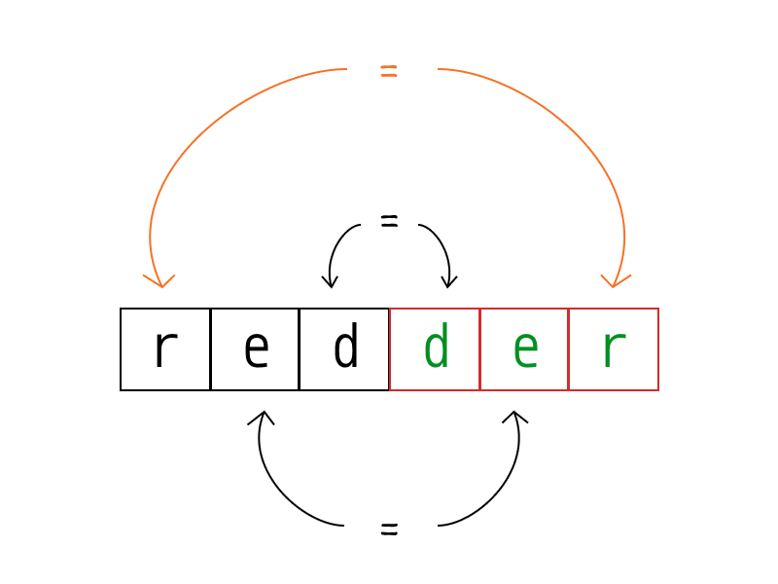

**Algorithm**

Since the input string contains characters that we need to ignore in our palindromic check, it becomes tedious to figure out the real middle point of our palindromic input.

Instead of going outwards from the middle, we could just go inwards towards the middle!

So, if we start traversing inwards, from both ends of the input string, we can expect to see the same characters, in the same order.

The resulting algorithm is simple:

* Set two pointers, one at each end of the input string
* If the input is palindromic, both the pointers should point to equivalent characters, at all times. [[1]](https://leetcode.com/problems/valid-palindrome/solution/#fn1)
  + If this condition is not met at any point of time, we break and return early. [[2]](https://leetcode.com/problems/valid-palindrome/solution/#fn2)
* We can simply ignore non-alphanumeric characters by continuing to traverse further.
* Continue traversing inwards until the pointers meet in the middle.

|  |
| --- |
| class Solution {  public boolean isPalindrome(String s) {  for (int i = 0, j = s.length() - 1; i < j; i++, j--) {  while (i < j && !Character.isLetterOrDigit(s.charAt(i))) {  i++;  }  while (i < j && !Character.isLetterOrDigit(s.charAt(j))) {  j--;  }  if (Character.toLowerCase(s.charAt(i)) != Character.toLowerCase(s.charAt(j)))  return false;  }  return true;  }  } |

**Complexity Analysis**

* Time complexity : *O*(*n*), in length n*n* of the string. We traverse over each character at-most once, until the two pointers meet in the middle, or when we break and return early.
* Space complexity : *O*(1). No extra space required, at all.

1. Such a property is formally known as a [loop invariant](https://en.wikipedia.org/wiki/Loop_invariant). [↩︎](https://leetcode.com/problems/valid-palindrome/solution/#fnref1)
2. Such a property is often called a loop termination condition. It is one of several used in this solution. Can you identify the others? [↩︎](https://leetcode.com/problems/valid-palindrome/solution/#fnref2)

**String to Integer (atoi)**

Implement the myAtoi(string s) function, which converts a string to a 32-bit signed integer (similar to C/C++'s atoi function).

The algorithm for myAtoi(string s) is as follows:

1. Read in and ignore any leading whitespace.
2. Check if the next character (if not already at the end of the string) is '-' or '+'. Read this character in if it is either. This determines if the final result is negative or positive respectively. Assume the result is positive if neither is present.
3. Read in next the characters until the next non-digit charcter or the end of the input is reached. The rest of the string is ignored.
4. Convert these digits into an integer (i.e. "123" -> 123, "0032" -> 32). If no digits were read, then the integer is 0. Change the sign as necessary (from step 2).
5. If the integer is out of the 32-bit signed integer range [-231, 231 - 1], then clamp the integer so that it remains in the range. Specifically, integers less than -231 should be clamped to -231, and integers greater than 231 - 1 should be clamped to 231 - 1.
6. Return the integer as the final result.

**Note:**

* Only the space character ' ' is considered a whitespace character.
* **Do not ignore** any characters other than the leading whitespace or the rest of the string after the digits.

**Example 1:**

**Input:** s = "42"

**Output:** 42

**Explanation:** The underlined characters are what is read in, the caret is the current reader position.

Step 1: "42" (no characters read because there is no leading whitespace)

^

Step 2: "42" (no characters read because there is neither a '-' nor '+')

^

Step 3: "42" ("42" is read in)

^

The parsed integer is 42.

Since 42 is in the range [-231, 231 - 1], the final result is 42.

**Example 2:**

**Input:** s = " -42"

**Output:** -42

**Explanation:**

Step 1: " -42" (leading whitespace is read and ignored)

^

Step 2: " -42" ('-' is read, so the result should be negative)

^

Step 3: " -42" ("42" is read in)

^

The parsed integer is -42.

Since -42 is in the range [-231, 231 - 1], the final result is -42.

**Example 3:**

**Input:** s = "4193 with words"

**Output:** 4193

**Explanation:**

Step 1: "4193 with words" (no characters read because there is no leading whitespace)

^

Step 2: "4193 with words" (no characters read because there is neither a '-' nor '+')

^

Step 3: "4193 with words" ("4193" is read in; reading stops because the next character is a non-digit)

^

The parsed integer is 4193.

Since 4193 is in the range [-231, 231 - 1], the final result is 4193.

**Example 4:**

**Input:** s = "words and 987"

**Output:** 0

**Explanation:**

Step 1: "words and 987" (no characters read because there is no leading whitespace)

^

Step 2: "words and 987" (no characters read because there is neither a '-' nor '+')

^

Step 3: "words and 987" (reading stops immediately because there is a non-digit 'w')

^

The parsed integer is 0 because no digits were read.

Since 0 is in the range [-231, 231 - 1], the final result is 0.

**Example 5:**

**Input:** s = "-91283472332"

**Output:** -2147483648

**Explanation:**

Step 1: "-91283472332" (no characters read because there is no leading whitespace)

^

Step 2: "-91283472332" ('-' is read, so the result should be negative)

^

Step 3: "-91283472332" ("91283472332" is read in)

^

The parsed integer is -91283472332.

Since -91283472332 is less than the lower bound of the range [-231, 231 - 1], the final result is clamped to -231 = -2147483648.

**Constraints:**

* 0 <= s.length <= 200
* s consists of English letters (lower-case and upper-case), digits (0-9), ' ', '+', '-', and '.'.

## Solution

#### **Approach 1: Scan from left to right**

**Intuition**

The problem looks simple at first glance. However, there are a few edge conditions that we must handle. The basic idea is to scan the string from left to right and build the result for numerical characters. In this process, we must carefully handle the integer overflow and underflow conditions.

**Algorithm**

We have to build numerical value by repeatedly shifting the result to left by one digit and adding the next number at the unit place. Since numerical value is a decimal number represented as base 10 in the number system, each digit can be expressed as multiples of powers of 10.

Example - "142" can be represented as 1 \* (10^2) + 4 \* (10^1) + 2 \* (10^0)

1 is at the hundredth place and left-shifted twice, 4 at tens place and shifted once, and so on.

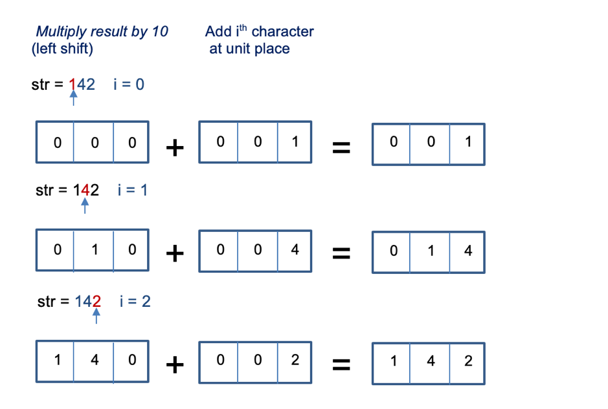

This can be formulated as :

result \* 10 + (str[i] - '0')

However, this could lead to integer overflow or underflow conditions. Since integer must be within the 32-bit signed integer range.

Handling overflow and underflow conditions

If the integer is positive, for 32 bit signed integer, INT\_MAX is 2147483647 (2^{31}-1) To avoid integer overflow, we must ensure that it doesn't exceed this value. This condition needs to be handled when the result is greater than or equal to INT\_MAX/10 (214748364)

* Case 1). If result = INT\_MAX/10, it would result in integer overflow if next integer character is greater than 7. (7 in this case is last digit of  INT\_MAX(2147483647)). We can use INT\_MAX%10 to generically represent the last digit.
* Case 2). If result > INT\\_MAX/10, we are sure that adding next number would result in integer overflow.

This holds for negative integer as well. In the 32-bit integer, INT\_MIN value is -2147483648 (-2^{31}). As the last digit is greater than 7 (INT\_MAX%10), integer underflow can also be handled using the above approach.

We must return INT\_MAX in case of integer overflow and INT\_MIN in case of integer underflow.

Also, it must be noted that in some languages like Python, an integer value is not restricted by the number of bits. Handling of overflow and underflow won't be required in such cases. We could simply check if the value of an integer is out of specified range [{−2}^{31}, {2}^{31} − 1]

**Steps**

The algorithm can be summarised as follows

1. Discard all the whitespaces at the beginning of the string.
2. There could be an optional sign of a numerical value +/−. It should be noted that the integer is positive by default if there is no sign present and there could be at most one sign character.
3. Build the result using the above algorithm until there exists a non-whitespace character that is a number (0 to 9). Simultaneously, check for overflow/underflow conditions at each step.

**Note:** If there exists any non-integer character at step 3, we return 0 by default since it is not a valid integer. Also, we have to just discard all the characters after the first numerical value.

|  |
| --- |
| class Solution {  public int myAtoi(String str) {  int i = 0;  int sign = 1;  int result = 0;  if (str.length() == 0) return 0;  //Discard whitespaces in the beginning  while (i < str.length() && str.charAt(i) == ' ')  i++;  // Check if optional sign if it exists  if (i < str.length() && (str.charAt(i) == '+' || str.charAt(i) == '-'))  sign = (str.charAt(i++) == '-') ? -1 : 1;  // Build the result and check for overflow/underflow condition  while (i < str.length() && str.charAt(i) >= '0' && str.charAt(i) <= '9') {  if (result > Integer.MAX\_VALUE / 10 ||  (result == Integer.MAX\_VALUE / 10 && str.charAt(i) - '0' > Integer.MAX\_VALUE % 10)) {  return (sign == 1) ? Integer.MAX\_VALUE : Integer.MIN\_VALUE;  }  result = result \* 10 + (str.charAt(i++) - '0');  }  return result \* sign;  }  } |

**Complexity Analysis**

* Time Complexity: O(*N*). Here, N is the length of string str. We perform only one iteration over string str.
* Space Complexity: O(1) We use constant extra space for storing sign of the result.

**Implement strStr()**

Implement [strStr()](http://www.cplusplus.com/reference/cstring/strstr/" \t "_blank).

Return the index of the first occurrence of needle in haystack, or -1 if needle is not part of haystack.

**Clarification:**

What should we return when needle is an empty string? This is a great question to ask during an interview.

For the purpose of this problem, we will return 0 when needle is an empty string. This is consistent to C's [strstr()](http://www.cplusplus.com/reference/cstring/strstr/" \t "_blank) and Java's [indexOf()](https://docs.oracle.com/javase/7/docs/api/java/lang/String.html" \l "indexOf(java.lang.String)" \t "_blank).

**Example 1:**

**Input:** haystack = "hello", needle = "ll"

**Output:** 2

**Example 2:**

**Input:** haystack = "aaaaa", needle = "bba"

**Output:** -1

**Example 3:**

**Input:** haystack = "", needle = ""

**Output:** 0

**Constraints:**

* 0 <= haystack.length, needle.length <= 5 \* 104
* haystack and needle consist of only lower-case English characters.

**Count and Say**

The **count-and-say** sequence is a sequence of digit strings defined by the recursive formula:

* countAndSay(1) = "1"
* countAndSay(n) is the way you would "say" the digit string from countAndSay(n-1), which is then converted into a different digit string.

To determine how you "say" a digit string, split it into the **minimal** number of groups so that each group is a contiguous section all of the **same character.** Then for each group, say the number of characters, then say the character. To convert the saying into a digit string, replace the counts with a number and concatenate every saying.

For example, the saying and conversion for digit string "3322251":

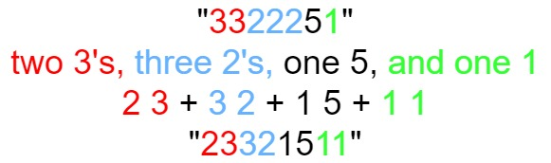

Given a positive integer n, return *the*nth*term of the****count-and-say****sequence*.

**Example 1:**

**Input:** n = 1

**Output:** "1"

**Explanation:** This is the base case.

**Example 2:**

**Input:** n = 4

**Output:** "1211"

**Explanation:**

countAndSay(1) = "1"

countAndSay(2) = say "1" = one 1 = "11"

countAndSay(3) = say "11" = two 1's = "21"

countAndSay(4) = say "21" = one 2 + one 1 = "12" + "11" = "1211"

**Constraints:**

* 1 <= n <= 30

   Hide Hint #1

The following are the terms from n=1 to n=10 of the count-and-say sequence:

1. 1

2. 11

3. 21

4. 1211

5. 111221

6. 312211

7. 13112221

8. 1113213211

9. 31131211131221

10. 13211311123113112211

   Hide Hint #2

To generate the *n*th term, just *count and say* the *n*-1th term.

## Solution

#### **Overview**

Before we proceed to the solutions, in this section, we would like to rephrase the problem.

Given two adjacent sequences of number, [*Sn*​,*Sn*+1​], there exists a pattern that one can produce the sequence *Sn*+1​ from its previous sequence *Sn*​.

More specifically, one can consider the sequence *Sn*+1​ as a sort of **summary** to its previous sequence *Sn*​, i.e. *Sn*+1​ contains a list of pairs as ∣count,digit∣ which **encodes** all the information about its previous sequence *Sn*​.

Let us take the sequence *S*4​=1211 as an example, from left to right, we then can divide the sequence into three sub-groups where each sub-group contains a list of identical and adjacent digit, i.e. *S*4​={1}{2}{11} , as shown in the following:

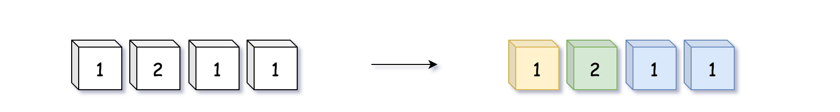

We then count the number of digits in each sub-group, and then output the summary in the format of ∣count,digit∣. As the end, we would obtain the exact sequence of *S*5​.

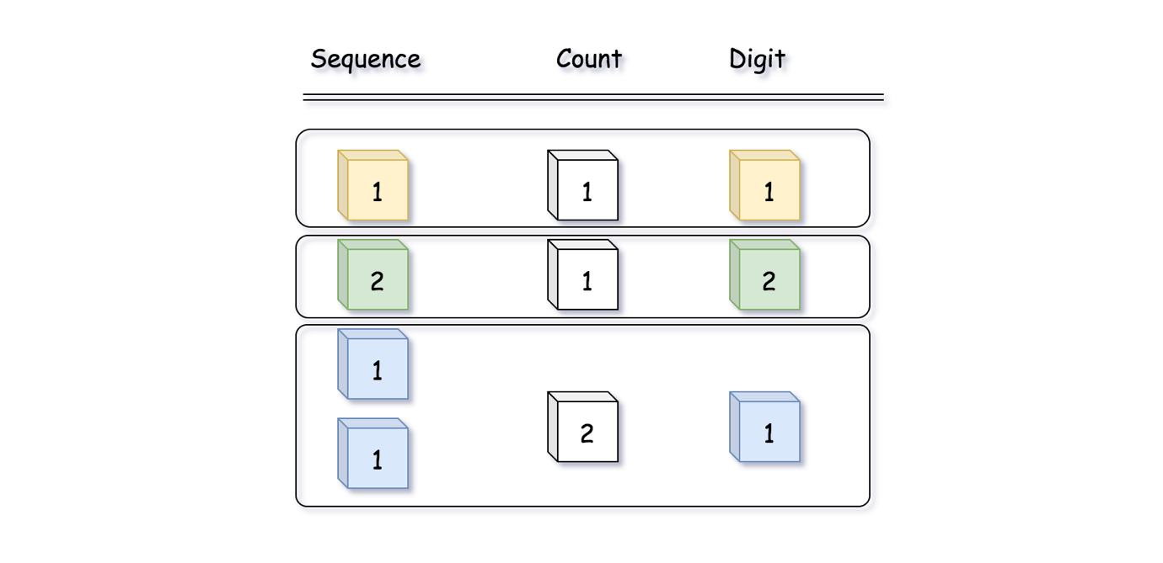

With the generated sequence *S*5​, we then ***recursively*** apply the above rule to generate the next sequence.

Now that the description of the problem is clear, one might dismiss it as yet another strange and artificial problem to solve. Well, it is not true in this case.

Actually, we could consider this problem as a **naive compression algorithm** for a sequence of numbers. Instead of storing repetitive adjacent digits as they are, we could summarize them a bit with the method presented in the problem, which could save us some space as long as there are indeed repetitive occurring patterns.

#### **Approach 1: Sliding Window**

**Intuition**

Now that the problem has been clarified, the solution should be intuitive.

Following the rule as we described above, in order to generate the next sequence, we could scan the current sequence with a sort of ***sliding window*** which would hold the identical and adjacent digits. With the sliding window, we would divide the original sequence into a list of sub-sequences. We then count the number of digits within each sub-sequence and output the summary as pairs of ∣count,digit∣.

**Algorithm**

Here we define a function nextSequence() to generate a following sequence from a previous sequence, and we recursively call this function to get the desired sequence that is located at a specific index.

* Within the function, we scan the sequence with two contextual variables: prevDigit and digitCnt which refers to respectively the digit that we are expecting in the sub-sequence and the number of occurrence of the digit in the sub-sequence.
* At the end of each sub-sequence, we append the summary to the result and then we reset the above two contextual variables for the next sub-sequence.
* Note that, we use an artificial delimiter in the sequence to facilitate the iteration.

|  |
| --- |
| class Solution {  public String countAndSay(int n) {  LinkedList<Integer> prevSeq = new LinkedList<Integer>();  prevSeq.add(1);  // Using -1 as the delimiter  prevSeq.add(-1);  List<Integer> finalSeq = this.nextSequence(n, prevSeq);  StringBuffer seqStr = new StringBuffer();  for (Integer digit : finalSeq) {  seqStr.append(String.valueOf(digit));  }  return seqStr.toString();  }  protected LinkedList<Integer> nextSequence(int n, LinkedList<Integer> prevSeq) {  if (n <= 1) {  // remove the delimiter before return  prevSeq.pollLast();  return prevSeq;  }  LinkedList<Integer> nextSeq = new LinkedList<Integer>();  Integer prevDigit = null;  Integer digitCnt = 0;  for (Integer digit : prevSeq) {  if (prevDigit == null) {  prevDigit = digit;  digitCnt += 1;  } else if (digit == prevDigit) {  // in the middle of the sub-sequence  digitCnt += 1;  } else {  // end of a sub-sequence  nextSeq.add(digitCnt);  nextSeq.add(prevDigit);  // reset for the next sub-sequence  prevDigit = digit;  digitCnt = 1;  }  }  // add the delimiter for the next recursion  nextSeq.add(-1);  return this.nextSequence(n - 1, nextSeq);  }  } |

**Complexity**

* Time Complexity: O(2^n) where n*n* is the index of the desired sequence.
  + First of all, we would invoke the function nextSequence() *n*−1 times to get the desired sequence.
  + For each invocation of the function, we would scan the current sequence whose length is difficult to determine though.
  + Let us image in the worst scenario where any two adjacent digit in the sequence are not identical, then its next sequence would ***double*** the length, rather than having a *reduced* length. As a result, we could assume that in the worst case, the length of the sequence would grow *exponentially*.
  + As a result, the overall time complexity of the algorithm would be 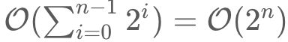
* Space Complexity: O(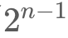).
  + Within each invocation of the nextSequence() function, we are using a container to keep the result of the next sequence. The memory consumption of the container is proportional to the length of the sequence that the function needs to process, *i.e* .
  + Though we were applying the recursion function, which typically incurs some additional memory consumption in call stack. In our case though, the recursion is implemented in the form of ***tail recursion***, and we assume that the compiler could optimize its execution which would not incur additional memory consumption.
  + One could also easily replace the recursion with the iteration in this case.
  + As a result, the overall space complexity of the algorithm would be dominated by the space needed to hold the final sequence, *i.e.* O().

#### **Approach 2: Regular Expression**

**Intuition**

This problem could be a good exercise to apply ***pattern matching***, where in our case we need to find out all those repetitive groups of digits.

A [regular expression](https://en.wikipedia.org/wiki/Regular_expression) (a.k.a regex) is a sequence of characters that defines a ***search pattern***. The regex serves as a common tool for many pattern matching problems. And many programming languages provides regex capacities either with build-in constructs or via some libraries.

Note that, although the syntax of regex is mostly universal across all programming languages, there might exist some subtile differences. Here we show two examples in Java and Python respectively.

Java: regex = "(.)\1\*"

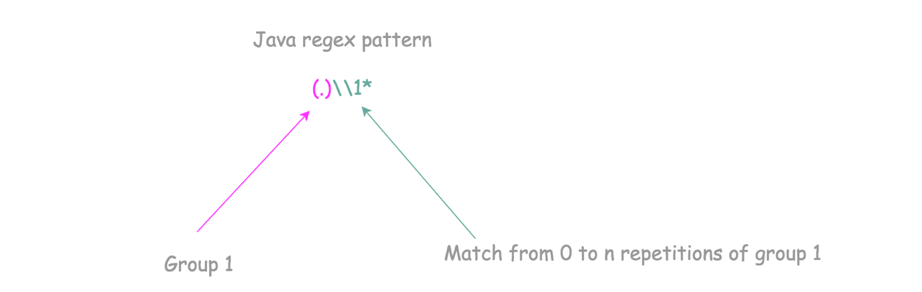

We could break down the above regex expression into three 3 parts:

* "(.)": it defines a group that contains a single character that could be of anything.
* "\1": this part refers to the defined group with the index of 1.
* "\*": this qualifier followed by the group reference \1, indicates that we would like to see the group repeats itself zero or more times.

Python: regex = "((.)\*)"

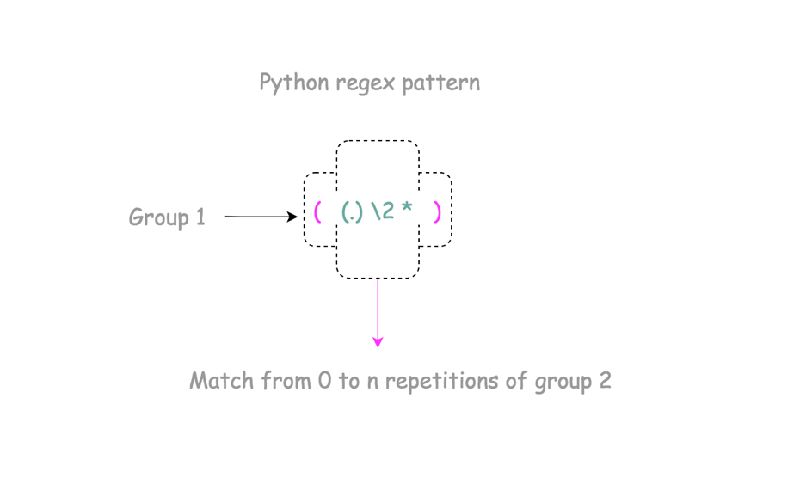

Slightly different than the above regex in Java, here we define two groups instead of one.

* "(.)": again, this is a group that contains a single character that could be of anything.
* "": this part refers to the second group (i.e. (.)) that we define.
* "((.)\*)": the outer bracket defines the scope of the first group, which contains the repetitive appearance of the second group above.

**Algorithm**

Based on the above definitions of regex, we then find all the matches to the regex and then concatenate the results together.

|  |
| --- |
| import java.util.regex.Matcher;  import java.util.regex.Pattern;  class Solution {  public String countAndSay(int n) {  String currSeq = "1";  // Pattern to match the repetitive digits  String regexPattern = "(.)\\1\*";  Pattern pattern = Pattern.compile(regexPattern);  for (int i = 1; i < n; ++i) {  Matcher m = pattern.matcher(currSeq);  StringBuffer nextSeq = new StringBuffer();  // each group contains identical and adjacent digits  while (m.find()) {  nextSeq.append(m.group().length() + String.valueOf(m.group().charAt(0)));  }  // prepare for the next iteration  currSeq = nextSeq.toString();  }  return currSeq;  }  } |

**Complexity**

* Time Complexity: O(2^n) where *n* is the index of the desired sequence.  
  + Similar with our sliding window approach, the overall algorithm consists of a nested loop.
  + We could assume that the time complexity of the regex matching is linear to the length of the input string.
  + As a result, the overall time complexity of the algorithm would be 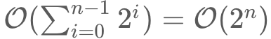
* Space Complexity: O().
  + Within the function, we are using a container to keep the result of the next sequence. The memory consumption of the container is proportional to the length of the sequence that the function needs to process, *i.e* .
  + As a result, the space complexity of the algorithm would be dominated by the space needed to hold the final sequence, *i.e.* O().

|  |
| --- |
| public String countAndSay(int n) {  if(n==1) return "1";  String ans = "1";  for(int i=2; i<=n; i++){  ans = f(ans);  }  return ans;  }  String f(String s){  char ch = s.charAt(0);  int count = 1;  StringBuilder sb = new StringBuilder();  for(int i=1; i<s.length(); i++){  if(s.charAt(i) != ch){  sb.append(count).append(ch);  ch = s.charAt(i);  count = 1;  } else {  count++;  }  }  sb.append(count).append(ch);  return sb.toString();  } |

**Longest Common Prefix**

Write a function to find the longest common prefix string amongst an array of strings.

If there is no common prefix, return an empty string "".

**Example 1:**

**Input:** strs = ["flower","flow","flight"]

**Output:** "fl"

**Example 2:**

**Input:** strs = ["dog","racecar","car"]

**Output:** ""

**Explanation:** There is no common prefix among the input strings.

**Constraints:**

* 0 <= strs.length <= 200
* 0 <= strs[i].length <= 200
* strs[i] consists of only lower-case English letters.

## Linked List

Linked List problems are relatively easy to master. Do not forget the [Two-pointer technique](https://leetcode.com/articles/two-pointer-technique/), which not only applicable to Array problems but also Linked List problems as well.

Another technique to greatly simplify coding in linked list problems is the dummy node trick.

We recommend: Reverse Linked List, Merge Two Sorted Lists and Linked List Cycle.

For additional challenge, solve these problems recursively: Reverse Linked List, Palindrome Linked List and Merge Two Sorted Lists.

  Delete Node in a Linked List

 Remove Nth Node From End of List

 Reverse Linked List

 Merge Two Sorted Lists

 Palindrome Linked List

 Linked List Cycle

**Delete Node in a Linked List**

Write a function to **delete a node** in a singly-linked list. You will **not** be given access to the head of the list, instead you will be given access to **the node to be deleted** directly.

It is **guaranteed** that the node to be deleted is **not a tail node** in the list.

**Example 1:**

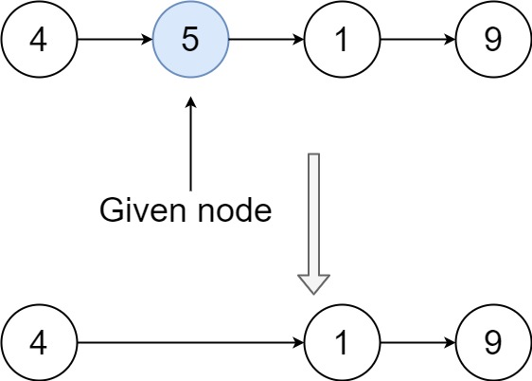

**Input:** head = [4,5,1,9], node = 5

**Output:** [4,1,9]

**Explanation:** You are given the second node with value 5, the linked list should become 4 -> 1 -> 9 after calling your function.

**Example 2:**

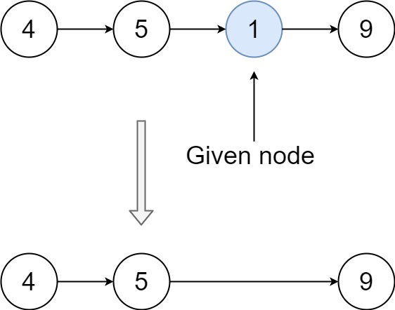

**Input:** head = [4,5,1,9], node = 1

**Output:** [4,5,9]

**Explanation:** You are given the third node with value 1, the linked list should become 4 -> 5 -> 9 after calling your function.

**Example 3:**

**Input:** head = [1,2,3,4], node = 3

**Output:** [1,2,4]

**Example 4:**

**Input:** head = [0,1], node = 0

**Output:** [1]

**Example 5:**

**Input:** head = [-3,5,-99], node = -3

**Output:** [5,-99]

**Constraints:**

* The number of the nodes in the given list is in the range [2, 1000].
* -1000 <= Node.val <= 1000
* The value of each node in the list is **unique**.
* The node to be deleted is **in the list** and is **not a tail** node

## Solution

#### **Approach: Swap with Next Node [Accepted]**

The usual way of deleting a node node from a linked list is to modify the next pointer of the node before it, to point to the node after it.

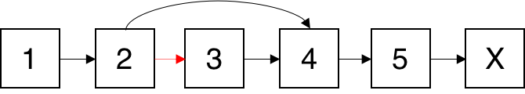

Since we do not have access to the node before the one we want to delete, we cannot modify the next pointer of that node in any way. Instead, we have to replace the value of the node we want to delete with the value in the node after it, and then delete the node after it.

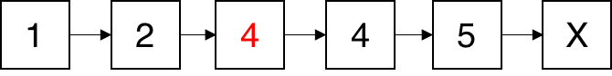 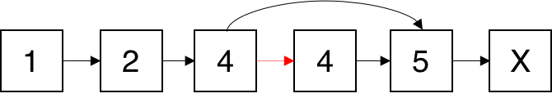 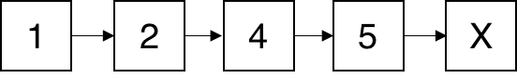

Because we know that the node we want to delete is not the tail of the list, we can guarantee that this approach is possible.

**Java**

public void deleteNode(ListNode node) {

node.val = node.next.val;

node.next = node.next.next;

}

**Complexity Analysis**

Time and space complexity are both *O*(1).

**Remove Nth Node From End of List**

Given the head of a linked list, remove the nth node from the end of the list and return its head.

**Follow up:** Could you do this in one pass?

**Example 1:**

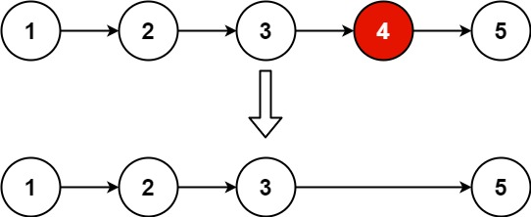

**Input:** head = [1,2,3,4,5], n = 2

**Output:** [1,2,3,5]

**Example 2:**

**Input:** head = [1], n = 1

**Output:** []

**Example 3:**

**Input:** head = [1,2], n = 1

**Output:** [1]

**Constraints:**

* The number of nodes in the list is sz.
* 1 <= sz <= 30
* 0 <= Node.val <= 100
* 1 <= n <= sz

Maintain two pointers and update one with a delay of n steps.

**Reverse Linked List**

Reverse a singly linked list.

**Example:**

**Input:** 1->2->3->4->5->NULL

**Output:** 5->4->3->2->1->NULL

**Follow up:**

A linked list can be reversed either iteratively or recursively. Could you implement both?

**Merge Two Sorted Lists**

Merge two sorted linked lists and return it as a **sorted** list. The list should be made by splicing together the nodes of the first two lists.

**Example 1:**

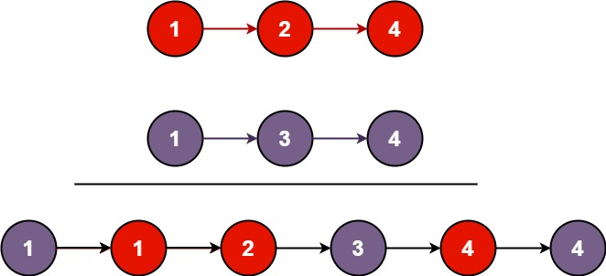

**Input:** l1 = [1,2,4], l2 = [1,3,4]

**Output:** [1,1,2,3,4,4]

**Example 2:**

**Input:** l1 = [], l2 = []

**Output:** []

**Example 3:**

**Input:** l1 = [], l2 = [0]

**Output:** [0]

**Constraints:**

* The number of nodes in both lists is in the range [0, 50].
* -100 <= Node.val <= 100
* Both l1 and l2 are sorted in **non-decreasing** order.

**Palindrome Linked List**

Given a singly linked list, determine if it is a palindrome.

**Example 1:**

**Input:** 1->2

**Output:** false

**Example 2:**

**Input:** 1->2->2->1

**Output:** true

**Follow up:**  
Could you do it in O(n) time and O(1) space?

**Linked List Cycle**

Given head, the head of a linked list, determine if the linked list has a cycle in it.

There is a cycle in a linked list if there is some node in the list that can be reached again by continuously following the next pointer. Internally, pos is used to denote the index of the node that tail's next pointer is connected to. **Note that pos is not passed as a parameter**.

Return true*if there is a cycle in the linked list*. Otherwise, return false.

**Example 1:**

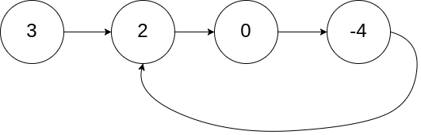

**Input:** head = [3,2,0,-4], pos = 1

**Output:** true

**Explanation:** There is a cycle in the linked list, where the tail connects to the 1st node (0-indexed).

**Example 2:**

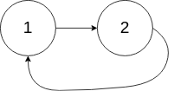

**Input:** head = [1,2], pos = 0

**Output:** true

**Explanation:** There is a cycle in the linked list, where the tail connects to the 0th node.

**Example 3:**



**Input:** head = [1], pos = -1

**Output:** false

**Explanation:** There is no cycle in the linked list.

**Constraints:**

* The number of the nodes in the list is in the range [0, 104].
* -105 <= Node.val <= 105
* pos is -1 or a **valid index** in the linked-list.

**Follow up:** Can you solve it using O(1) (i.e. constant) memory?

## Trees

Tree is slightly more complex than linked list, because the latter is a linear data structure while the former is not. Tree problems can be solved either **breadth-first** or **depth-first**. We have one problem here which is great for practicing breadth-first traversal.

We recommend: Maximum Depth of Binary Tree, Validate Binary Search Tree, Binary Tree Level Order Traversal and Convert Sorted Array to Binary Search Tree.

Maximum Depth of Binary Tree

 Validate Binary Search Tree

 Symmetric Tree

 Binary Tree Level Order Traversal

 Convert Sorted Array to Binary Search Tree

**Maximum Depth of Binary Tree**

Given the root of a binary tree, return *its maximum depth*.

A binary tree's **maximum depth** is the number of nodes along the longest path from the root node down to the farthest leaf node.

**Example 1:**

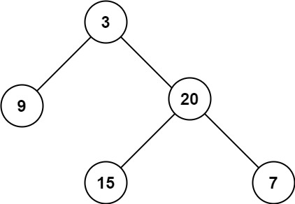

**Input:** root = [3,9,20,null,null,15,7]

**Output:** 3

**Example 2:**

**Input:** root = [1,null,2]

**Output:** 2

**Example 3:**

**Input:** root = []

**Output:** 0

**Example 4:**

**Input:** root = [0]

**Output:** 1

**Constraints:**

* The number of nodes in the tree is in the range [0, 104].
* -100 <= Node.val <= 100

## Solution

**Tree definition**

First of all, here is the definition of the TreeNode which we would use.

|  |
| --- |
| /\* Definition for a binary tree node. \*/  public class TreeNode {  int val;  TreeNode left;  TreeNode right;  TreeNode(int x) {  val = x;  }  } |

#### **Approach 1: Recursion**

**Intuition** By definition, the maximum depth of a binary tree is the maximum number of steps to reach a leaf node from the root node.

From the definition, an intuitive idea would be to traverse the tree and record the maximum depth during the traversal.

**Algorithm**

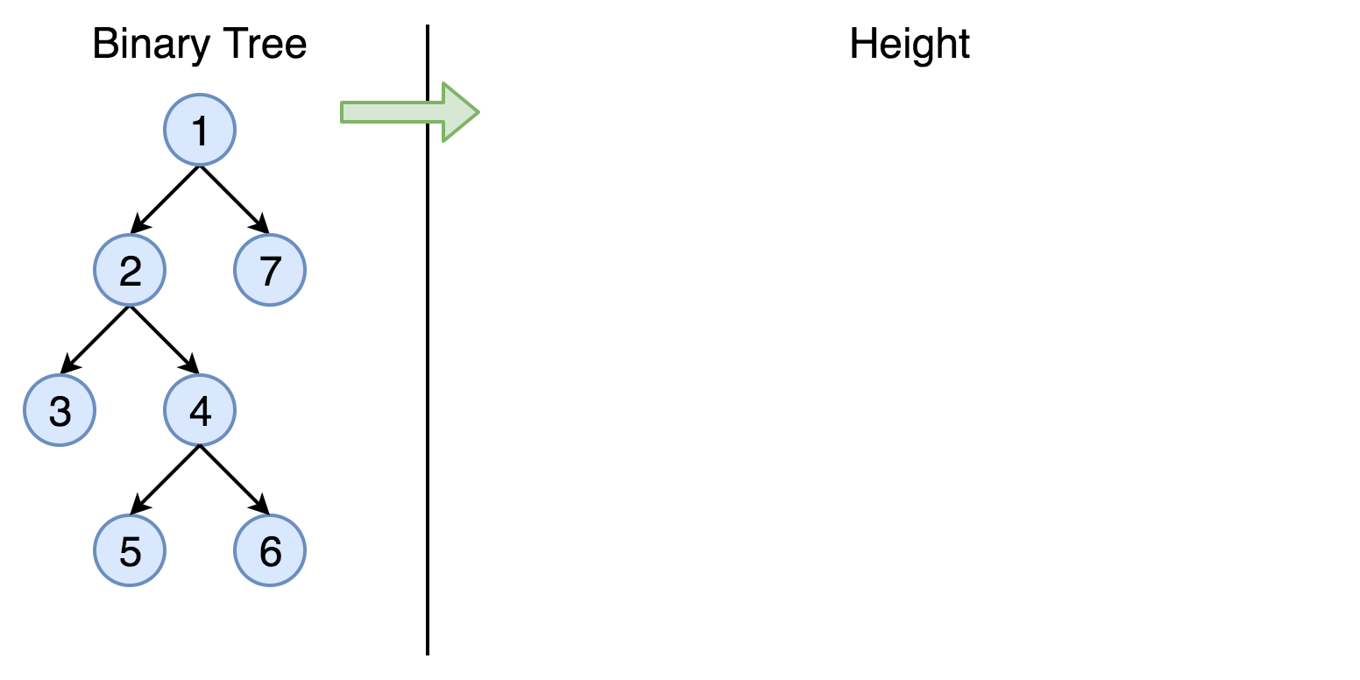

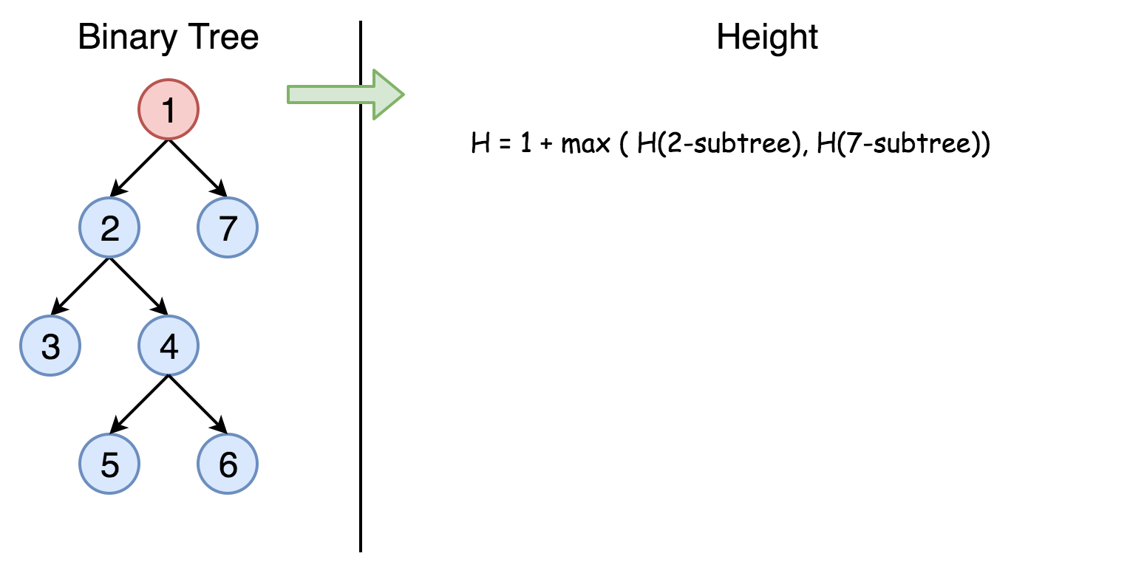

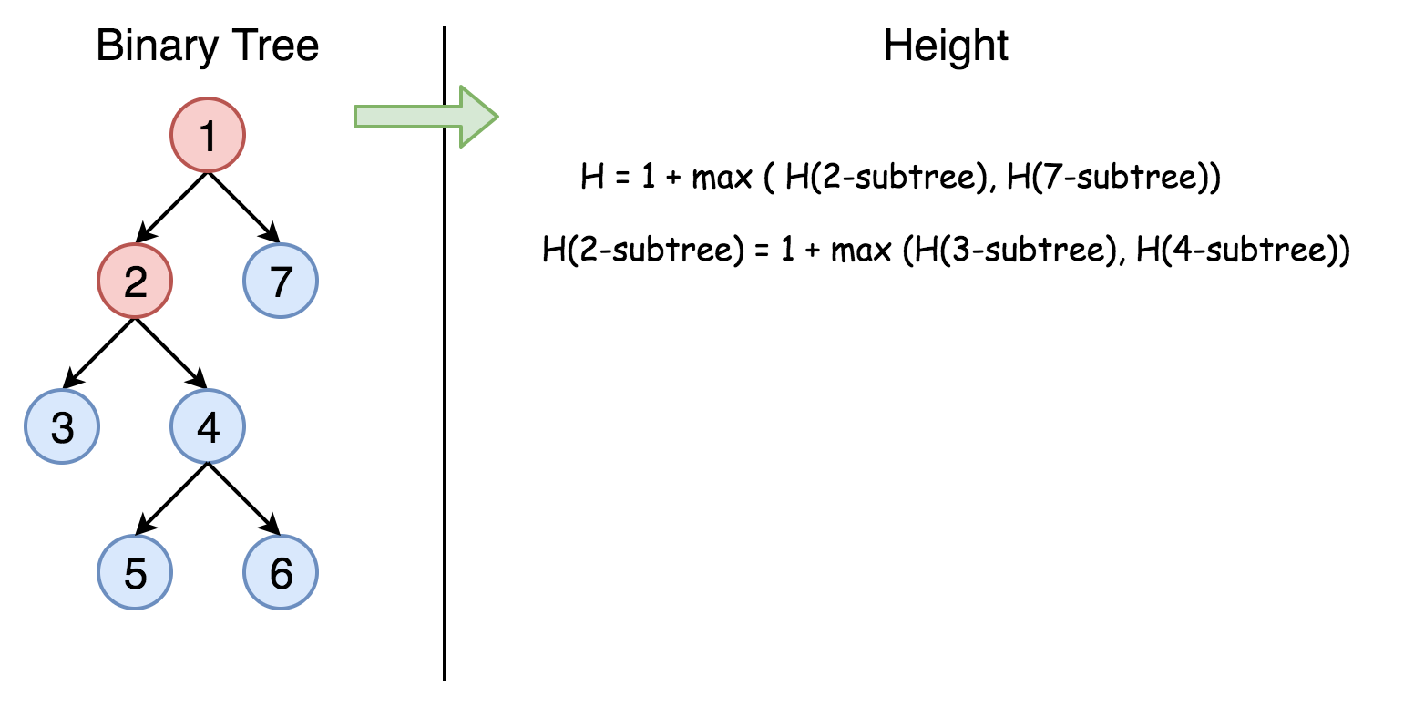

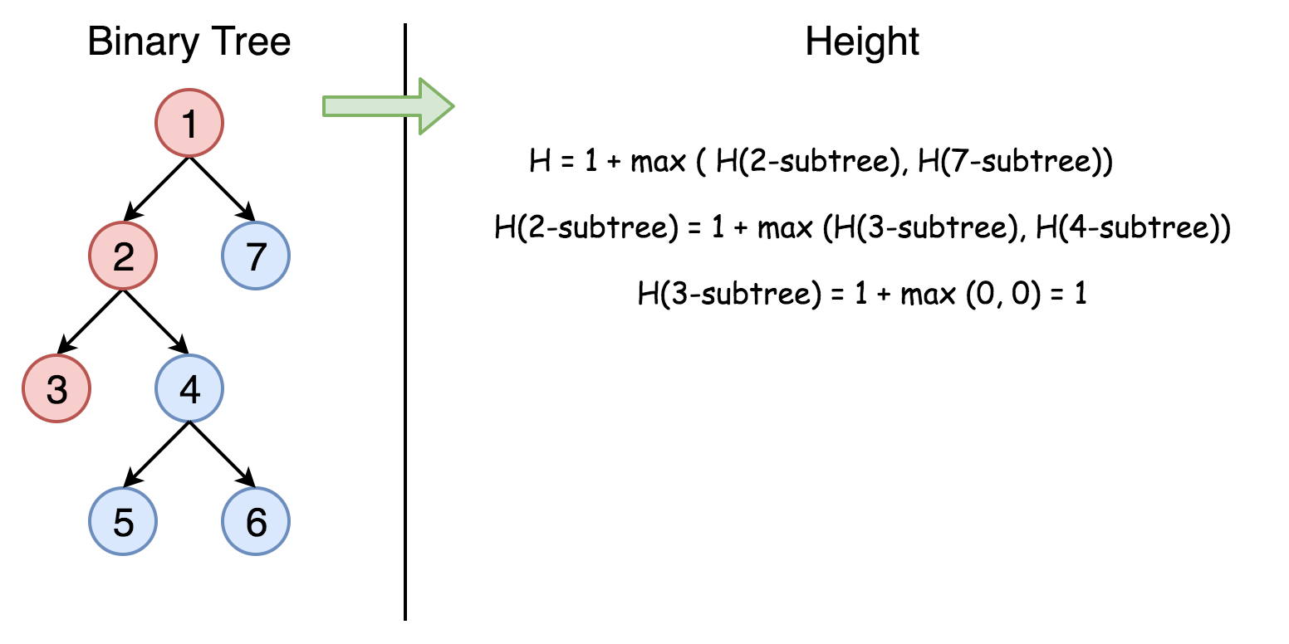

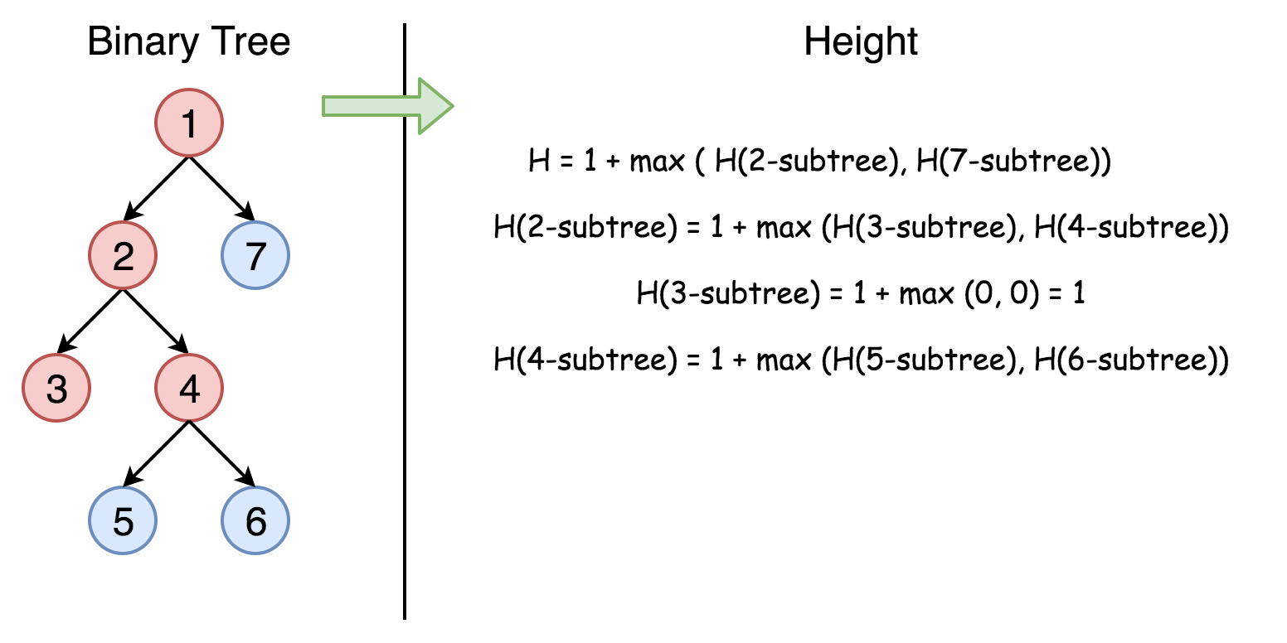

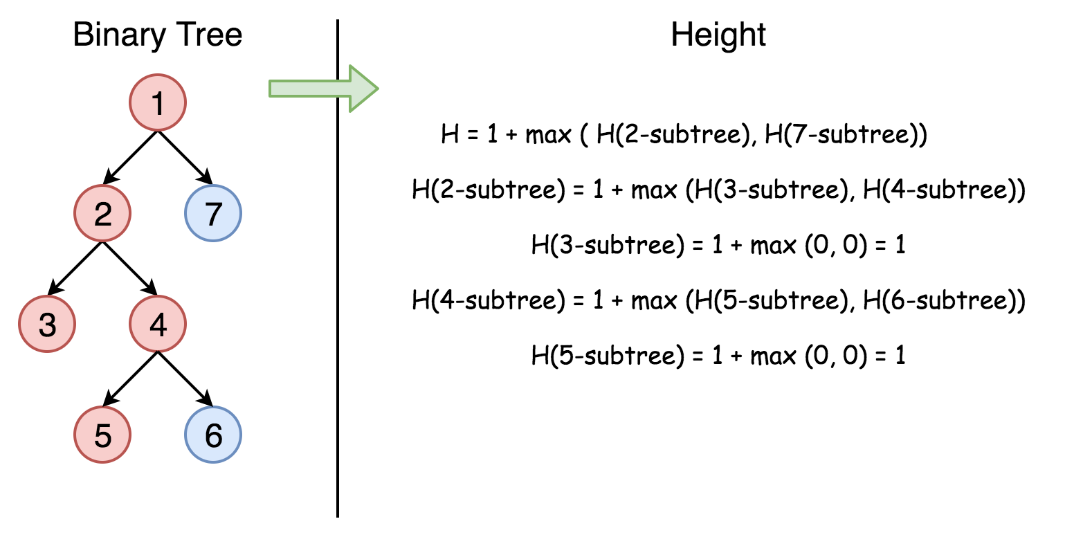

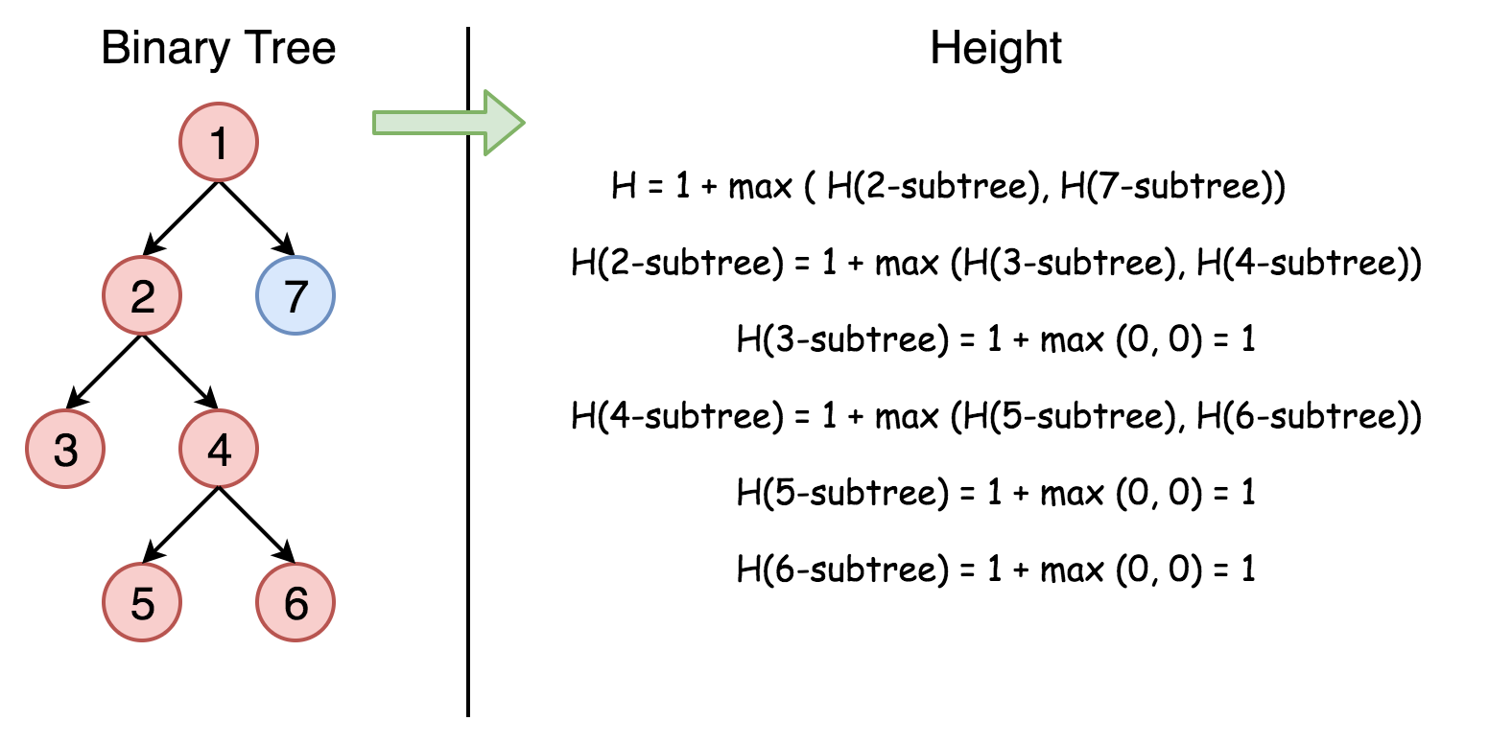

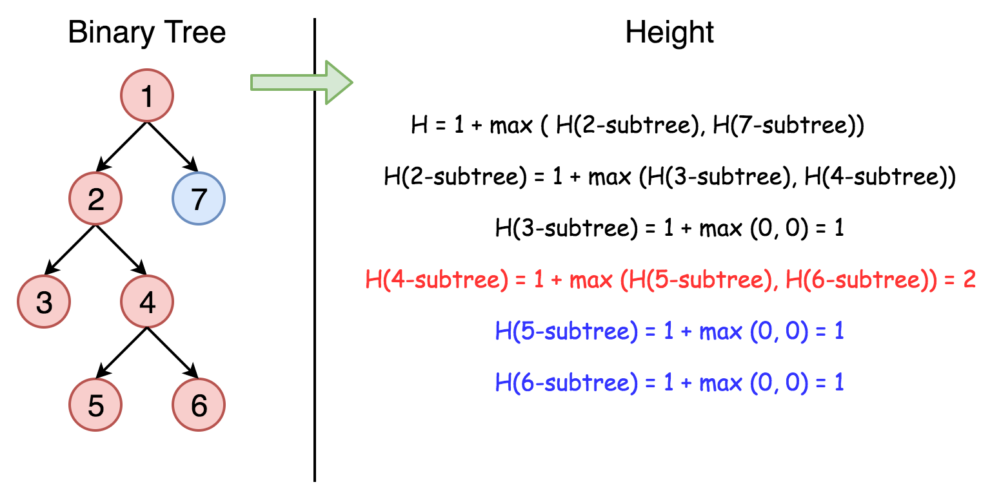

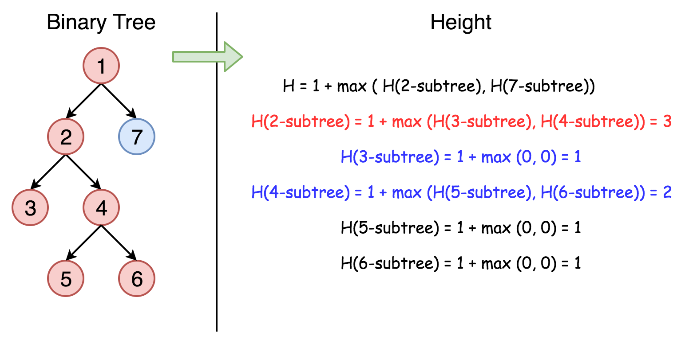

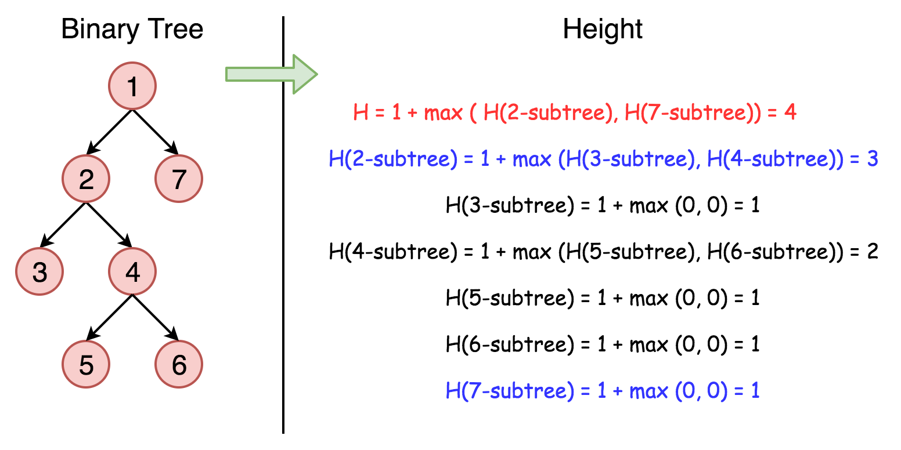

One could traverse the tree either by Depth-First Search (DFS) strategy or Breadth-First Search (BFS) strategy. For this problem, either way would do. Here we demonstrate a solution that is implemented with the **DFS** strategy and **recursion**.

|  |
| --- |
| class Solution {  public int maxDepth(TreeNode root) {  if (root == null) {  return 0;  } else {  int left\_height = maxDepth(root.left);  int right\_height = maxDepth(root.right);  return java.lang.Math.max(left\_height, right\_height) + 1;  }  }  } |

**Complexity analysis**

* Time complexity : we visit each node exactly once, thus the time complexity is O(*N*), where *N* is the number of nodes.
* Space complexity : in the worst case, the tree is completely unbalanced, e.g. each node has only left child node, the recursion call would occur *N* times (the height of the tree), therefore the storage to keep the call stack would be O(*N*). But in the best case (the tree is completely balanced), the height of the tree would be log(*N*). Therefore, the space complexity in this case would be O(log(*N*)).

#### **Approach 2: Tail Recursion + BFS**

One might have noticed that the above recursion solution is probably not the most optimal one in terms of the space complexity, and in the extreme case the overhead of call stack might even lead to stack overflow.

To address the issue, one can tweak the solution a bit to make it **tail recursion**, which is a specific form of recursion where the recursive call is the last action in the function.

The benefit of having tail recursion, is that for certain programming languages (e.g. C++) the compiler could optimize the memory allocation of call stack by reusing the same space for every recursive call, rather than creating the space for each one. As a result, one could obtain the constant space complexity O(1) for the overhead of the recursive calls.

Here is a sample solution. Note that the optimization of tail recursion is not supported by Python or Java.

|  |
| --- |
| class Solution {  private:  // The queue that contains the next nodes to visit,  // along with the level/depth that each node is located.  queue<pair<TreeNode\*, int>> next\_items;  int max\_depth = 0;    /\*\*  \* A tail recursion function to calculate the max depth  \* of the binary tree.  \*/  int next\_maxDepth() {    if (next\_items.size() == 0) {  return max\_depth;  }    auto next\_item = next\_items.front();  next\_items.pop();  auto next\_node = next\_item.first;  auto next\_level = next\_item.second + 1;    max\_depth = max(max\_depth, next\_level);  // Add the nodes to visit in the following recursive calls.  if (next\_node->left != NULL) {  next\_items.push(make\_pair(next\_node->left, next\_level));  }  if (next\_node->right != NULL) {  next\_items.push(make\_pair(next\_node->right, next\_level));  }    // The last action should be the ONLY recursive call  // in the tail-recursion function.  return next\_maxDepth();  }    public:  int maxDepth(TreeNode\* root) {  if (root == NULL) return 0;    // clear the previous queue.  std::queue<pair<TreeNode\*, int>> empty;  std::swap(next\_items, empty);  max\_depth = 0;    // push the root node into the queue to kick off the next visit.  next\_items.push(make\_pair(root, 0));    return next\_maxDepth();  }  }; |

**Complexity analysis**

* Time complexity : O(*N*), still we visit each node once and only once.
* Space complexity : , i.e. the maximum number of nodes at the same level (the number of leaf nodes in a full binary tree), since we traverse the tree in the **BFS** manner.

As one can see, this probably is not the best example to apply the tail recursion technique. Because though we did gain the constant space complexity for the recursive calls, we pay the price of O(*N*) complexity to maintain the state information for recursive calls. This defeats the purpose of applying tail recursion.

However, we would like to stress on the point that tail recursion is a useful form of recursion that could eliminate the space overhead incurred by the recursive function calls.

Note: a function cannot be tail recursion if there are multiple occurrences of recursive calls in the function, even if the last action is the recursive call. Because the system has to maintain the function call stack for the sub-function calls that occur within the same function.

#### **Approach 3: Iteration**

**Intuition**

We could also convert the above recursion into iteration, with the help of the stack data structure. Similar with the behaviors of the function call stack, the stack data structure follows the pattern of FILO (First-In-Last-Out), i.e. the last element that is added to a stack would come out first.

With the help of the stack data structure, one could mimic the behaviors of function call stack that is involved in the recursion, to convert a recursive function to a function with iteration.

**Algorithm**

The idea is to keep the next nodes to visit in a stack. Due to the FILO behavior of stack, one would get the order of visit same as the one in recursion.

We start from a stack which contains the root node and the corresponding depth which is 1. Then we proceed to the iterations: pop the current node out of the stack and push the child nodes. The depth is updated at each step.

|  |
| --- |
| class Solution {  public int maxDepth(TreeNode root) {  LinkedList<TreeNode> stack = new LinkedList<>();  LinkedList<Integer> depths = new LinkedList<>();  if (root == null) return 0;  stack.add(root);  depths.add(1);  int depth = 0, current\_depth = 0;  while(!stack.isEmpty()) {  root = stack.pollLast();  current\_depth = depths.pollLast();  if (root != null) {  depth = Math.max(depth, current\_depth);  stack.add(root.left);  stack.add(root.right);  depths.add(current\_depth + 1);  depths.add(current\_depth + 1);  }  }  return depth;  }  }; |

**Complexity analysis**

* Time complexity : O(*N*).
* Space complexity : in the worst case, the tree is completely unbalanced, e.g. each node has only left child node, the recursion call would occur *N* times (the height of the tree), therefore the storage to keep the call stack would be O(*N*). But in the average case (the tree is balanced), the height of the tree would be log(*N*). Therefore, the space complexity in this case would be O(log(*N*)).

|  |
| --- |
| class Solution {  public int maxDepth(TreeNode root) {  if (root == null) return 0;  Deque<TreeNode> dq = new ArrayDeque<>();  int depth = 0, next = 0;  TreeNode cur;  dq.offer(root);    while (!dq.isEmpty()) {  depth++;  next = dq.size();  for (int i = 0; i < next; ++i) {  cur = dq.poll();  if (cur.left != null) dq.offer(cur.left);  if (cur.right != null) dq.offer(cur.right);  }  }  return depth;  }  } |

**Validate Binary Search Tree**

Given the root of a binary tree, *determine if it is a valid binary search tree (BST)*.

A **valid BST** is defined as follows:

* The left subtree of a node contains only nodes with keys **less than** the node's key.
* The right subtree of a node contains only nodes with keys **greater than** the node's key.
* Both the left and right subtrees must also be binary search trees.

**Example 1:**

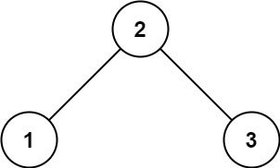

**Input:** root = [2,1,3]

**Output:** true

**Example 2:**

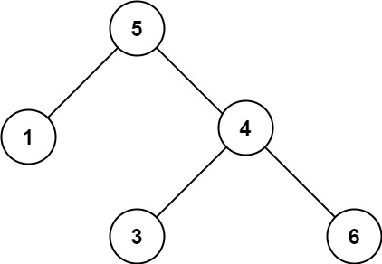

**Input:** root = [5,1,4,null,null,3,6]

**Output:** false

**Explanation:** The root node's value is 5 but its right child's value is 4.

**Constraints:**

* The number of nodes in the tree is in the range [1, 104].
* -231 <= Node.val <= 231 - 1

## Solution Article

#### **Tree definition**

First of all, here is the definition of the TreeNode which we would use.

|  |
| --- |
| // Definition for a binary tree node.  public class TreeNode {  int val;  TreeNode left;  TreeNode right;  TreeNode(int x) {  val = x;  }  } |

#### **Intuition**

On the first sight, the problem is trivial. Let's traverse the tree and check at each step if node.right.val > node.val and node.left.val < node.val. This approach would even work for some trees   
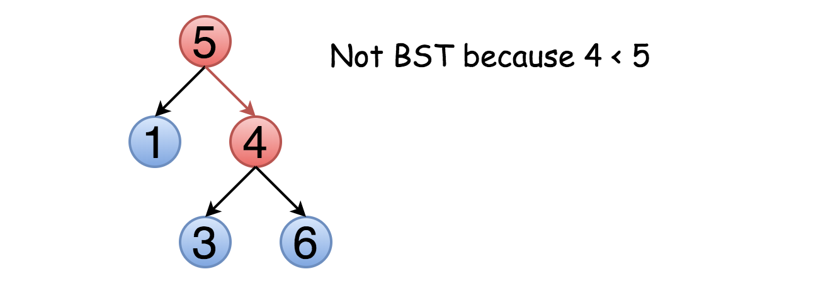

The problem is this approach will not work for all cases. Not only the right child should be larger than the node but all the elements in the right subtree. Here is an example :

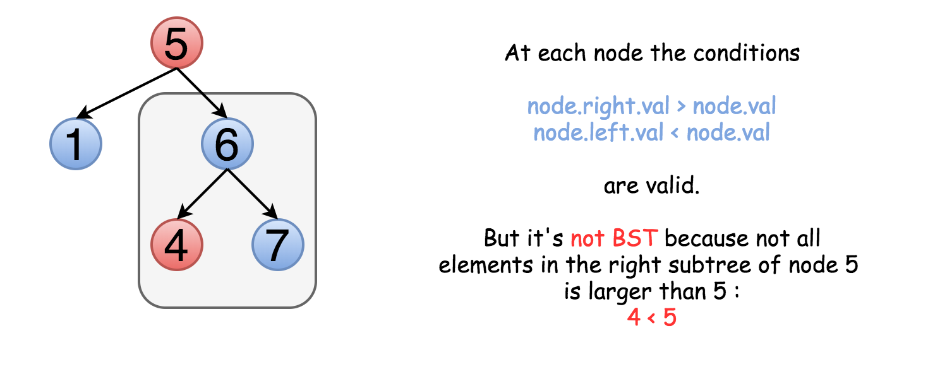

That means one should keep both upper and lower limits for each node while traversing the tree, and compare the node value not with children values but with these limits.

#### **Approach 1: Recursive Traversal with Valid Range**

The idea above could be implemented as a recursion. One compares the node value with its upper and lower limits if they are available. Then one repeats the same step recursively for left and right subtrees.

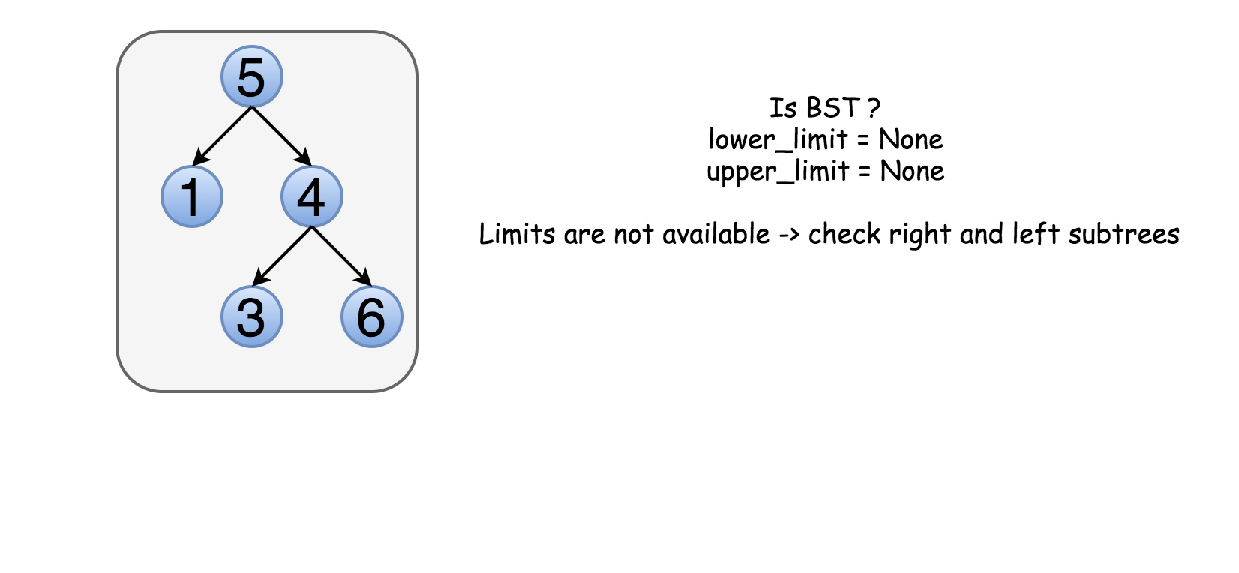

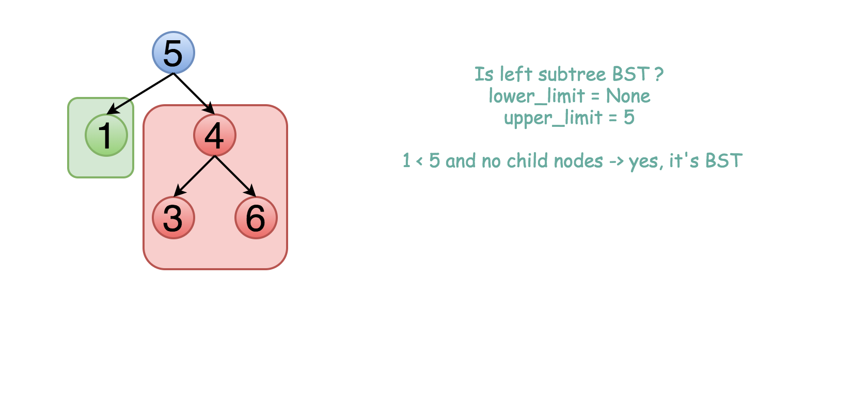

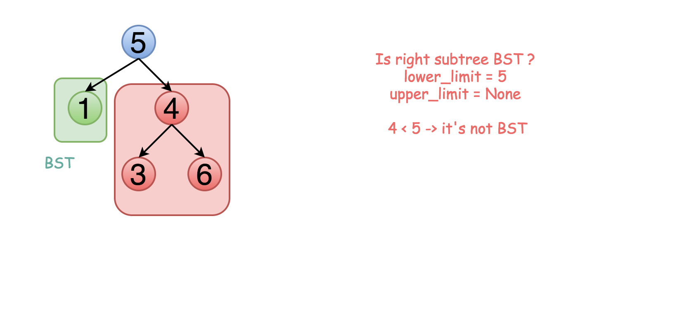

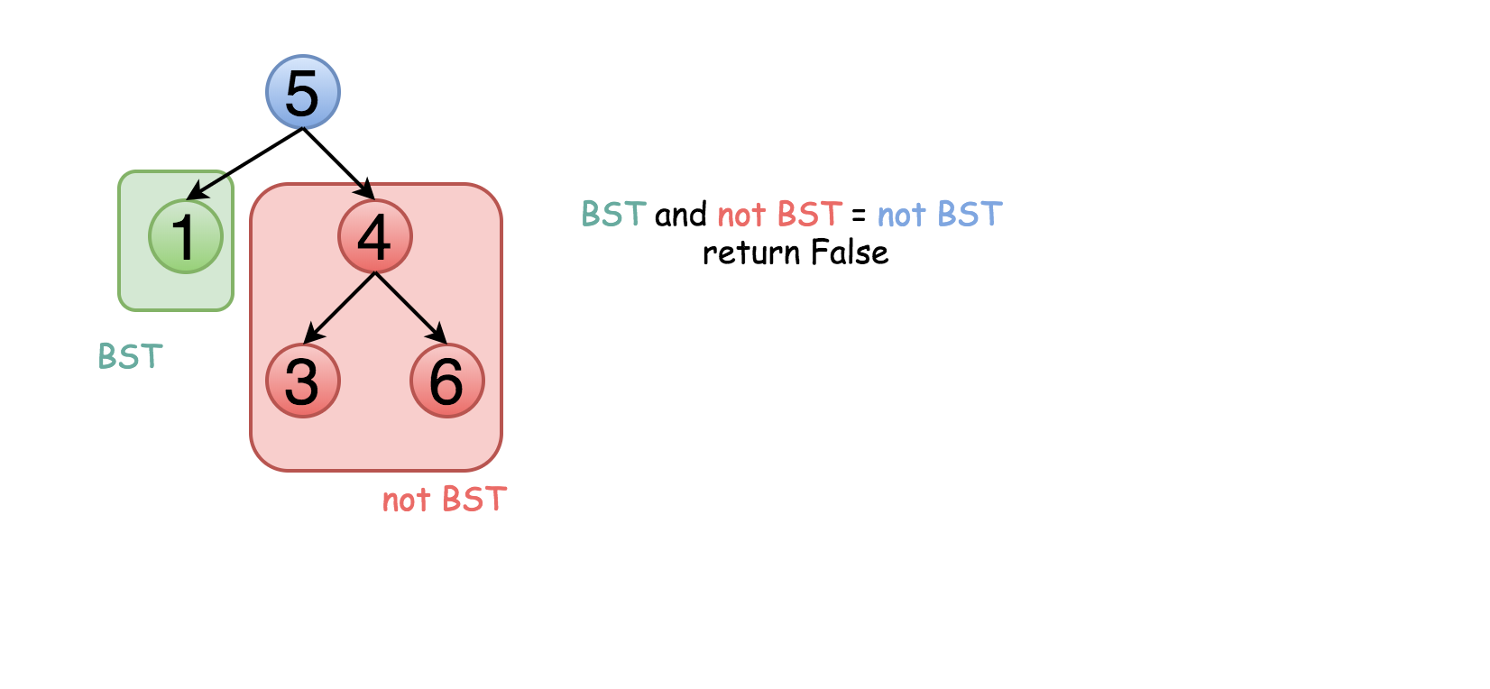

|  |
| --- |
| class Solution {  public boolean validate(TreeNode root, Integer low, Integer high) {  // Empty trees are valid BSTs.  if (root == null) {  return true;  }  // The current node's value must be between low and high.  if ((low != null && root.val <= low) || (high != null && root.val >= high)) {  return false;  }  // The left and right subtree must also be valid.  return validate(root.right, root.val, high) && validate(root.left, low, root.val);  }  public boolean isValidBST(TreeNode root) {  return validate(root, null, null);  }  } |

**Complexity Analysis**

* Time complexity : O(*N*) since we visit each node exactly once.
* Space complexity : O(*N*) since we keep up to the entire tree.

#### **Approach 2: Iterative Traversal with Valid Range**

The above recursion could be converted into iteration, with the help of an explicit stack. DFS would be better than BFS since it works faster here.

|  |
| --- |
| class Solution {  private Deque<TreeNode> stack = new LinkedList();  private Deque<Integer> upperLimits = new LinkedList();  private Deque<Integer> lowerLimits = new LinkedList();  public void update(TreeNode root, Integer low, Integer high) {  stack.add(root);  lowerLimits.add(low);  upperLimits.add(high);  }  public boolean isValidBST(TreeNode root) {  Integer low = null, high = null, val;  update(root, low, high);  while (!stack.isEmpty()) {  root = stack.poll();  low = lowerLimits.poll();  high = upperLimits.poll();  if (root == null) continue;  val = root.val;  if (low != null && val <= low) {  return false;  }  if (high != null && val >= high) {  return false;  }  update(root.right, val, high);  update(root.left, low, val);  }  return true;  }  } |

**Complexity Analysis**

* Time complexity : O(*N*) since we visit each node exactly once.
* Space complexity : O(*N*) since we keep up to the entire tree.

#### **Approach 3: Recursive Inorder Traversal**

**Algorithm**

Let's use the order of nodes in the [inorder traversal](https://leetcode.com/articles/binary-tree-inorder-traversal/) Left -> Node -> Right.

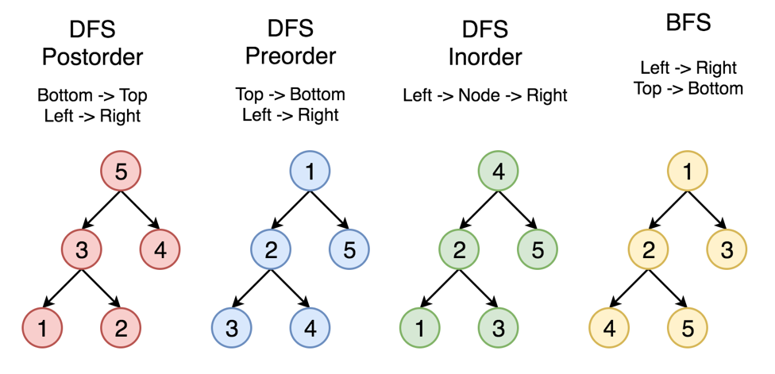

Here the nodes are enumerated in the order you visit them, and you could follow 1-2-3-4-5 to compare different strategies.

Left -> Node -> Right order of inorder traversal means for BST that each element should be smaller than the next one.

Hence the algorithm with O(*N*) time complexity and O(*N*) space complexity could be simple:

* Compute inorder traversal list inorder.
* Check if each element in inorder is smaller than the next one.

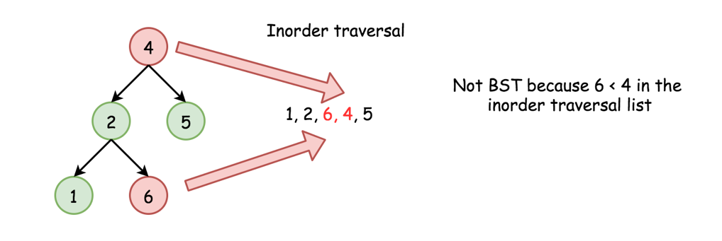

Do we need to keep the whole inorder traversal list?

Actually, no. The last added inorder element is enough to ensure at each step that the tree is BST (or not). Hence one could merge both steps into one and reduce the used space.

**Code**

We can implement the algorithm recursively.

|  |
| --- |
| class Solution {  // We use Integer instead of int as it supports a null value.  private Integer prev;  public boolean isValidBST(TreeNode root) {  prev = null;  return inorder(root);  }  private boolean inorder(TreeNode root) {  if (root == null) {  return true;  }  if (!inorder(root.left)) {  return false;  }  if (prev != null && root.val <= prev) {  return false;  }  prev = root.val;  return inorder(root.right);  }  } |

**Complexity Analysis**

* Time complexity : O(*N*) in the worst case when the tree is a BST or the "bad" element is a rightmost leaf.
* Space complexity : O(*N*) for the space on the run-time stack.

#### **Approach 4: Iterative Inorder Traversal**

Alternatively, we could implement the above algorithm iteratively.

|  |
| --- |
| class Solution {  public boolean isValidBST(TreeNode root) {  Deque<TreeNode> stack = new ArrayDeque<>();  Integer prev = null;  while (!stack.isEmpty() || root != null) {  while (root != null) {  stack.push(root);  root = root.left;  }  root = stack.pop();  // If next element in inorder traversal  // is smaller than the previous one  // that's not BST.  if (prev != null && root.val <= prev) {  return false;  }  prev = root.val;  root = root.right;  }  return true;  }  } |

**Complexity Analysis**

* Time complexity : O(*N*) in the worst case when the tree is BST or the "bad" element is a rightmost leaf.
* Space complexity : O(*N*) to keep stack.

|  |
| --- |
| bool isValidBST(TreeNode\* root, TreeNode\* min=NULL, TreeNode\* max=NULL) {  if (!root) return true;  if (min != NULL && root->val <= min->val) return false;  if (max != NULL && root->val >= max->val) return false;  return isValidBST(root->left, min, root) && isValidBST(root->right, root, max);  } |

**Symmetric Tree**

Given a binary tree, check whether it is a mirror of itself (ie, symmetric around its center).

For example, this binary tree [1,2,2,3,4,4,3] is symmetric:

1

/ \

2 2

/ \ / \

3 4 4 3

 But the following [1,2,2,null,3,null,3] is not:

1

/ \

2 2

\ \

3 3

**Follow up:** Solve it both recursively and iteratively.

## Solution

#### **Approach 1: Recursive**

A tree is symmetric if the left subtree is a mirror reflection of the right subtree.

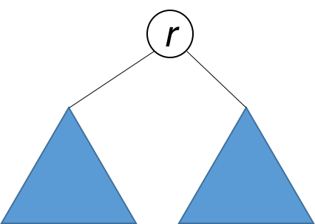

Therefore, the question is: when are two trees a mirror reflection of each other?

Two trees are a mirror reflection of each other if:

1. Their two roots have the same value.
2. The right subtree of each tree is a mirror reflection of the left subtree of the other tree.

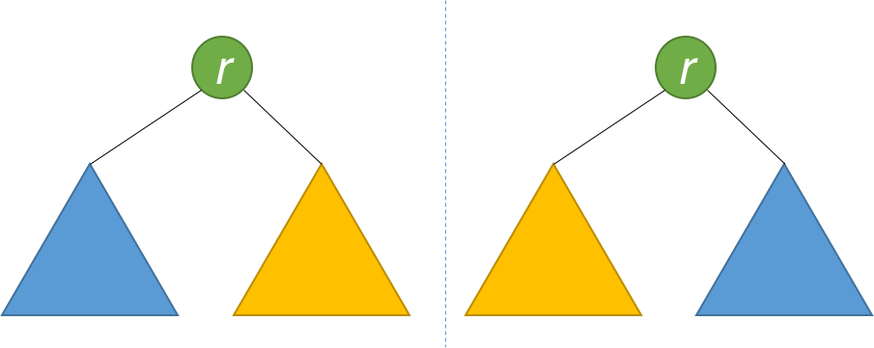

This is like a person looking at a mirror. The reflection in the mirror has the same head, but the reflection's right arm corresponds to the actual person's left arm, and vice versa.

The explanation above translates naturally to a recursive function as follows.

|  |
| --- |
| public boolean isSymmetric(TreeNode root) {  return isMirror(root, root);  }  public boolean isMirror(TreeNode t1, TreeNode t2) {  if (t1 == null && t2 == null) return true;  if (t1 == null || t2 == null) return false;  return (t1.val == t2.val)  && isMirror(t1.right, t2.left)  && isMirror(t1.left, t2.right);  } |

**Complexity Analysis**

* Time complexity : *O*(*n*). Because we traverse the entire input tree once, the total run time is *O*(*n*), where *n* is the total number of nodes in the tree.
* Space complexity : The number of recursive calls is bound by the height of the tree. In the worst case, the tree is linear and the height is in *O*(*n*). Therefore, space complexity due to recursive calls on the stack is *O*(*n*) in the worst case.

#### **Approach 2: Iterative**

Instead of recursion, we can also use iteration with the aid of a queue. Each two consecutive nodes in the queue should be equal, and their subtrees a mirror of each other. Initially, the queue contains root and root. Then the algorithm works similarly to BFS, with some key differences. Each time, two nodes are extracted and their values compared. Then, the right and left children of the two nodes are inserted in the queue in opposite order. The algorithm is done when either the queue is empty, or we detect that the tree is not symmetric (i.e. we pull out two consecutive nodes from the queue that are unequal).

|  |
| --- |
| public boolean isSymmetric(TreeNode root) {  Queue<TreeNode> q = new LinkedList<>();  q.add(root);  q.add(root);  while (!q.isEmpty()) {  TreeNode t1 = q.poll();  TreeNode t2 = q.poll();  if (t1 == null && t2 == null) continue;  if (t1 == null || t2 == null) return false;  if (t1.val != t2.val) return false;  q.add(t1.left);  q.add(t2.right);  q.add(t1.right);  q.add(t2.left);  }  return true;  } |

**Complexity Analysis**

* Time complexity : *O*(*n*). Because we traverse the entire input tree once, the total run time is *O*(*n*), where *n* is the total number of nodes in the tree.
* Space complexity : There is additional space required for the search queue. In the worst case, we have to insert *O*(*n*) nodes in the queue. Therefore, space complexity is *O*(*n*).

**Binary Tree Level Order Traversal**

Given a binary tree, return the *level order* traversal of its nodes' values. (ie, from left to right, level by level).

For example:  
Given binary tree [3,9,20,null,null,15,7],

3

/ \

9 20

/ \

15 7

return its level order traversal as:

[

[3],

[9,20],

[15,7]

]

## Solution

#### **How to traverse the tree**

There are two general strategies to traverse a tree:

* Depth First Search (DFS)

In this strategy, we adopt the depth as the priority, so that one would start from a root and reach all the way down to certain leaf, and then back to root to reach another branch.

The DFS strategy can further be distinguished as preorder, inorder, and postorder depending on the relative order among the root node, left node and right node.

* Breadth First Search (BFS)

We scan through the tree level by level, following the order of height, from top to bottom. The nodes on higher level would be visited before the ones with lower levels.

On the following figure the nodes are numerated in the order you visit them, please follow 1-2-3-4-5 to compare different strategies.

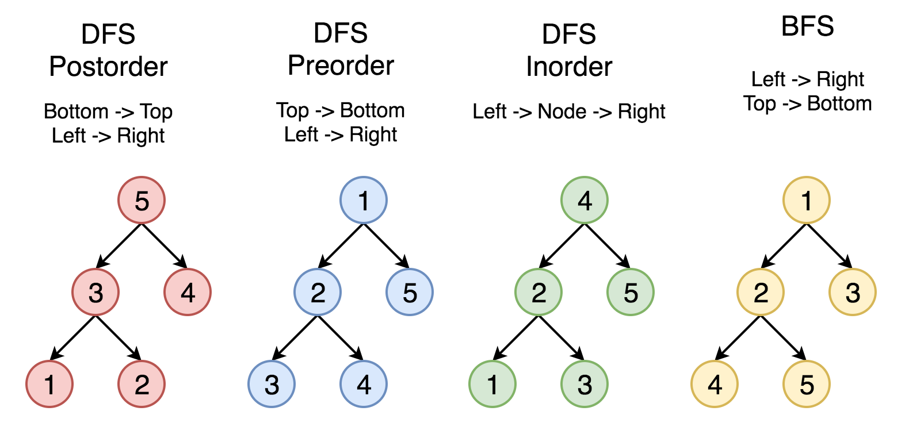

Here the problem is to implement split-level BFS traversal : [[1], [2, 3], [4, 5]].

#### **Approach 1: Recursion**

**Algorithm**

The simplest way to solve the problem is to use a recursion. Let's first ensure that the tree is not empty, and then call recursively the function helper(node, level), which takes the current node and its level as the arguments.

This function does the following :

* The output list here is called levels, and hence the current level is just a length of this list len(levels). Compare the number of a current level len(levels) with a node level level. If you're still on the previous level - add the new one by adding a new list into levels.
* Append the node value to the last list in levels.
* Process recursively child nodes if they are not None : helper(node.left / node.right, level + 1).

**Implementation**

|  |
| --- |
| class Solution {  List<List<Integer>> levels = new ArrayList<List<Integer>>();  public void helper(TreeNode node, int level) {  // start the current level  if (levels.size() == level)  levels.add(new ArrayList<Integer>());  // fulfil the current level  levels.get(level).add(node.val);  // process child nodes for the next level  if (node.left != null)  helper(node.left, level + 1);  if (node.right != null)  helper(node.right, level + 1);  }    public List<List<Integer>> levelOrder(TreeNode root) {  if (root == null) return levels;  helper(root, 0);  return levels;  }  } |

**Complexity Analysis**

* Time complexity : O(*N*) since each node is processed exactly once.
* Space complexity : O(*N*) to keep the output structure which contains N node values.

#### **Approach 2: Iteration**

**Algorithm**

The recursion above could be rewritten in the iteration form.

Let's keep nodes of each tree level in the queue structure, which typically orders elements in a FIFO (first-in-first-out) manner. In Java one could use [LinkedList implementation of the Queue interface](https://docs.oracle.com/javase/7/docs/api/java/util/Queue.html). In Python using [Queue structure](https://docs.python.org/3/library/queue.html) would be an overkill since it's designed for a safe exchange between multiple threads and hence requires locking which leads to a performance loose. In Python the queue implementation with a fast atomic append() and popleft() is [deque](https://docs.python.org/3/library/collections.html#collections.deque).

The zero level contains only one node root. The algorithm is simple :

* Initiate queue with a root and start from the level number 0 : level = 0.
* While queue is not empty :
  + Start the current level by adding an empty list into output structure levels.
  + Compute how many elements should be on the current level : it's a queue length.
  + Pop out all these elements from the queue and add them into the current level.
  + Push their child nodes into the queue for the next level.
  + Go to the next level level++.

**Implementation**

|  |
| --- |
| class Solution {  public List<List<Integer>> levelOrder(TreeNode root) {  List<List<Integer>> levels = new ArrayList<List<Integer>>();  if (root == null) return levels;  Queue<TreeNode> queue = new LinkedList<TreeNode>();  queue.add(root);  int level = 0;  while ( !queue.isEmpty() ) {  // start the current level  levels.add(new ArrayList<Integer>());  // number of elements in the current level  int level\_length = queue.size();  for(int i = 0; i < level\_length; ++i) {  TreeNode node = queue.remove();  // fulfill the current level  levels.get(level).add(node.val);  // add child nodes of the current level  // in the queue for the next level  if (node.left != null) queue.add(node.left);  if (node.right != null) queue.add(node.right);  }  // go to next level  level++;  }  return levels;  }  } |

**Complexity Analysis**

* Time complexity : O(*N*) since each node is processed exactly once.
* Space complexity : O(*N*) to keep the output structure which contains N node values.

**Convert Sorted Array to Binary Search Tree**

Given an array where elements are sorted in ascending order, convert it to a height balanced BST.

For this problem, a height-balanced binary tree is defined as a binary tree in which the depth of the two subtrees of *every* node never differ by more than 1.

**Example:**

Given the sorted array: [-10,-3,0,5,9],

One possible answer is: [0,-3,9,-10,null,5], which represents the following height balanced BST:

0

/ \

-3 9

/ /

-10 5

## Solution

#### **How to Traverse the Tree. DFS: Preorder, Inorder, Postorder; BFS.**

There are two general strategies to traverse a tree:

* Depth First Search (DFS)

In this strategy, we adopt the depth as the priority, so that one would start from a root and reach all the way down to certain leaf, and then back to root to reach another branch.

The DFS strategy can further be distinguished as preorder, inorder, and postorder depending on the relative order among the root node, left node and right node.

* Breadth First Search (BFS)

We scan through the tree level by level, following the order of height, from top to bottom. The nodes on higher level would be visited before the ones with lower levels.

On the following figure the nodes are enumerated in the order you visit them, please follow 1-2-3-4-5 to compare different strategies.

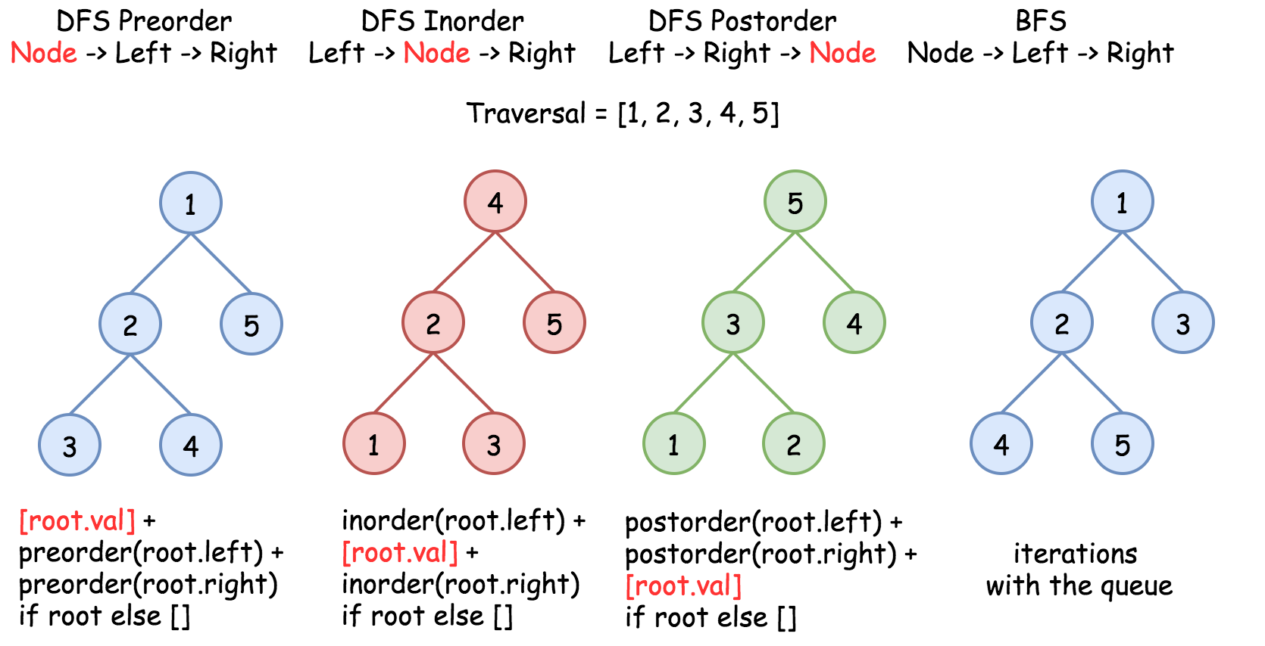

#### **Construct BST from Inorder Traversal: Why the Solution is Not Unique**

It's known that [inorder traversal of BST is an array sorted in the ascending order](https://leetcode.com/articles/delete-node-in-a-bst/).

Having sorted array as an input, we could rewrite the problem as Construct Binary Search Tree from Inorder Traversal.

Does this problem have a unique solution, i.e. could inorder traversal be used as a unique identifier to encore/decode BST? The answer is no.

Here is the funny thing about BST. Inorder traversal is not a unique identifier of BST. At the same time both preorder and postorder traversals are unique identifiers of BST. [From these traversals one could restore the inorder one](https://leetcode.com/articles/construct-bst-from-preorder-traversal/): inorder = sorted(postorder) = sorted(preorder), and [inorder + postorder or inorder + preorder are both unique identifiers of whatever binary tree](https://leetcode.com/articles/construct-binary-tree-from-inorder-and-postorder-t/).

So, the problem "sorted array -> BST" has multiple solutions.

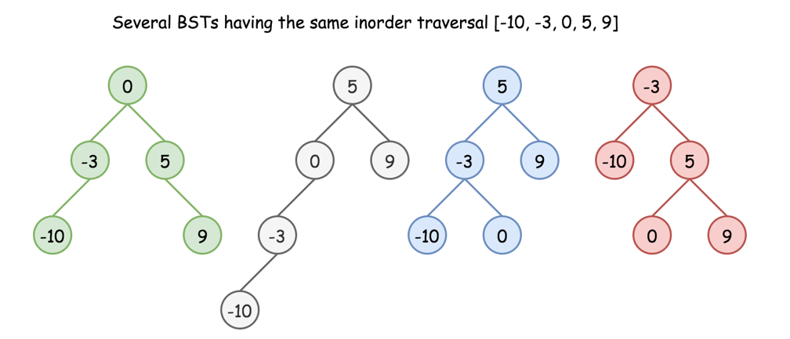

Here we have an additional condition: the tree should be height-balanced, i.e. the depths of the two subtrees of every node never differ by more than 1.

Does it make the solution to be unique? Still no.

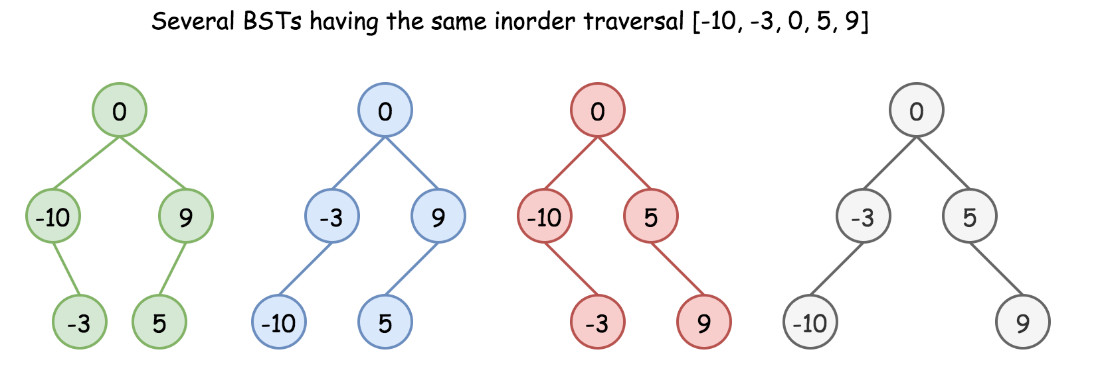

Basically, the height-balanced restriction means that at each step one has to pick up the number in the middle as a root. That works fine with arrays containing odd number of elements but there is no predefined choice for arrays with even number of elements.

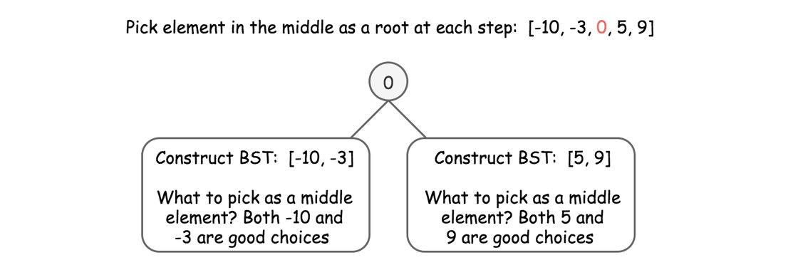

One could choose left middle element, or right middle one, and both choices will lead to different height-balanced BSTs. Let's see that in practice: in Approach 1 we will always pick up left middle element, in Approach 2 - right middle one. That will generate different BSTs but both solutions will be accepted.

#### **Approach 1: Preorder Traversal: Always Choose Left Middle Node as a Root**

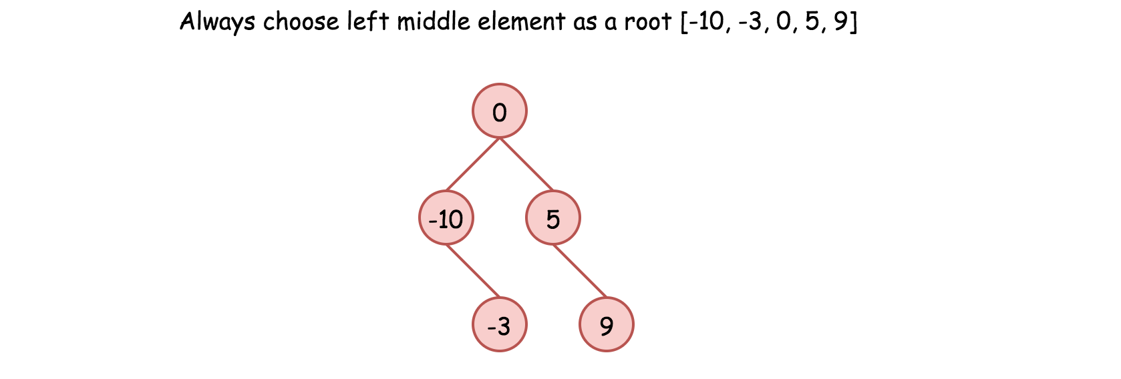

* Implement helper function helper(left, right), which constructs BST from nums elements between indexes left and right:
  + If left > right, then there is no elements available for that subtree. Return None.
  + Pick left middle element: p = (left + right) // 2.
  + Initiate the root: root = TreeNode(nums[p]).
  + Compute recursively left and right subtrees: root.left = helper(left, p - 1), root.right = helper(p + 1, right).
* Return helper(0, len(nums) - 1).

**Implementation**

|  |
| --- |
| class Solution {  int[] nums;  public TreeNode helper(int left, int right) {  if (left > right) return null;  // always choose left middle node as a root  int p = (left + right) / 2;  // preorder traversal: node -> left -> right  TreeNode root = new TreeNode(nums[p]);  root.left = helper(left, p - 1);  root.right = helper(p + 1, right);  return root;  }  public TreeNode sortedArrayToBST(int[] nums) {  this.nums = nums;  return helper(0, nums.length - 1);  }  } |

**Complexity Analysis**

* Time complexity: O(*N*) since we visit each node exactly once.
* Space complexity: O(*N*). O(*N*) to keep the output, and O(log*N*) for the recursion stack.

#### **Approach 2: Preorder Traversal: Always Choose Right Middle Node as a Root**

**Algorithm**

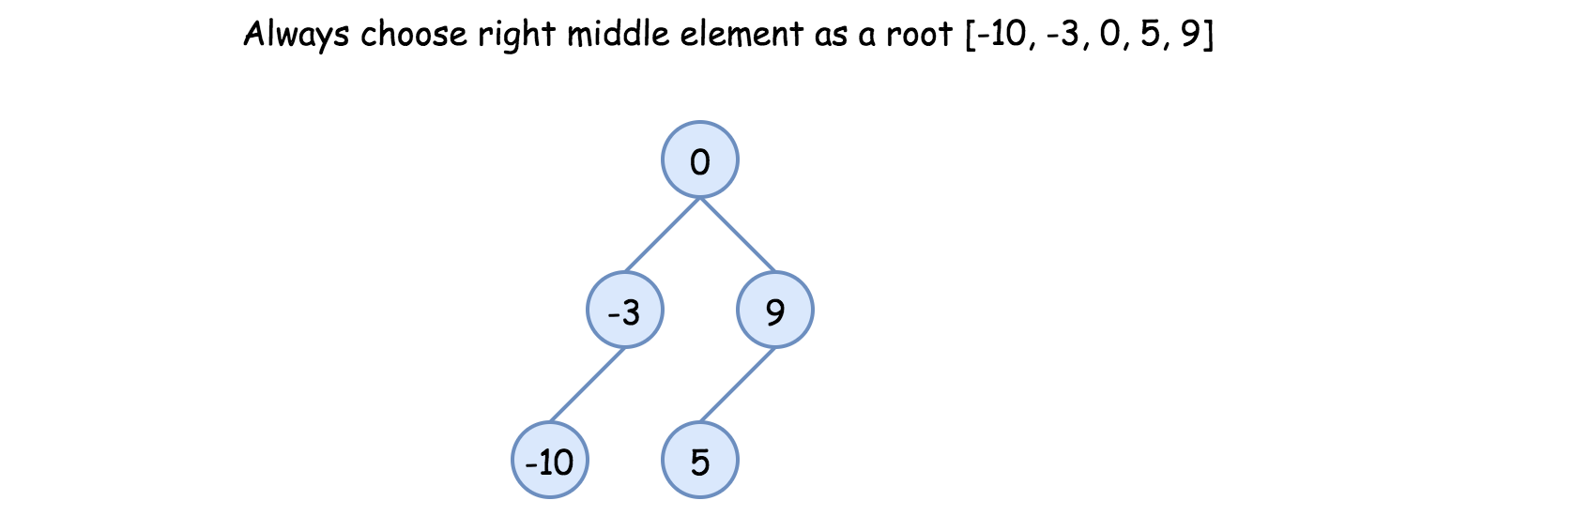

* Implement helper function helper(left, right), which constructs BST from nums elements between indexes left and right:
  + If left > right, then there is no elements available for that subtree. Return None.
  + Pick right middle element:
    - p = (left + right) // 2.
    - If left + right is odd, add 1 to p-index.
  + Initiate the root: root = TreeNode(nums[p]).
  + Compute recursively left and right subtrees: root.left = helper(left, p - 1), root.right = helper(p + 1, right).
* Return helper(0, len(nums) - 1).

**Implementation**

|  |
| --- |
| class Solution {  int[] nums;  public TreeNode helper(int left, int right) {  if (left > right) return null;  // always choose right middle node as a root  int p = (left + right) / 2;  if ((left + right) % 2 == 1) ++p;  // preorder traversal: node -> left -> right  TreeNode root = new TreeNode(nums[p]);  root.left = helper(left, p - 1);  root.right = helper(p + 1, right);  return root;  }  public TreeNode sortedArrayToBST(int[] nums) {  this.nums = nums;  return helper(0, nums.length - 1);  }  } |

**Complexity Analysis**

* Time complexity: O(*N*) since we visit each node exactly once.
* Space complexity: O(*N*). O(*N*) to keep the output, and O(log*N*) for the recursion stack.

#### **Approach 3: Preorder Traversal: Choose Random Middle Node as a Root**

This one is for fun. Instead of predefined choice we will pick randomly left or right middle node at each step. Each run will result in different solution and they all will be accepted.

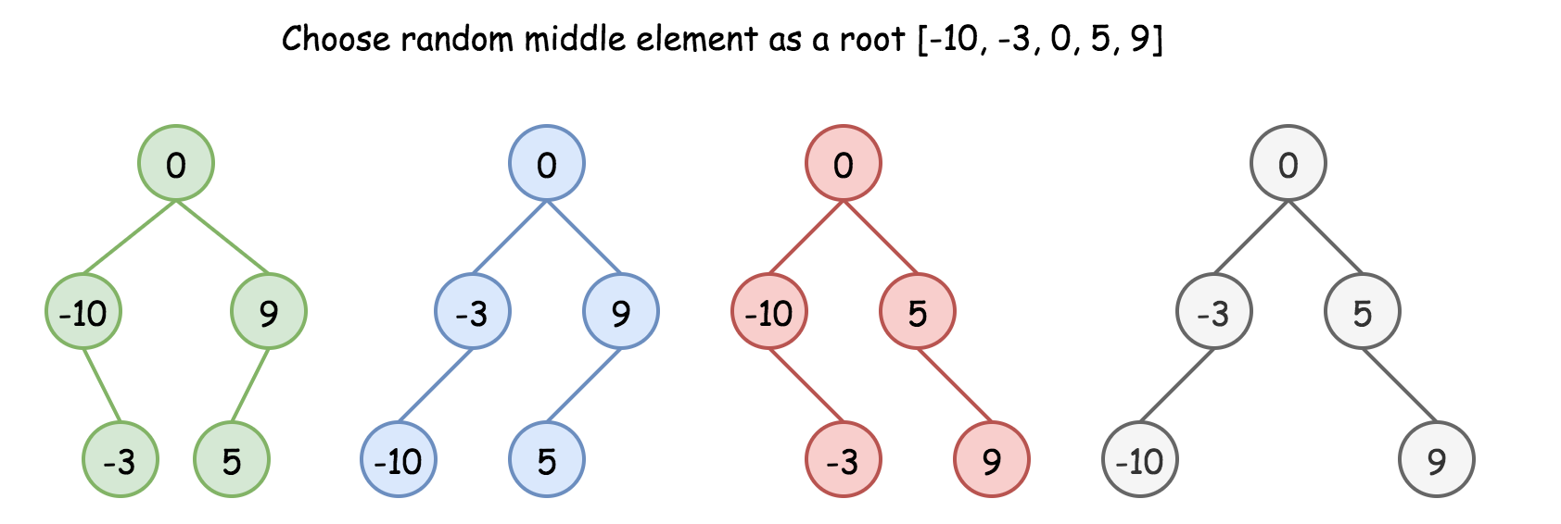

**Algorithm**

* Implement helper function helper(left, right), which constructs BST from nums elements between indexes left and right:
  + If left > right, then there is no elements available for that subtree. Return None.
  + Pick random middle element:
    - p = (left + right) // 2.
    - If left + right is odd, add randomly 0 or 1 to p-index.
  + Initiate the root: root = TreeNode(nums[p]).
  + Compute recursively left and right subtrees: root.left = helper(left, p - 1), root.right = helper(p + 1, right).
* Return helper(0, len(nums) - 1).

**Implementation**

|  |
| --- |
| class Solution {  int[] nums;  Random rand = new Random();    public TreeNode helper(int left, int right) {  if (left > right) return null;    // choose random middle node as a root  int p = (left + right) / 2;  if ((left + right) % 2 == 1) p += rand.nextInt(2);  // preorder traversal: node -> left -> right  TreeNode root = new TreeNode(nums[p]);  root.left = helper(left, p - 1);  root.right = helper(p + 1, right);  return root;  }    public TreeNode sortedArrayToBST(int[] nums) {  this.nums = nums;  return helper(0, nums.length - 1);  }  } |

**Complexity Analysis**

* Time complexity: )O(*N*) since we visit each node exactly once.
* Space complexity:  O(*N*).  O(*N*) to keep the output, and O(log*N*) for the recursion stack.

## Sorting and Searching

These problems deal with sorting or searching in a sorted structure.

We recommend First Bad Version as a great introduction to a very important algorithm.

Merge Sorted Array

First Bad Version

**Merge Sorted Array**

Given two sorted integer arrays nums1 and nums2, merge nums2 into nums1 as one sorted array.

The number of elements initialized in nums1 and nums2 are m and n respectively. You may assume that nums1 has a size equal to m + n such that it has enough space to hold additional elements from nums2.

**Example 1:**

**Input:** nums1 = [1,2,3,0,0,0], m = 3, nums2 = [2,5,6], n = 3

**Output:** [1,2,2,3,5,6]

**Example 2:**

**Input:** nums1 = [1], m = 1, nums2 = [], n = 0

**Output:** [1]

**Constraints:**

* nums1.length == m + n
* nums2.length == n
* 0 <= m, n <= 200
* 1 <= m + n <= 200
* -109 <= nums1[i], nums2[i] <= 109

Hint #1

You can easily solve this problem if you simply think about two elements at a time rather than two arrays. We know that each of the individual arrays is sorted. What we don't know is how they will intertwine. Can we take a local decision and arrive at an optimal solution?

   Hide Hint #2

If you simply consider one element each at a time from the two arrays and make a decision and proceed accordingly, you will arrive at the optimal solution.

## Solution

#### **Approach 1 : Merge and sort**

**Intuition**

A naive approach would be to simply write the values from nums2 into the end of nums1, and then sort nums1. Remember that we do not need to return a value, as we should modify nums1 in-place. While straightforward to code, this approach has a high time complexity as we're not taking advantage of the existing sorting.

**Implementation**

|  |
| --- |
| class Solution {  public void merge(int[] nums1, int m, int[] nums2, int n) {  for (int i = 0; i < n; i++) {  nums1[i + m] = nums2[i];  }  Arrays.sort(nums1);  }  } |

* Time complexity :  O((*n*+*m*)log(*n*+*m*)).

The cost of sorting a list of length x*x* using a built-in sorting algorithm is O(*x*log*x*). Because in this case we're sorting a list of length *m*+*n*, we get a total time complexity of O((*n*+*m*)log(*n*+*m*)).

* Space complexity :  O(*n*), but it can vary.

Most programming languages have a built-in sorting algorithm that uses O(*n*) space.

#### **Approach 2 : Three Pointers (Start From the Beginning)**

**Intuition**

Because each array is already sorted, we can achieve an \mathcal{O}(n + m)O(*n*+*m*) time complexity with the help of the two-pointer technique.

**Algorithm**

The simplest implementation would be to make a copy of the values in nums1, called nums1Copy, and then use two **read** pointers and one **write** pointer to read values from nums1Copy and nums2 and write them into nums1.

* Initialize nums1Copy to be a new array containing the first m values of nums1.
* Initialize read pointer p1 to the beginning of nums1Copy.
* Initialize read pointer p2 to the beginning of nums2.
* Initialize write pointer p to the beginning of nums1.
* While p is still within nums1:
  + If nums1Copy[p1] exists and is less than or equal to nums2[p2]:
    - Write nums1Copy[p1] into nums1[p], and increment p1 by 1.
  + Else
    - Write nums2[p2] into nums1[p], and increment p2 by 1.
  + Increment p by 1.

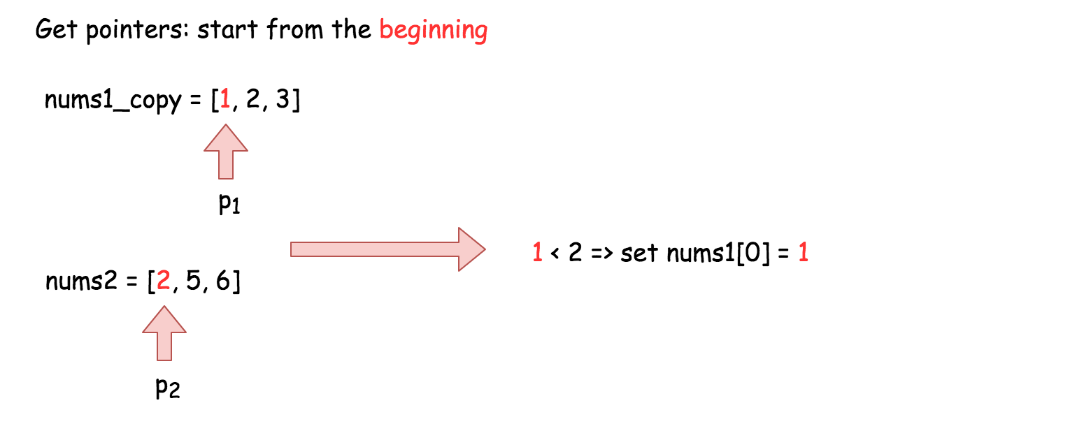

**Implementation**

|  |
| --- |
| class Solution {  public void merge(int[] nums1, int m, int[] nums2, int n) {  // Make a copy of the first m elements of nums1.  int[] nums1Copy = new int[m];  for (int i = 0; i < m; i++) {  nums1Copy[i] = nums1[i];  }  // Read pointers for nums1Copy and nums2 respectively.  int p1 = 0;  int p2 = 0;    // Compare elements from nums1Copy and nums2 and write the smallest to nums1.  for (int p = 0; p < m + n; p++) {  // We also need to ensure that p1 and p2 aren't over the boundaries  // of their respective arrays.  if (p2 >= n || (p1 < m && nums1Copy[p1] < nums2[p2])) {  nums1[p] = nums1Copy[p1++];  } else {  nums1[p] = nums2[p2++];  }  }  }  } |

**Complexity Analysis**

* Time complexity :  O(*n*+*m*).

We are performing n +2⋅*m* reads and n +2⋅*m* writes. Because constants are ignored in Big O notation, this gives us a time complexity of  O(*n*+*m*).

* Space complexity :  O(*m*).

We are allocating an additional array of length *m*.

#### **Approach 3 : Three Pointers (Start From the End)**

**Intuition**

**Interview Tip**: This is a medium-level solution to an easy-level problem. Many of LeetCode's easy-level problems have more difficult solutions, and good candidates are expected to find them.

Approach 2 already demonstrates the best possible time complexity, O(*n*+*m*), but still uses additional space. This is because the elements of array nums1 have to be stored somewhere so that they aren't overwritten.

So, what if instead we start to overwrite nums1 from the end, where there is no information yet?

The algorithm is similar to before, except this time we set p1 to point at index m - 1 of nums1, p2 to point at index n - 1 of nums2, and p to point at index m + n - 1 of nums1. This way, it is guaranteed that once we start overwriting the first m values in nums1, we will have already written each into its new position. In this way, we can eliminate the additional space.

**Interview Tip**: Whenever you're trying to solve an array problem in-place, always consider the possibility of iterating backwards instead of forwards through the array. It can completely change the problem, and make it a lot easier.

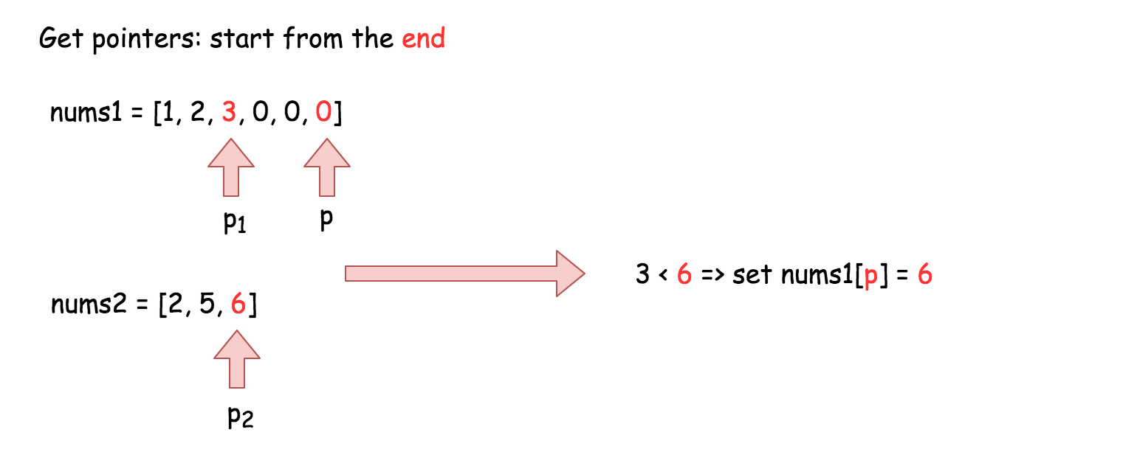

**Implementation**

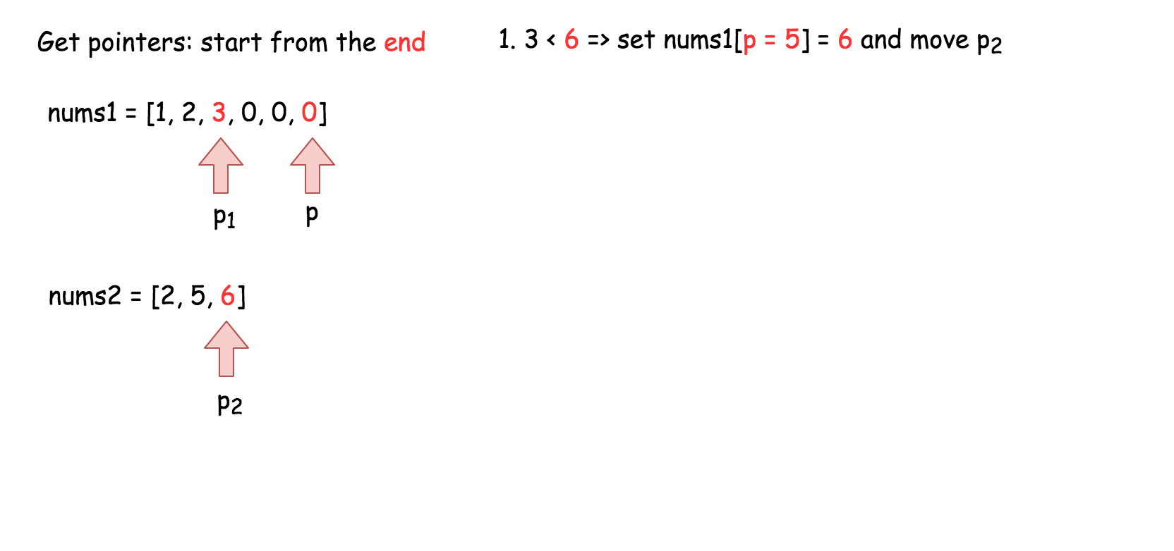

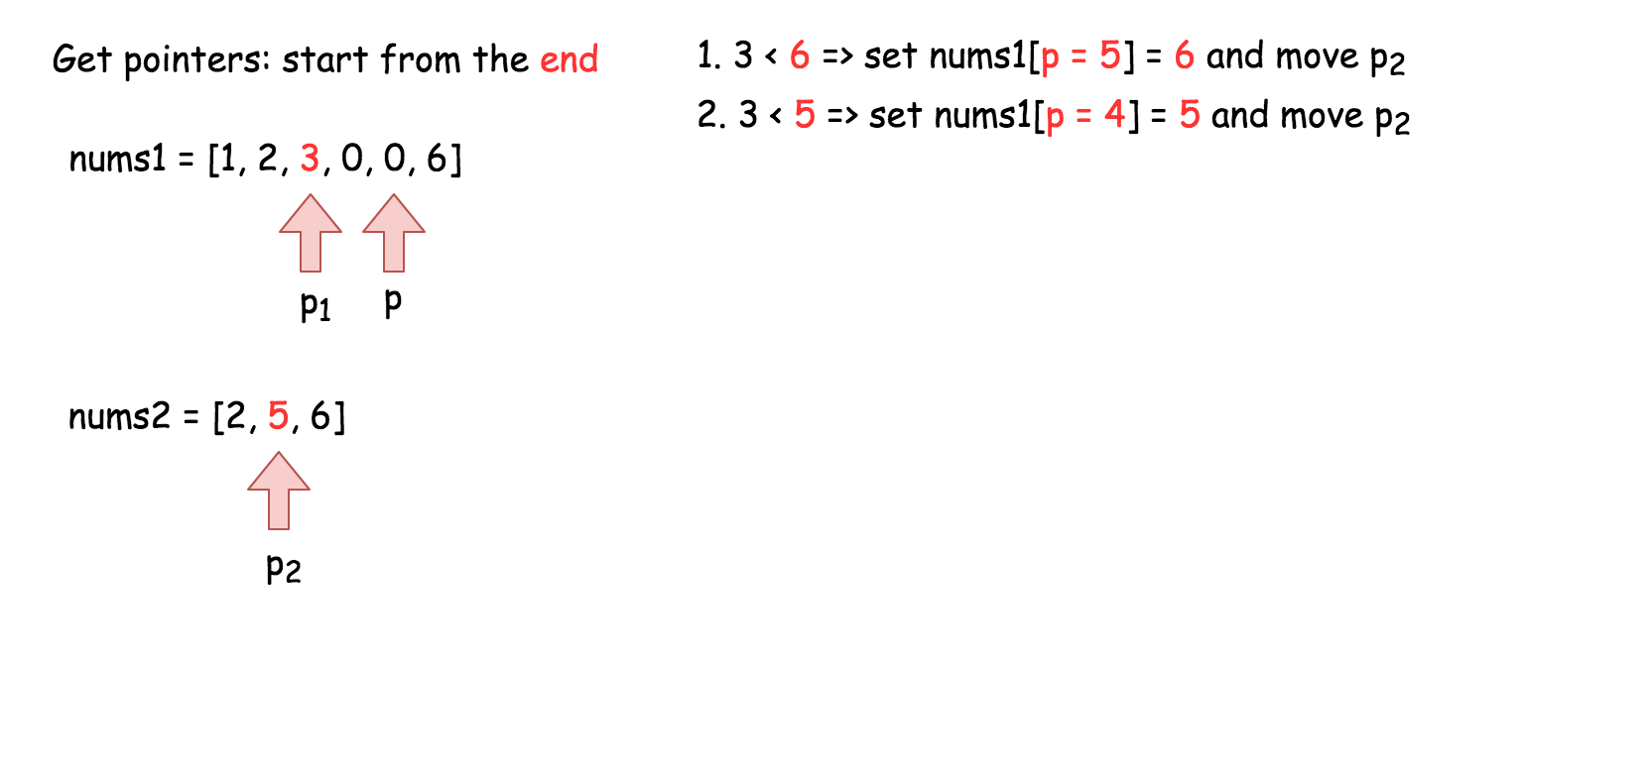

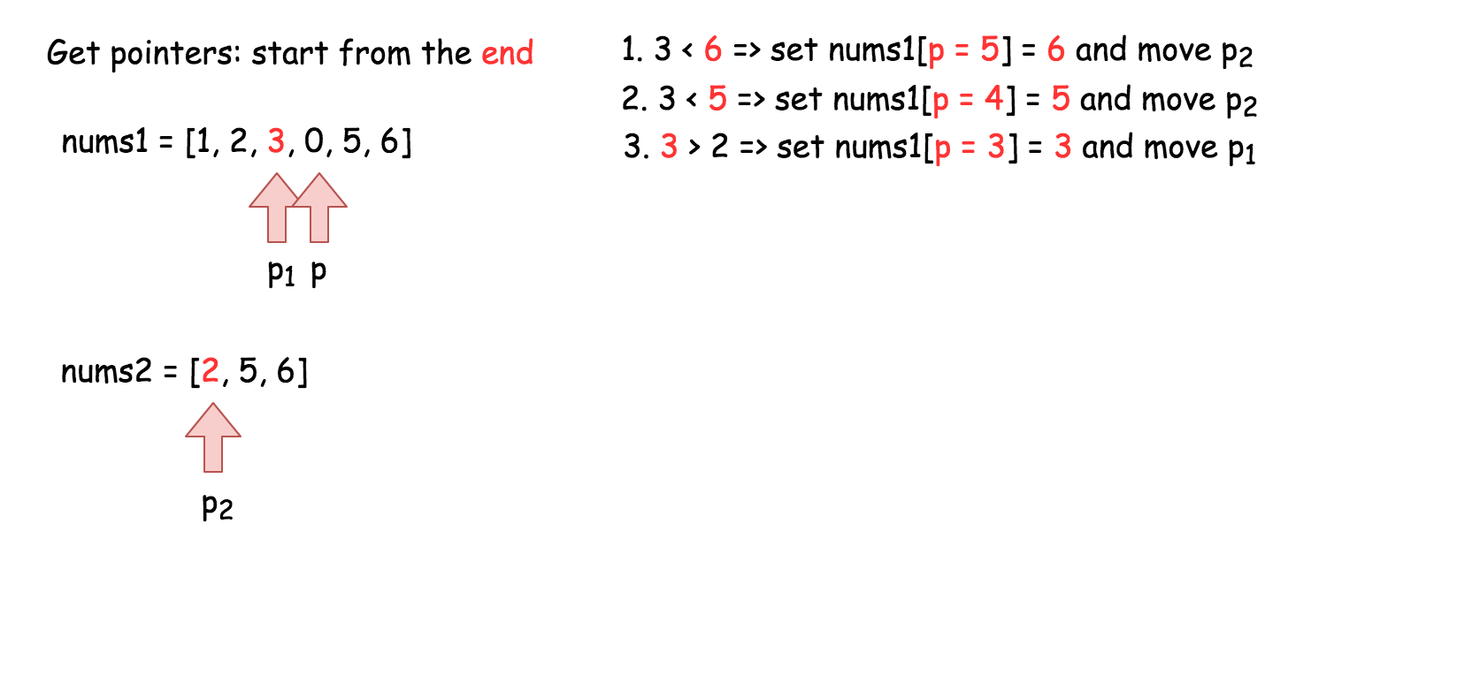

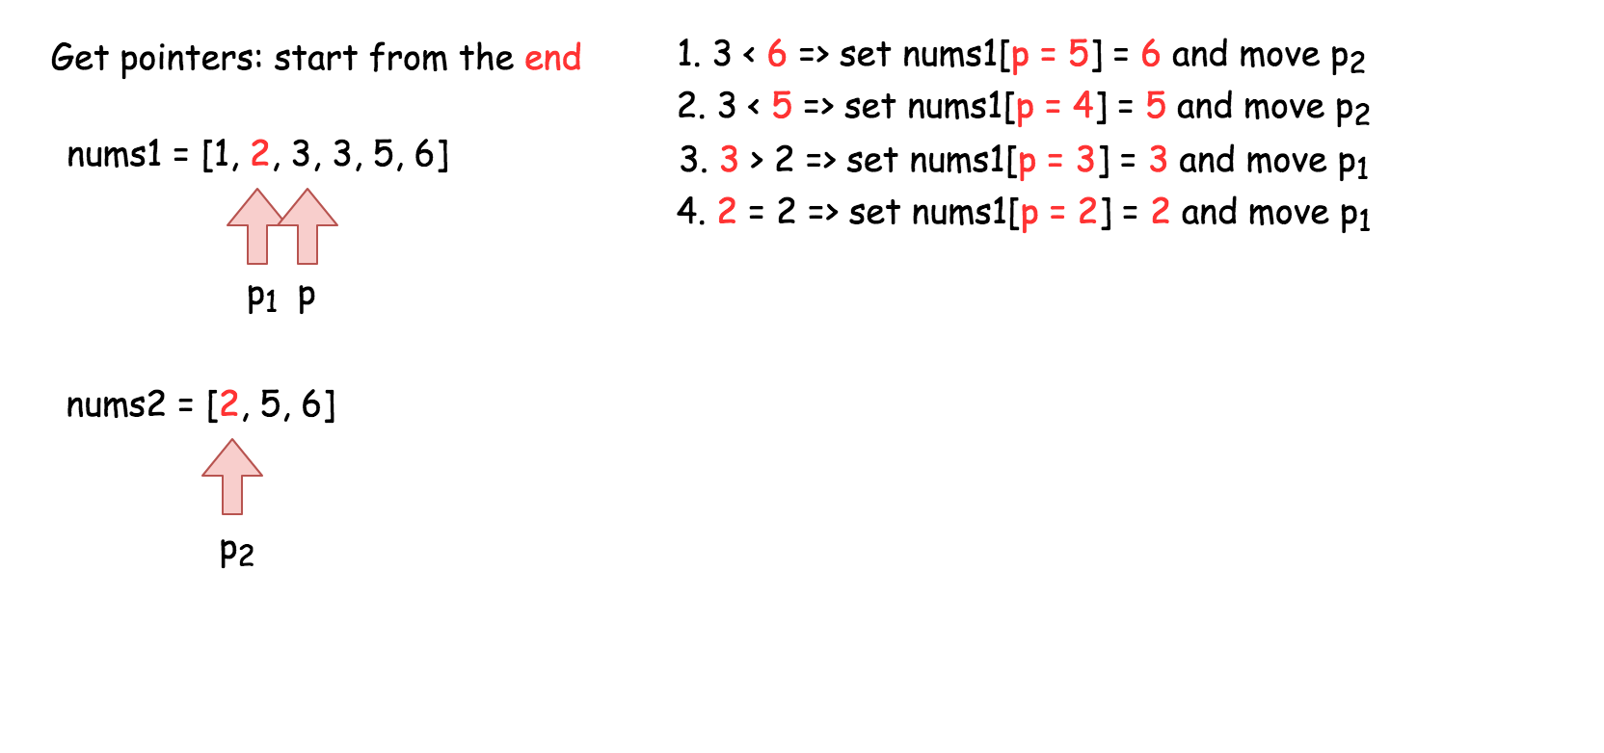

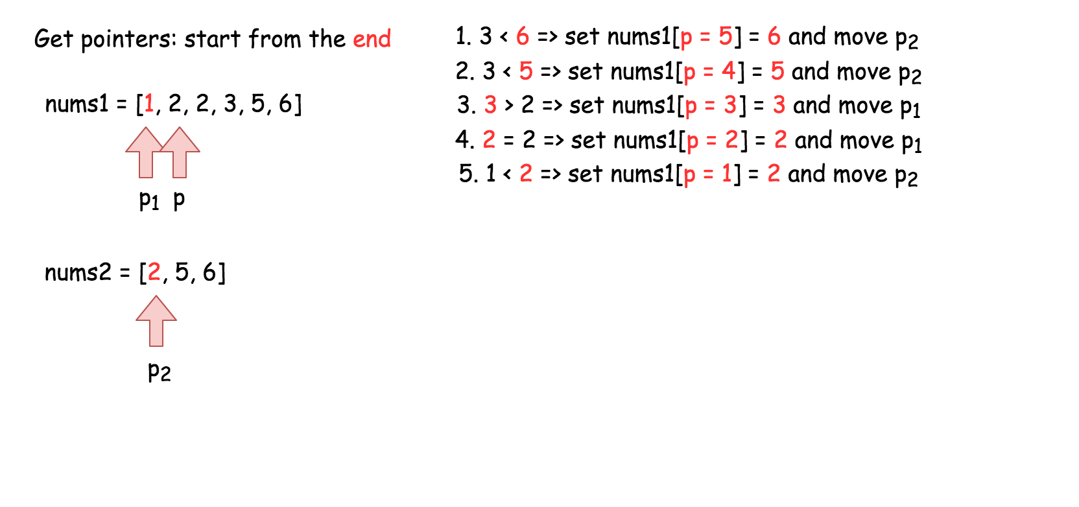

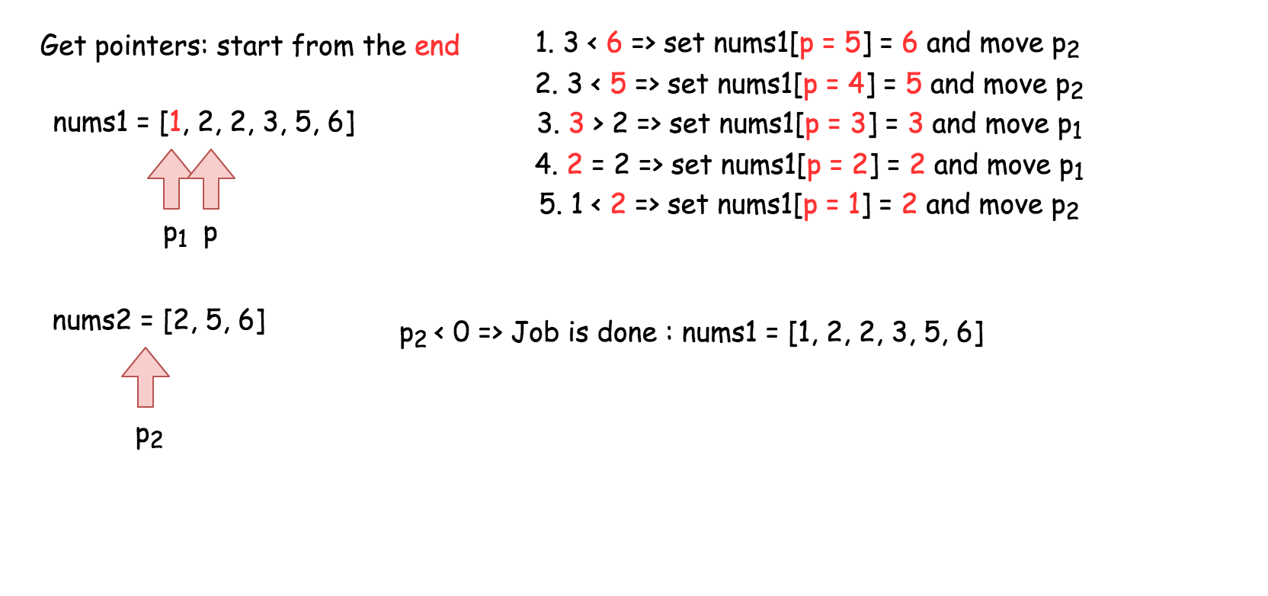

|  |
| --- |
| class Solution {  public void merge(int[] nums1, int m, int[] nums2, int n) {  // Set p1 and p2 to point to the end of their respective arrays.  int p1 = m - 1;  int p2 = n - 1;    // And move p backwards through the array, each time writing  // the smallest value pointed at by p1 or p2.  for (int p = m + n - 1; p >= 0; p--) {  if (p2 < 0) {  break;  }  if (p1 >= 0 && nums1[p1] > nums2[p2]) {  nums1[p] = nums1[p1--];  } else {  nums1[p] = nums2[p2--];  }  }  }  } |

**Complexity Analysis**

* Time complexity : O(*n*+*m*).

Same as Approach 2.

* Space complexity : O(1).

Unlike Approach 2, we're not using an extra array.

**Proof (optional)**

You might be a bit sceptical of this claim. Does it really work in every case? Is it safe to be making such a bold claim?

This way, it is guaranteed that once we start overwriting the first m values in nums1, we will have already written each into its new position. In this way, we can eliminate the additional space.

Great question! So, why does this work? To prove it, we need to ensure that p never overwrites a value in nums1 that p1 hasn't yet read from nums1.

**Words of Advice**: Terrified of proofs? Many software engineers are. Good proofs are simply a series of logical assertions, each building on the next. In this way, we can go from "obvious" statements, all the way to the one we want to prove. I recommend reading each statement one-by-one, ensuring that you understand each before moving onto the next.

1. We know that upon initialization, p is n steps ahead of p1 (in other words, p1 + n = p).
2. We also know that during each of the p iterations this algorithm performs, p is always decremented by 1, and either p1 or p2 is decremented by 1.
3. We can deduce that when p1 decremented, the gap between p and p1 stays the same, so there can't be an "overtake" in that case.
4. We can also deduce that when p2 is decremented though, the gap between p and p1 shrinks by 1 as p moves, but not p1.
5. And from that, we can deduce that the maximum number of times that p2 can be decremented is n. In other words, the gap between p and p1 can shrink by 1, at most n times.
6. In conclusion, it's impossible for an overtake to occur, as they started n apart. And when p = p1, the gap has to have shrunk n times. This means that all of nums2 have been merged in, and so there is nothing more to do.

**First Bad Version**

You are a product manager and currently leading a team to develop a new product. Unfortunately, the latest version of your product fails the quality check. Since each version is developed based on the previous version, all the versions after a bad version are also bad.

Suppose you have n versions [1, 2, ..., n] and you want to find out the first bad one, which causes all the following ones to be bad.

You are given an API bool isBadVersion(version) which returns whether version is bad. Implement a function to find the first bad version. You should minimize the number of calls to the API.

**Example 1:**

**Input:** n = 5, bad = 4

**Output:** 4

**Explanation:**

call isBadVersion(3) -> false

call isBadVersion(5) -> true

call isBadVersion(4) -> true

Then 4 is the first bad version.

**Example 2:**

**Input:** n = 1, bad = 1

**Output:** 1

**Constraints:**

* 1 <= bad <= n <= 231 - 1

## Summary

This is a very simple problem. There is a subtle trap that you may fall into if you are not careful. Other than that, it is a direct application of a very famous algorithm.

## Solution

#### **Approach #1 (Linear Scan) [Time Limit Exceeded]**

The straight forward way is to brute force it by doing a linear scan.

|  |
| --- |
| public int firstBadVersion(int n) {  for (int i = 1; i < n; i++) {  if (isBadVersion(i)) {  return i;  }  }  return n;  } |

**Complexity analysis**

* Time complexity : *O*(*n*). Assume that isBadVersion(version)*isBadVersion*(*version*) takes constant time to check if a version is bad. It takes at most *n*−1 checks, therefore the overall time complexity is *O*(*n*).
* Space complexity : *O*(1).

#### **Approach #2 (Binary Search) [Accepted]**

It is not difficult to see that this could be solved using a classic algorithm - Binary search. Let us see how the search space could be halved each time below.

Scenario #1: isBadVersion(mid) => false

1 2 3 4 5 6 7 8 9

G G G G G G B B B G = Good, B = Bad

| | |

left mid right

Let us look at the first scenario above where *isBadVersion*(*mid*)⇒*false*. We know that all versions preceding and including *mid* are all good. So we set *left*=*mid*+1 to indicate that the new search space is the interval [*mid*+1,*right*] (inclusive).

Scenario #2: isBadVersion(mid) => true

1 2 3 4 5 6 7 8 9

G G G B B B B B B G = Good, B = Bad

| | |

left mid right

The only scenario left is where *isBadVersion*(*mid*)⇒*true*. This tells us that *mid* may or may not be the first bad version, but we can tell for sure that all versions after *mid* can be discarded. Therefore we set *right*=*mid* as the new search space of interval [*left*,*mid*] (inclusive).

In our case, we indicate *left* and *right* as the boundary of our search space (both inclusive). This is why we initialize *left*=1 and *right*=*n*. How about the terminating condition? We could guess that *left* and *right* eventually both meet and it must be the first bad version, but how could you tell for sure?

The formal way is to [prove by induction](http://www.cs.cornell.edu/courses/cs211/2006sp/Lectures/L06-Induction/binary_search.html), which you can read up yourself if you are interested. Here is a helpful tip to quickly prove the correctness of your binary search algorithm during an interview. We just need to test an input of size 2. Check if it reduces the search space to a single element (which must be the answer) for both of the scenarios above. If not, your algorithm will never terminate.

If you are setting mid = (left + right)/2 ​, you have to be very careful. Unless you are using a language that does not overflow such as [Python](https://www.reddit.com/r/Python/comments/36xu5z/can_integer_operations_overflow_in_python/), *left*+*right* could overflow. One way to fix this is to use left +(right – left)/2 ​ instead.

If you fall into this subtle overflow bug, you are not alone. Even Jon Bentley's own implementation of binary search had this [overflow bug](https://en.wikipedia.org/wiki/Binary_search_algorithm#Implementation_issues) and remained undetected for over twenty years.

|  |
| --- |
| public int firstBadVersion(int n) {  int left = 1;  int right = n;  while (left < right) {  int mid = left + (right - left) / 2;  if (isBadVersion(mid)) {  right = mid;  } else {  left = mid + 1;  }  }  return left;  } |

**Complexity analysis**

* Time complexity : *O*(log*n*). The search space is halved each time, so the time complexity is *O*(log*n*).
* Space complexity : *O*(1).

## Dynamic Programming

Here are some classic Dynamic Programming interview questions.

We recommend: Climbing Stairs, Best Time to Buy and Sell Stock and Maximum Subarray.

  Climbing Stairs

 Best Time to Buy and Sell Stock

 Maximum Subarray

 House Robber

**Climbing Stairs**

You are climbing a staircase. It takes n steps to reach the top.

Each time you can either climb 1 or 2 steps. In how many distinct ways can you climb to the top?

**Example 1:**

**Input:** n = 2

**Output:** 2

**Explanation:** There are two ways to climb to the top.

1. 1 step + 1 step

2. 2 steps

**Example 2:**

**Input:** n = 3

**Output:** 3

**Explanation:** There are three ways to climb to the top.

1. 1 step + 1 step + 1 step

2. 1 step + 2 steps

3. 2 steps + 1 step

**Constraints:**

* 1 <= n <= 45

   Hide Hint #1

To reach nth step, what could have been your previous steps? (Think about the step sizes)

## Summary

You are climbing a stair case. It takes n steps to reach to the top.

Each time you can either climb 1 or 2 steps. In how many distinct ways can you climb to the top?

## Solution

#### **Approach 1: Brute Force**

**Algorithm**

In this brute force approach we take all possible step combinations i.e. 1 and 2, at every step. At every step we are calling the function *climbStairs* for step 1 and 2, and return the sum of returned values of both functions.

*climbStairs*(*i*,*n*)=(*i*+1,*n*)+*climbStairs*(*i*+2,*n*)

where *i* defines the current step and *n* defines the destination step.

|  |
| --- |
| public class Solution {  public int climbStairs(int n) {  return climb\_Stairs(0, n);  }  public int climb\_Stairs(int i, int n) {  if (i > n) {  return 0;  }  if (i == n) {  return 1;  }  return climb\_Stairs(i + 1, n) + climb\_Stairs(i + 2, n);  }  } |

**Complexity Analysis**

* Time complexity : O(2^n). Size of recursion tree will be 2^n.

Recursion tree for n=5 would be like this:

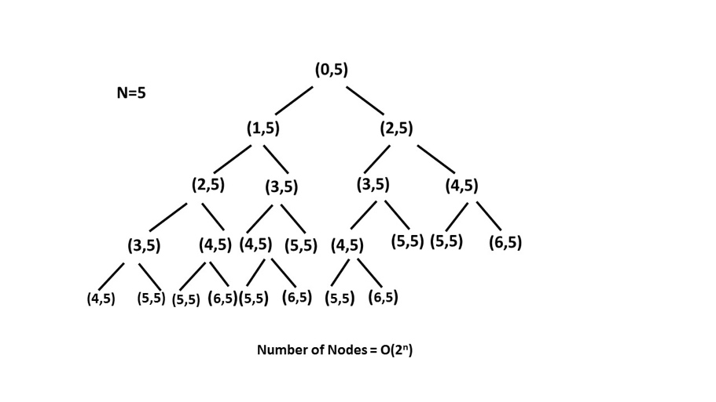

* Space complexity : *O*(*n*). The depth of the recursion tree can go upto *n*.

#### **Approach 2: Recursion with Memoization**

**Algorithm**

In the previous approach we are redundantly calculating the result for every step. Instead, we can store the result at each step in memo*memo* array and directly returning the result from the memo array whenever that function is called again.

In this way we are pruning recursion tree with the help of memo*memo* array and reducing the size of recursion tree upto n*n*.

|  |
| --- |
| public class Solution {  public int climbStairs(int n) {  int memo[] = new int[n + 1];  return climb\_Stairs(0, n, memo);  }  public int climb\_Stairs(int i, int n, int memo[]) {  if (i > n) {  return 0;  }  if (i == n) {  return 1;  }  if (memo[i] > 0) {  return memo[i];  }  memo[i] = climb\_Stairs(i + 1, n, memo) + climb\_Stairs(i + 2, n, memo);  return memo[i];  }  } |

**Complexity Analysis**

* Time complexity : *O*(*n*). Size of recursion tree can go upto *n*.
* Space complexity : *O*(*n*). The depth of recursion tree can go upto *n*.

#### **Approach 3: Dynamic Programming**

**Algorithm**

As we can see this problem can be broken into subproblems, and it contains the optimal substructure property i.e. its optimal solution can be constructed efficiently from optimal solutions of its subproblems, we can use dynamic programming to solve this problem.

One can reach *ith* step in one of the two ways:

1. Taking a single step from (*i*−1)*th* step.
2. Taking a step of 2 from (*i*−2)*th* step.

So, the total number of ways to reach *ith* is equal to sum of ways of reaching (*i*−1)*th* step and ways of reaching (*i*−2)*th* step.

Let *dp*[*i*] denotes the number of ways to reach on *ith* step:

*dp*[*i*]=*dp*[*i*−1]+*dp*[*i*−2]

Example:

|  |
| --- |
| public class Solution {  public int climbStairs(int n) {  if (n == 1) {  return 1;  }  int[] dp = new int[n + 1];  dp[1] = 1;  dp[2] = 2;  for (int i = 3; i <= n; i++) {  dp[i] = dp[i - 1] + dp[i - 2];  }  return dp[n];  }  } |

**Complexity Analysis**

* Time complexity : *O*(*n*). Single loop upto *n*.
* Space complexity : *O*(*n*). *dp* array of size *n* is used.

#### **Approach 4: Fibonacci Number**

**Algorithm**

In the above approach we have used *dp* array where *dp*[*i*]=*dp*[*i*−1]+*dp*[*i*−2]. It can be easily analysed that *dp*[*i*] is nothing but *ith* fibonacci number.

*Fib*(*n*)=*Fib*(*n*−1)+*Fib*(*n*−2)

Now we just have to find *nth* number of the fibonacci series having 1 and 2 their first and second term respectively, i.e. *Fib*(1)=1 and *Fib*(2)=2.

|  |
| --- |
| public class Solution {  public int climbStairs(int n) {  if (n == 1) {  return 1;  }  int first = 1;  int second = 2;  for (int i = 3; i <= n; i++) {  int third = first + second;  first = second;  second = third;  }  return second;  }  } |

**Complexity Analysis**

* Time complexity : *O*(*n*). Single loop upto *n* is required to calculate *nth* fibonacci number.
* Space complexity : *O*(1). Constant space is used.

**Best Time to Buy and Sell Stock**

You are given an array prices where prices[i] is the price of a given stock on the ith day.

You want to maximize your profit by choosing a **single day** to buy one stock and choosing a **different day in the future** to sell that stock.

Return *the maximum profit you can achieve from this transaction*. If you cannot achieve any profit, return 0.

**Example 1:**

**Input:** prices = [7,1,5,3,6,4]

**Output:** 5

**Explanation:** Buy on day 2 (price = 1) and sell on day 5 (price = 6), profit = 6-1 = 5.

Note that buying on day 2 and selling on day 1 is not allowed because you must buy before you sell.

**Example 2:**

**Input:** prices = [7,6,4,3,1]

**Output:** 0

**Explanation:** In this case, no transactions are done and the max profit = 0.

**Constraints:**

* 1 <= prices.length <= 105
* 0 <= prices[i] <= 104

## Solution

We need to find out the maximum difference (which will be the maximum profit) between two numbers in the given array. Also, the second number (selling price) must be larger than the first one (buying price).

In formal terms, we need to find max(prices[j]−prices[i]), for every *i* and *j* such that *j*>*i*.

#### **Approach 1: Brute Force**

|  |
| --- |
| public class Solution {  public int maxProfit(int prices[]) {  int maxprofit = 0;  for (int i = 0; i < prices.length - 1; i++) {  for (int j = i + 1; j < prices.length; j++) {  int profit = prices[j] - prices[i];  if (profit > maxprofit)  maxprofit = profit;  }  }  return maxprofit;  }  } |

**Complexity Analysis**

* Time complexity : O(n^2). Loop runs n(n-1)/2 times.
* Space complexity : *O*(1). Only two variables - maxprofit and profit are used.

#### **Approach 2: One Pass**

**Algorithm**

Say the given array is:

[7, 1, 5, 3, 6, 4]

If we plot the numbers of the given array on a graph, we get:

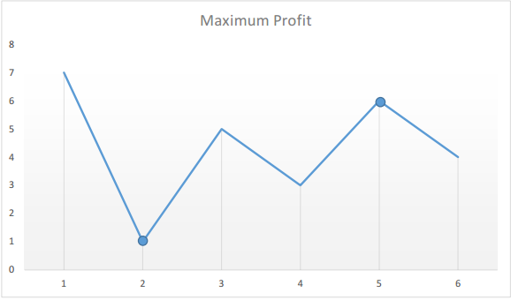

The points of interest are the peaks and valleys in the given graph. We need to find the largest peak following the smallest valley. We can maintain two variables - minprice and maxprofit corresponding to the smallest valley and maximum profit (maximum difference between selling price and minprice) obtained so far respectively.

|  |
| --- |
| public class Solution {  public int maxProfit(int prices[]) {  int minprice = Integer.MAX\_VALUE;  int maxprofit = 0;  for (int i = 0; i < prices.length; i++) {  if (prices[i] < minprice)  minprice = prices[i];  else if (prices[i] - minprice > maxprofit)  maxprofit = prices[i] - minprice;  }  return maxprofit;  }  } |

**Complexity Analysis**

* Time complexity : *O*(*n*). Only a single pass is needed.
* Space complexity : *O*(1). Only two variables are used.

**Maximum Subarray**

Given an integer array nums, find the contiguous subarray (containing at least one number) which has the largest sum and return *its sum*.

**Example 1:**

**Input:** nums = [-2,1,-3,4,-1,2,1,-5,4]

**Output:** 6

**Explanation:** [4,-1,2,1] has the largest sum = 6.

**Example 2:**

**Input:** nums = [1]

**Output:** 1

**Example 3:**

**Input:** nums = [0]

**Output:** 0

**Example 4:**

**Input:** nums = [-1]

**Output:** -1

**Example 5:**

**Input:** nums = [-100000]

**Output:** -100000

**Constraints:**

* 1 <= nums.length <= 3 \* 104
* -105 <= nums[i] <= 105

**Follow up:** If you have figured out the O(n) solution, try coding another solution using the **divide and conquer** approach, which is more subtle.

## Solution

#### **Approach 1: Divide and Conquer**

The problem is a classical example of [divide and conquer approach](https://leetcode.com/explore/learn/card/recursion-ii/470/divide-and-conquer/), and can be solved with the algorithm similar with the merge sort.

Let's follow here a solution template for the divide and conquer problems :

* Define the base case(s).
* Split the problem into subproblems and solve them recursively.
* Merge the solutions for the subproblems to obtain the solution for the original problem.

**Algorithm**

maxSubArray for array with n numbers:

* If n == 1 : return this single element.
* left\_sum = maxSubArray for the left subarray, i.e. for the first n/2 numbers (middle element at index (left + right) / 2 always belongs to the left subarray).
* right\_sum = maxSubArray for the right subarray, i.e. for the last n/2 numbers.
* cross\_sum = maximum sum of the subarray containing elements from both left and right subarrays and hence crossing the middle element at index (left + right) / 2.
* Merge the subproblems solutions, i.e. return max(left\_sum, right\_sum, cross\_sum).

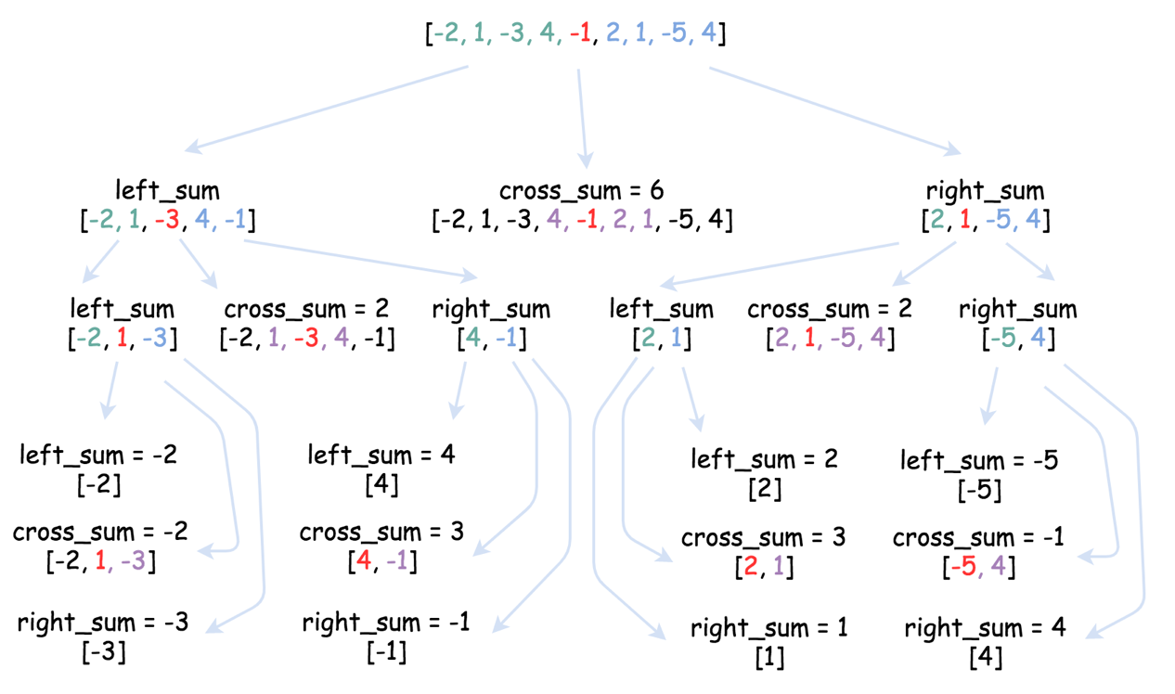

**Implementation**

|  |
| --- |
| class Solution {  public int crossSum(int[] nums, int left, int right, int p) {  if (left == right) return nums[left];  int leftSubsum = Integer.MIN\_VALUE;  int currSum = 0;  for(int i = p; i > left - 1; --i) {  currSum += nums[i];  leftSubsum = Math.max(leftSubsum, currSum);  }  int rightSubsum = Integer.MIN\_VALUE;  currSum = 0;  for(int i = p + 1; i < right + 1; ++i) {  currSum += nums[i];  rightSubsum = Math.max(rightSubsum, currSum);  }  return leftSubsum + rightSubsum;  }  public int helper(int[] nums, int left, int right) {  if (left == right) return nums[left];  int p = (left + right) / 2;  int leftSum = helper(nums, left, p);  int rightSum = helper(nums, p + 1, right);  int crossSum = crossSum(nums, left, right, p);  return Math.max(Math.max(leftSum, rightSum), crossSum);  }  public int maxSubArray(int[] nums) {  return helper(nums, 0, nums.length - 1);  }  } |

**Complexity Analysis**

* Time complexity : O(*N*log*N*).
* Space complexity : O(log*N*) to keep the recursion stack.

#### **Approach 2: Greedy**

The problem to find maximum (or minimum) element (or sum) with a single array as the input is a good candidate to be solved by the greedy approach in linear time. One can find the examples of linear time greedy solutions in our articles of  
[Super Washing Machines](https://leetcode.com/articles/super-washing-machines/), and [Gas Problem](https://leetcode.com/articles/gas-station/).

Pick the locally optimal move at each step, and that will lead to the globally optimal solution.

The algorithm is general and straightforward: iterate over the array and update at each step the standard set for such problems:

* current element
* current local maximum sum (at this given point)
* global maximum sum seen so far.

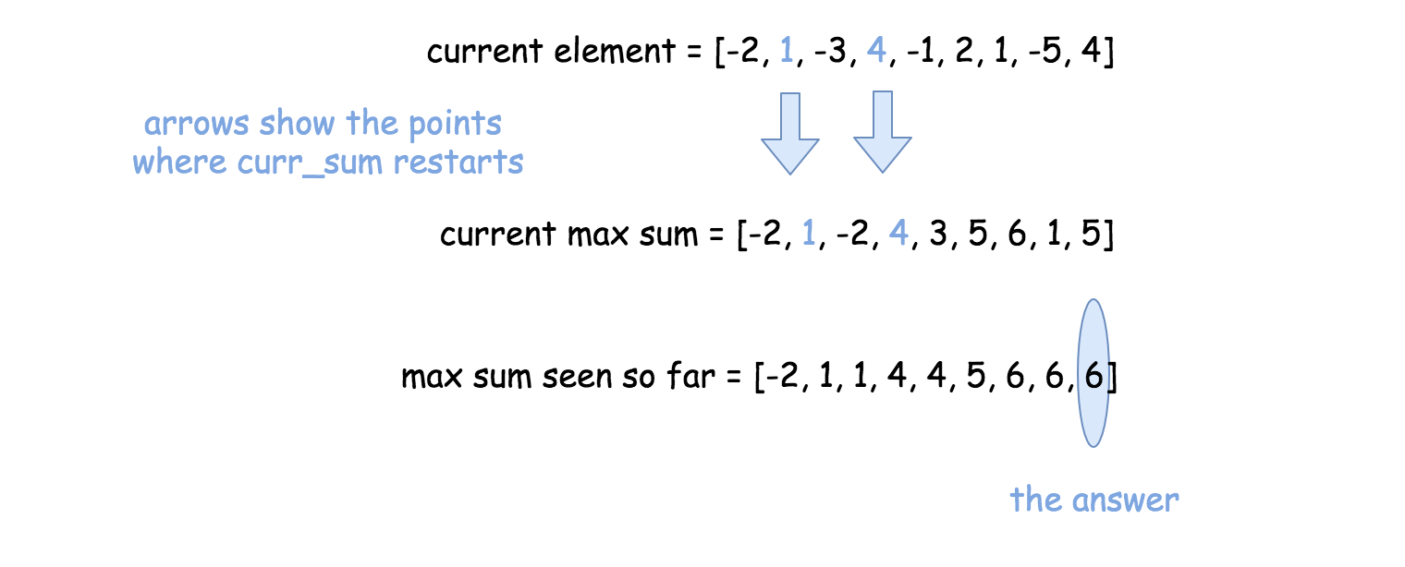

**Implementation**

|  |
| --- |
| class Solution {  public int maxSubArray(int[] nums) {  int n = nums.length;  int currSum = nums[0], maxSum = nums[0];  for(int i = 1; i < n; ++i) {  currSum = Math.max(nums[i], currSum + nums[i]);  maxSum = Math.max(maxSum, currSum);  }  return maxSum;  }  } |

**Complexity Analysis**

* Time complexity : O(*N*) since it's one pass along the array.
* Space complexity : O(1), since it's a constant space solution.

#### **Approach 3: Dynamic Programming (Kadane's algorithm)**

The problem to find sum or maximum or minimum in an entire array or in a fixed-size sliding window could be solved by the dynamic programming (DP) approach in linear time.

There are two standard DP approaches suitable for arrays:

* Constant space one. Move along the array and modify the array itself.
* Linear space one. First move in the direction left->right, then in the direction right->left. Combine the results. [Here is an example](https://leetcode.com/articles/sliding-window-maximum/).

Let's use here the first approach since one could modify the array to track the current local maximum sum at this given point.

Next step is to update the global maximum sum, knowing the local one.

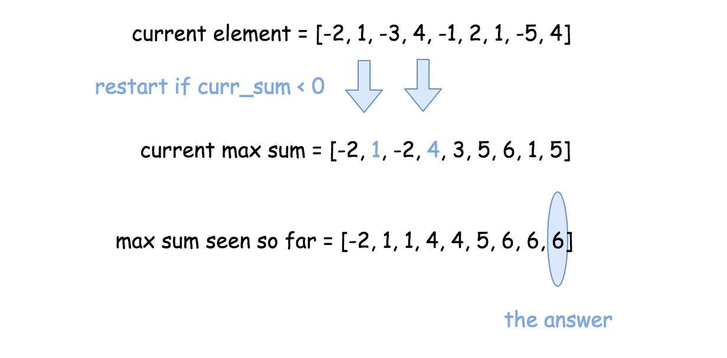

**Implementation**

|  |
| --- |
| class Solution {  public int maxSubArray(int[] nums) {  int n = nums.length, maxSum = nums[0];  for(int i = 1; i < n; ++i) {  if (nums[i - 1] > 0) nums[i] += nums[i - 1];  maxSum = Math.max(nums[i], maxSum);  }  return maxSum;  }  } |

**Complexity Analysis**

* Time complexity : O(*N*) since it's one pass along the array.
* Space complexity : O(1), since it's a constant space solution.

**House Robber**

You are a professional robber planning to rob houses along a street. Each house has a certain amount of money stashed, the only constraint stopping you from robbing each of them is that adjacent houses have security system connected and **it will automatically contact the police if two adjacent houses were broken into on the same night**.

Given a list of non-negative integers representing the amount of money of each house, determine the maximum amount of money you can rob tonight **without alerting the police**.

**Example 1:**

**Input:** nums = [1,2,3,1]

**Output:** 4

**Explanation:** Rob house 1 (money = 1) and then rob house 3 (money = 3).

  Total amount you can rob = 1 + 3 = 4.

**Example 2:**

**Input:** nums = [2,7,9,3,1]

**Output:** 12

**Explanation:** Rob house 1 (money = 2), rob house 3 (money = 9) and rob house 5 (money = 1).

  Total amount you can rob = 2 + 9 + 1 = 12.

**Constraints:**

* 0 <= nums.length <= 100
* 0 <= nums[i] <= 400

## Solution

#### **Approach #1 (Dynamic Programming) [Accepted]**

**Algorithm**

It could be overwhelming thinking of all possibilities on which houses to rob.

A natural way to approach this problem is to work on the simplest case first.

Let us denote that:



Let us look at the case n = 1, clearly f(1) = A1.

Now, let us look at n = 2, which f(2) = max(A1, A2).

For n = 3, you have basically the following two options:

1. Rob the third house, and add its amount to the first house's amount.
2. Do not rob the third house, and stick with the maximum amount of the first two houses.

Clearly, you would want to choose the larger of the two options at each step.

Therefore, we could summarize the formula as following:

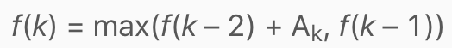  
We choose the base case as f(–1) = f(0) = 0, which will greatly simplify our code as you can see.

The answer will be calculated as f(n). We could use an array to store and calculate the result, but since at each step you only need the previous two maximum values, two variables are suffice.

|  |
| --- |
| public int rob(int[] num) {  int prevMax = 0;  int currMax = 0;  for (int x : num) {  int temp = currMax;  currMax = Math.max(prevMax + x, currMax);  prevMax = temp;  }  return currMax;  } |

**Complexity analysis**

* Time complexity : *O*(*n*). Assume that *n* is the number of houses, the time complexity is *O*(*n*).
* Space complexity : *O*(1).

## Design

These problems may require you to implement a given interface of a class, and may involve using one or more data structures. These are great exercises to improve your data structure skills.

We recommend: Shuffle an Array and Min Stack.

 Shuffle an Array

 Min Stack

**Shuffle an Array**

Given an integer array nums, design an algorithm to randomly shuffle the array.

Implement the Solution class:

* Solution(int[] nums) Initializes the object with the integer array nums.
* int[] reset() Resets the array to its original configuration and returns it.
* int[] shuffle() Returns a random shuffling of the array.

**Example 1:**

**Input**

["Solution", "shuffle", "reset", "shuffle"]

[[[1, 2, 3]], [], [], []]

**Output**

[null, [3, 1, 2], [1, 2, 3], [1, 3, 2]]

**Explanation**

Solution solution = new Solution([1, 2, 3]);

solution.shuffle(); // Shuffle the array [1,2,3] and return its result. Any permutation of [1,2,3] must be equally likely to be returned. Example: return [3, 1, 2]

solution.reset(); // Resets the array back to its original configuration [1,2,3]. Return [1, 2, 3]

solution.shuffle(); // Returns the random shuffling of array [1,2,3]. Example: return [1, 3, 2]

**Constraints:**

* 1 <= nums.length <= 200
* -106 <= nums[i] <= 106
* All the elements of nums are **unique**.
* At most 5 \* 104 calls will be made to reset and shuffle.

   Hide Hint #1

The solution expects that we always use the original array to shuffle() else some of the test cases fail. (Credits; @snehasingh31)

#### **Initial Thoughts**

Normally I would display more than two approaches, but shuffling is deceptively easy to do almost properly, and the Fisher-Yates algorithm is both the canonical solution and asymptotically optimal.

A few notes on randomness are necessary before beginning - both approaches displayed below assume that the languages' pseudorandom number generators (PRNGs) are sufficiently random. The sample code uses the simplest techniques available for getting pseudorandom numbers, but for each possible permutation of the array to be truly equally likely, more care must be taken. For example, an array of length *n* has *n*! distinct permutations. Therefore, in order to encode all permutations in an integer space, ⌈*lg*(*n*!)⌉ bits are necessary, which may not be guaranteed by the default PRNG.

#### **Approach #1 Brute Force [Accepted]**

**Intuition**

If we put each number in a "hat" and draw them out at random, the order in which we draw them will define a random ordering.

**Algorithm**

The brute force algorithm essentially puts each number in the aforementioned "hat", and draws them at random (without replacement) until there are none left. Mechanically, this is performed by copying the contents of array into a second auxiliary array named aux before overwriting each element of array with a randomly selected one from aux. After selecting each random element, it is removed from aux to prevent duplicate draws. The implementation of reset is simple, as we just store the original state of nums on construction.

The correctness of the algorithm follows from the fact that an element (without loss of generality) is equally likely to be selected during all iterations of the for loop. To prove this, observe that the probability of a particular element *e* being chosen on the *k*th iteration (indexed from 0) is simply P(*e* being chosen during the *k*th iteration) ⋅*P*(*e* not being chosen before the *k*th iteration)). Given that the array to be shuffled has *n* elements, this probability is more concretely stated as the following:

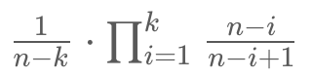

When expanded (and rearranged), it looks like this (for sufficiently large *k*):

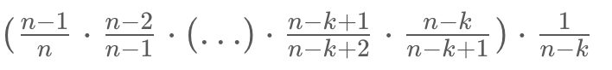

For the base case (*k*=0), it is trivial to see that 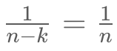​. For *k*>0, the numerator of each fraction can be cancelled with the denominator of the next, leaving the *n* from the 0th draw as the only uncancelled denominator. Therefore, no matter on which draw an element is drawn, it is drawn with a 1/n​ chance, so each array permutation is equally likely to arise.

|  |
| --- |
| class Solution {  private int[] array;  private int[] original;  private Random rand = new Random();  private List<Integer> getArrayCopy() {  List<Integer> asList = new ArrayList<Integer>();  for (int i = 0; i < array.length; i++) {  asList.add(array[i]);  }  return asList;  }  public Solution(int[] nums) {  array = nums;  original = nums.clone();  }    public int[] reset() {  array = original;  original = original.clone();  return array;  }    public int[] shuffle() {  List<Integer> aux = getArrayCopy();  for (int i = 0; i < array.length; i++) {  int removeIdx = rand.nextInt(aux.size());  array[i] = aux.get(removeIdx);  aux.remove(removeIdx);  }  return array;  }  } |

**Complexity Analysis**

* Time complexity : O(n^2)

The quadratic time complexity arises from the calls to list.remove (or list.pop), which run in linear time. *n* linear list removals occur, which results in a fairly easy quadratic analysis.

* Space complexity : O(*n*)

Because the problem also asks us to implement reset, we must use linear additional space to store the original array. Otherwise, it would be lost upon the first call to shuffle.

#### **Approach #2 Fisher-Yates Algorithm [Accepted]**

**Intuition**

We can cut down the time and space complexities of shuffle with a bit of cleverness - namely, by swapping elements around within the array itself, we can avoid the linear space cost of the auxiliary array and the linear time cost of list modification.

**Algorithm**

The Fisher-Yates algorithm is remarkably similar to the brute force solution. On each iteration of the algorithm, we generate a random integer between the current index and the last index of the array. Then, we swap the elements at the current index and the chosen index - this simulates drawing (and removing) the element from the hat, as the next range from which we select a random index will not include the most recently processed one. One small, yet important detail is that it is possible to swap an element with itself - otherwise, some array permutations would be more likely than others. To see this illustrated more clearly, consider the animation below:

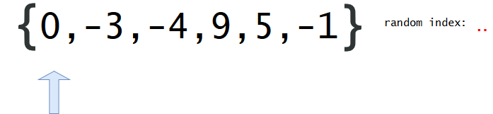

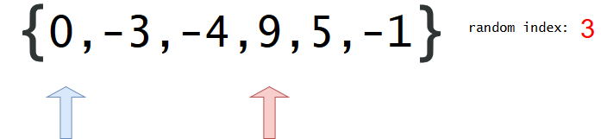

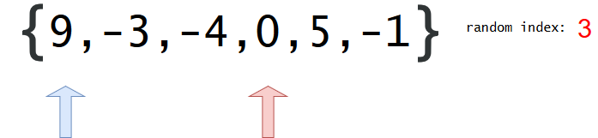

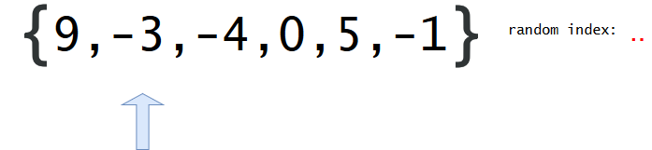

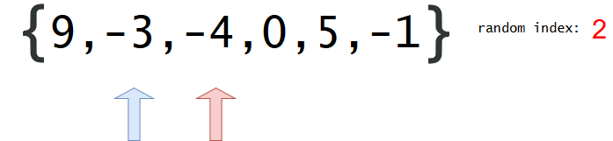

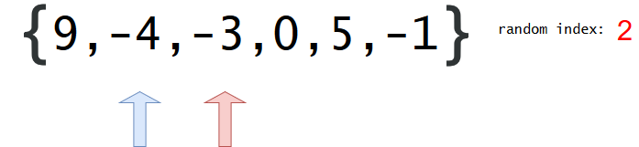

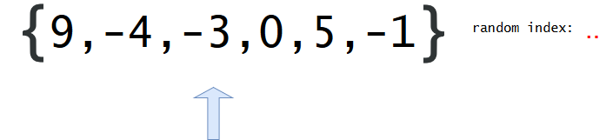

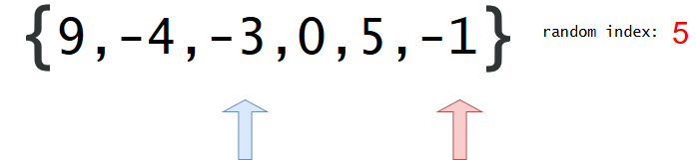

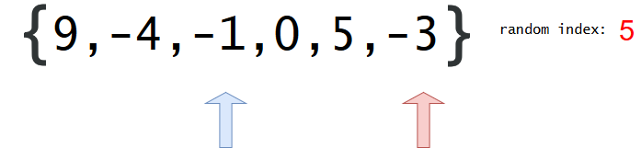

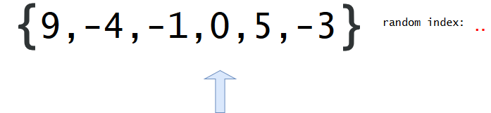

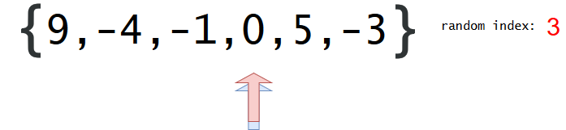

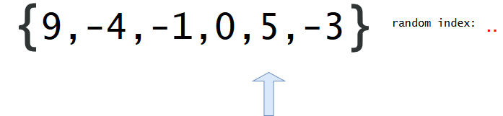

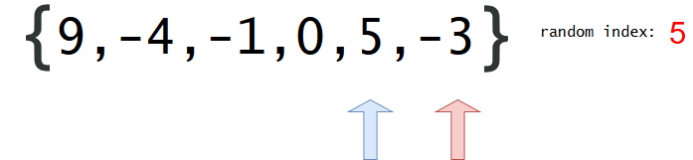

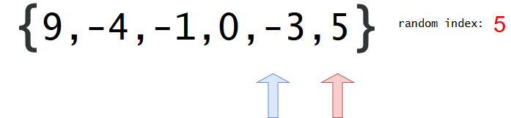

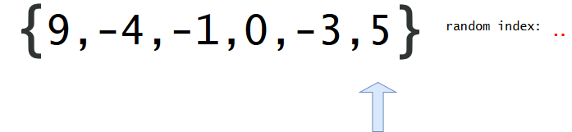

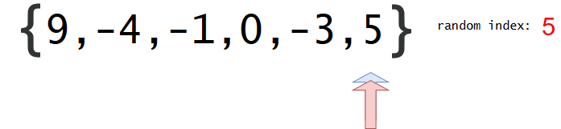

|  |
| --- |
| class Solution {  private int[] array;  private int[] original;  Random rand = new Random();  private int randRange(int min, int max) {  return rand.nextInt(max - min) + min;  }  private void swapAt(int i, int j) {  int temp = array[i];  array[i] = array[j];  array[j] = temp;  }  public Solution(int[] nums) {  array = nums;  original = nums.clone();  }    public int[] reset() {  array = original;  original = original.clone();  return original;  }    public int[] shuffle() {  for (int i = 0; i < array.length; i++) {  swapAt(i, randRange(i, array.length));  }  return array;  }  } |

**Complexity Analysis**

* Time complexity : O(*n*)

The Fisher-Yates algorithm runs in linear time, as generating a random index and swapping two values can be done in constant time.

* Space complexity : O(*n*)

Although we managed to avoid using linear space on the auxiliary array from the brute force approach, we still need it for reset, so we're stuck with linear space complexity.

**Min Stack**

Design a stack that supports push, pop, top, and retrieving the minimum element in constant time.

* push(x) -- Push element x onto stack.
* pop() -- Removes the element on top of the stack.
* top() -- Get the top element.
* getMin() -- Retrieve the minimum element in the stack.

**Example 1:**

**Input**

["MinStack","push","push","push","getMin","pop","top","getMin"]

[[],[-2],[0],[-3],[],[],[],[]]

**Output**

[null,null,null,null,-3,null,0,-2]

**Explanation**

MinStack minStack = new MinStack();

minStack.push(-2);

minStack.push(0);

minStack.push(-3);

minStack.getMin(); // return -3

minStack.pop();

minStack.top(); // return 0

minStack.getMin(); // return -2

**Constraints:**

* Methods pop, top and getMin operations will always be called on **non-empty** stacks.

Consider each node in the stack having a minimum value. (Credits to @aakarshmadhavan)

## Math

Most of the math questions asked in interviews do not require math knowledge beyond middle school level.

We recommend: Count Primes and Power of Three.

 Fizz Buzz

 Count Primes

 Power of Three

 Roman to Integer

**Fizz Buzz**

Write a program that outputs the string representation of numbers from 1 to *n*.

But for multiples of three it should output “Fizz” instead of the number and for the multiples of five output “Buzz”. For numbers which are multiples of both three and five output “FizzBuzz”.

**Example:**

n = 15,

Return:

[

"1",

"2",

"Fizz",

"4",

"Buzz",

"Fizz",

"7",

"8",

"Fizz",

"Buzz",

"11",

"Fizz",

"13",

"14",

"FizzBuzz"

]

## Solution

You must have played FizzBuzz as kids. FizzBuzz charm never gets old. And so here we are looking at how you can take on one step at a time and impress your interviewer with a better and neat approach to solve this problem.

#### **Approach 1: Naive Approach**

**Intuition**

The moment you hear of FizzBuzz you think whether the number is divisible by 3, 5 or both.

**Algorithm**

1. Initialize an empty answer list.
2. Iterate on the numbers from 1...*N*.
3. For every number, if it is divisible by both 3 and 5, add FizzBuzz to the answer list.
4. Else, Check if the number is divisible by 3, add Fizz.
5. Else, Check if the number is divisible by 5, add Buzz.
6. Else, add the number.

|  |
| --- |
| class Solution {  public List<String> fizzBuzz(int n) {  // ans list  List<String> ans = new ArrayList<String>();  for (int num = 1; num <= n; num++) {  boolean divisibleBy3 = (num % 3 == 0);  boolean divisibleBy5 = (num % 5 == 0);  if (divisibleBy3 && divisibleBy5) {  // Divides by both 3 and 5, add FizzBuzz  ans.add("FizzBuzz");  } else if (divisibleBy3) {  // Divides by 3, add Fizz  ans.add("Fizz");  } else if (divisibleBy5) {  // Divides by 5, add Buzz  ans.add("Buzz");  } else {  // Not divisible by 3 or 5, add the number  ans.add(Integer.toString(num));  }  }  return ans;  }  } |

#### **Approach 2: String Concatenation**

**Intuition**

This approach won't reduce the asymptotic complexity, but proves to be a neater solution when FizzBuzz comes with a twist. What if FizzBuzz is now FizzBuzzJazz i.e.

3 ---> "Fizz" , 5 ---> "Buzz", 7 ---> "Jazz"

If you try to solve this with the previous approach the program would have too many conditions to check:

1. Divisible by 3
2. Divisible by 5
3. Divisible by 7
4. Divisible by 3 and 5
5. Divisible by 3 and 7
6. Divisible by 7 and 3
7. Divisible by 3 and 5 and 7
8. Not divisible by 3 or 5 or 7.

This way if the FizzBuzz mappings increase, the conditions would grow exponentially in your program.

**Algorithm**

Instead of checking for every combination of these conditions, check for divisibility by given numbers i.e. 3, 5 as given in the problem. If the number is divisible, concatenate the corresponding string mapping Fizz or Buzz to the current answer string.

For eg. If we are checking for the number 15, the steps would be:

Condition 1: 15 % 3 == 0 , num\_ans\_str = "Fizz"

Condition 2: 15 % 5 == 0 , num\_ans\_str += "Buzz"

=> num\_ans\_str = "FizzBuzz"

So for FizzBuzz we just check for two conditions instead of three conditions as in the first approach.

Similarly, for FizzBuzzJazz now we would just have three conditions to check for divisibility.

|  |
| --- |
| class Solution {  public List<String> fizzBuzz(int n) {  // ans list  List<String> ans = new ArrayList<String>();  for (int num = 1; num <= n; num++) {  boolean divisibleBy3 = (num % 3 == 0);  boolean divisibleBy5 = (num % 5 == 0);  String numAnsStr = "";  if (divisibleBy3) {  // Divides by 3, add Fizz  numAnsStr += "Fizz";  }  if (divisibleBy5) {  // Divides by 5, add Buzz  numAnsStr += "Buzz";  }  if (numAnsStr.equals("")) {  // Not divisible by 3 or 5, add the number  numAnsStr += Integer.toString(num);  }  // Append the current answer str to the ans list  ans.add(numAnsStr);  }  return ans;  }  } |

**Complexity Analysis**

* Time Complexity: *O*(*N*)
* Space Complexity: *O*(1)

#### **Approach 3: Hash it!**

**Intuition**

This approach is an optimization over approach 2. When the number of mappings are limited, approach 2 looks good. But what if you face a tricky interviewer and he decides to add too many mappings?

Having a condition for every mapping is not feasible or may be we can say the code might get ugly and tough to maintain.

What if tomorrow we have to change a mapping or may be delete a mapping? Are we going to change the code every time we have a modification in the mappings?

We don't have to. We can put all these mappings in a Hash Table.

**Algorithm**

1. Put all the mappings in a hash table. The hash table fizzBuzzHash would look something like { 3: 'Fizz', 5: 'Buzz' }
2. Iterate on the numbers from 1...*N*.
3. For every number, iterate over the fizzBuzzHash keys and check for divisibility.
4. If the number is divisible by the key, concatenate the corresponding hash value to the answer string for current number. We do this for every entry in the hash table.
5. Add the answer string to the answer list.

This way you can add/delete mappings to/from to the hash table and not worry about changing the code.

So, for FizzBuzzJazz the hash table would look something like { 3: 'Fizz', 5: 'Buzz', 7: 'Jazz' }

|  |
| --- |
| class Solution {  public List<String> fizzBuzz(int n) {  // ans list  List<String> ans = new ArrayList<String>();  // Hash map to store all fizzbuzz mappings.  HashMap<Integer, String> fizzBizzDict =  new HashMap<Integer, String>() {  {  put(3, "Fizz");  put(5, "Buzz");  }  };  for (int num = 1; num <= n; num++) {  String numAnsStr = "";  for (Integer key : fizzBizzDict.keySet()) {  // If the num is divisible by key,  // then add the corresponding string mapping to current numAnsStr  if (num % key == 0) {  numAnsStr += fizzBizzDict.get(key);  }  }  if (numAnsStr.equals("")) {  // Not divisible by 3 or 5, add the number  numAnsStr += Integer.toString(num);  }  // Append the current answer str to the ans list  ans.add(numAnsStr);  }  return ans;  }  } |

**Complexity Analysis**

* Time Complexity : *O*(*N*)
* Space Complexity : *O*(1)

**Count Primes**

Count the number of prime numbers less than a non-negative number, n.

**Example 1:**

**Input:** n = 10

**Output:** 4

**Explanation:** There are 4 prime numbers less than 10, they are 2, 3, 5, 7.

**Example 2:**

**Input:** n = 0

**Output:** 0

**Example 3:**

**Input:** n = 1

**Output:** 0

**Constraints:**

* 0 <= n <= 5 \* 106

 Hide Hint #1

Let's start with a *isPrime* function. To determine if a number is prime, we need to check if it is not divisible by any number less than *n*. The runtime complexity of *isPrime* function would be O(*n*) and hence counting the total prime numbers up to *n* would be O(*n*2). Could we do better?

   Hide Hint #2

As we know the number must not be divisible by any number > *n* / 2, we can immediately cut the total iterations half by dividing only up to *n* / 2. Could we still do better?

   Hide Hint #3

Let's write down all of 12's factors:

2 × 6 = 12

3 × 4 = 12

4 × 3 = 12

6 × 2 = 12

As you can see, calculations of 4 × 3 and 6 × 2 are not necessary. Therefore, we only need to consider factors up to √*n* because, if *n* is divisible by some number *p*, then *n* = *p* × *q* and since *p* ≤ *q*, we could derive that *p* ≤ √*n*.

Our total runtime has now improved to O(*n*1.5), which is slightly better. Is there a faster approach?

public int countPrimes(int n) {

int count = 0;

for (int i = 1; i < n; i++) {

if (isPrime(i)) count++;

}

return count;

}

private boolean isPrime(int num) {

if (num <= 1) return false;

// Loop's ending condition is i \* i <= num instead of i <= sqrt(num)

// to avoid repeatedly calling an expensive function sqrt().

for (int i = 2; i \* i <= num; i++) {

if (num % i == 0) return false;

}

return true;

}

   Hide Hint #4

The [Sieve of Eratosthenes](http://en.wikipedia.org/wiki/Sieve_of_Eratosthenes) is one of the most efficient ways to find all prime numbers up to *n*. But don't let that name scare you, I promise that the concept is surprisingly simple.

  
Sieve of Eratosthenes: algorithm steps for primes below 121. "[Sieve of Eratosthenes Animation](http://commons.wikimedia.org/wiki/File:Sieve_of_Eratosthenes_animation.gif)" by [SKopp](http://de.wikipedia.org/wiki/Benutzer:SKopp" \t "_blank) is licensed under [CC BY 2.0](http://creativecommons.org/licenses/by/2.0/).

We start off with a table of *n* numbers. Let's look at the first number, 2. We know all multiples of 2 must not be primes, so we mark them off as non-primes. Then we look at the next number, 3. Similarly, all multiples of 3 such as 3 × 2 = 6, 3 × 3 = 9, ... must not be primes, so we mark them off as well. Now we look at the next number, 4, which was already marked off. What does this tell you? Should you mark off all multiples of 4 as well?

   Hide Hint #5

4 is not a prime because it is divisible by 2, which means all multiples of 4 must also be divisible by 2 and were already marked off. So we can skip 4 immediately and go to the next number, 5. Now, all multiples of 5 such as 5 × 2 = 10, 5 × 3 = 15, 5 × 4 = 20, 5 × 5 = 25, ... can be marked off. There is a slight optimization here, we do not need to start from 5 × 2 = 10. Where should we start marking off?

   Hide Hint #6

In fact, we can mark off multiples of 5 starting at 5 × 5 = 25, because 5 × 2 = 10 was already marked off by multiple of 2, similarly 5 × 3 = 15 was already marked off by multiple of 3. Therefore, if the current number is *p*, we can always mark off multiples of *p* starting at *p*2, then in increments of *p*: *p*2 + *p*, *p*2 + 2*p*, ... Now what should be the terminating loop condition?

   Hide Hint #7

It is easy to say that the terminating loop condition is *p* < *n*, which is certainly correct but not efficient. Do you still remember *Hint #3*?

   Hide Hint #8

Yes, the terminating loop condition can be *p* < √*n*, as all non-primes ≥ √*n* must have already been marked off. When the loop terminates, all the numbers in the table that are non-marked are prime.

The Sieve of Eratosthenes uses an extra O(*n*) memory and its runtime complexity is O(*n* log log *n*). For the more mathematically inclined readers, you can read more about its algorithm complexity on [Wikipedia](http://en.wikipedia.org/wiki/Sieve_of_Eratosthenes#Algorithm_complexity).

public int countPrimes(int n) {

boolean[] isPrime = new boolean[n];

for (int i = 2; i < n; i++) {

isPrime[i] = true;

}

// Loop's ending condition is i \* i < n instead of i < sqrt(n)

// to avoid repeatedly calling an expensive function sqrt().

for (int i = 2; i \* i < n; i++) {

if (!isPrime[i]) continue;

for (int j = i \* i; j < n; j += i) {

isPrime[j] = false;

}

}

int count = 0;

for (int i = 2; i < n; i++) {

if (isPrime[i]) count++;

}

return count;

}

**Power of Three**

Given an integer n, return *true if it is a power of three. Otherwise, return false*.

An integer n is a power of three, if there exists an integer x such that n == 3x.

**Example 1:**

**Input:** n = 27

**Output:** true

**Example 2:**

**Input:** n = 0

**Output:** false

**Example 3:**

**Input:** n = 9

**Output:** true

**Example 4:**

**Input:** n = 45

**Output:** false

**Constraints:**

* -231 <= n <= 231 - 1

**Follow up:**Could you do it without using any loop / recursion?

## Solution

In this article we will look into ways of speeding up simple computations and why that is useful in practice.

#### **Approach 1: Loop Iteration**

One simple way of finding out if a number n is a power of a number b is to keep dividing n by b as long as the remainder is **0**. This is because we can write

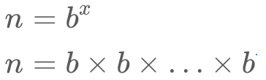

Hence it should be possible to divide n by b x times, every time with a remainder of **0** and the end result to be **1**.

|  |
| --- |
| public class Solution {  public boolean isPowerOfThree(int n) {  if (n < 1) {  return false;  }  while (n % 3 == 0) {  n /= 3;  }  return n == 1;  }  } |

Notice that we need a guard to check that n != 0, otherwise the while loop will never finish. For negative numbers, the algorithm does not make sense, so we will include this guard as well.

**Complexity Analysis**

* Time complexity : O(\log\_b(n))*O*(log*b*​(*n*)). In our case that is O(\log\_3n)*O*(log3​*n*). The number of divisions is given by that logarithm.
* Space complexity : O(1)*O*(1). We are not using any additional memory.

#### **Approach 2: Base Conversion**

In Base 10, all powers of 10 start with the digit **1** and then are followed only by **0** (e.g. 10, 100, 1000). This is true for other bases and their respective powers. For instance in base 2, the representations of 102​, 1002​ and 10002​ are 210​, 410​ and 810​ respectively. Therefore if we convert our number to base 3 and the representation is of the form 100...0, then the number is a power of 3.

**Proof**

Given the base 3 representation of a number as the array s, with the least significant digit on index 0, the formula for converting from base **3** to base **10** is:

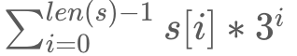

Therefore, having just one digit of **1** and everything else **0** means the number is a power of 3.

**Implementation**

All we need to do is convert [[1]](https://leetcode.com/problems/power-of-three/solution/#fn1) the number to base 3 and check if it is written as a leading **1** followed by all **0**.

A couple of built-in Java functions will help us along the way.

|  |
| --- |
| String baseChange = Integer.toString(number, base); |

The code above converts number into base base and returns the result as a String. For example, Integer.toString(5, 2) == "101" and Integer.toString(5, 3) == "12".

|  |
| --- |
| boolean matches = myString.matches("123"); |

The code above checks if a certain **Regular Expression** [[2]](https://leetcode.com/problems/power-of-three/solution/#fn2) pattern exists inside a string. For instance the above will return true if the substring "123" exists inside the string myString.

|  |
| --- |
| boolean powerOfThree = baseChange.matches("^10\*$") |

We will use the regular expression above for checking if the string starts with **1** ^1, is followed by zero or more **0**s 0\* and contains nothing else ＄.

|  |
| --- |
| public class Solution {  public boolean isPowerOfThree(int n) {  return Integer.toString(n, 3).matches("^10\*$");  }  } |

**Complexity Analysis**

* Time complexity : *O*(log3​*n*).

Assumptions:

* + Integer.toString() - Base conversion is generally implemented as a repeated division. The complexity of should be similar to our Approach 1: *O*(log3​*n*).
  + String.matches() - Method iterates over the entire string. The number of digits in the base 3 representation of n is *O*(log3​*n*).
* Space complexity : *O*(log3​*n*).

We are using two additional variables,

* + The string of the base 3 representation of the number (size log3​*n*)
  + The string of the regular expression (constant size)

## Conclusion

Simple optimizations like this might seem negligible, but historically, when computation power was an issue, it allowed certain computer programs (such as Quake 3 [[4]](https://leetcode.com/problems/power-of-three/solution/#fn4)) possible.

## References

1. <http://www.cut-the-knot.org/recurrence/conversion.shtml> [↩︎](https://leetcode.com/problems/power-of-three/solution/#fnref1)
2. <https://en.wikipedia.org/wiki/Regular_expression> [↩︎](https://leetcode.com/problems/power-of-three/solution/#fnref2)
3. <http://developer.classpath.org/doc/java/lang/StrictMath-source.html> [↩︎](https://leetcode.com/problems/power-of-three/solution/#fnref3)
4. <https://en.wikipedia.org/wiki/Fast_inverse_square_root> [↩︎](https://leetcode.com/problems/power-of-three/solution/#fnref4)

**Roman to Integer**

Roman numerals are represented by seven different symbols: I, V, X, L, C, D and M.

**Symbol** **Value**

I 1

V 5

X 10

L 50

C 100

D 500

M 1000

For example, 2 is written as II in Roman numeral, just two one's added together. 12 is written as XII, which is simply X + II. The number 27 is written as XXVII, which is XX + V + II.

Roman numerals are usually written largest to smallest from left to right. However, the numeral for four is not IIII. Instead, the number four is written as IV. Because the one is before the five we subtract it making four. The same principle applies to the number nine, which is written as IX. There are six instances where subtraction is used:

* I can be placed before V (5) and X (10) to make 4 and 9.
* X can be placed before L (50) and C (100) to make 40 and 90.
* C can be placed before D (500) and M (1000) to make 400 and 900.

Given a roman numeral, convert it to an integer.

**Example 1:**

**Input:** s = "III"

**Output:** 3

**Example 2:**

**Input:** s = "IV"

**Output:** 4

**Example 3:**

**Input:** s = "IX"

**Output:** 9

**Example 4:**

**Input:** s = "LVIII"

**Output:** 58

**Explanation:** L = 50, V= 5, III = 3.

**Example 5:**

**Input:** s = "MCMXCIV"

**Output:** 1994

**Explanation:** M = 1000, CM = 900, XC = 90 and IV = 4.

**Constraints:**

* 1 <= s.length <= 15
* s contains only the characters ('I', 'V', 'X', 'L', 'C', 'D', 'M').
* It is **guaranteed** that s is a valid roman numeral in the range [1, 3999].

Problem is simpler to solve by working the string from back to front and using a map.

## Solution

#### **Overview**

In a lot of countries, Roman Numerals are taught in elementary school-level math. This has made them a somewhat popular "easy" interview question. Unfortunately though, this ignores the fact that not everybody learned them in school, and therefore a big advantage has been given to those who did. I suspect it's also difficult for a lot of us who have learned them previously to fully appreciate how much easier prior experience makes this question. While this is very unfair, and possibly very frustrating, keep in mind that the best thing you can do is work through this question and the related question [Integer to Roman](https://leetcode.com/problems/integer-to-roman/) so that you don't get caught out by it in a real interview.

**Can we assume the input is valid?**

Yes. Here on Leetcode, you can make that assumption because you haven't been told what to do if it isn't.

In a real interview, this is a question you should ask the interviewer. Don't ever assume without asking in a real interview that the input has to be valid.

**Is there only one valid representation for each number?**

This is more relevant to the other question, [Integer to Roman](https://leetcode.com/problems/integer-to-roman/), however we'll still briefly look at it now.

Given that the representation for 3 is III, it could seem natural that the representation for 15 is VVV, because that would be 5 + 5 + 5. However, it's actually XV, which is 10 + 5. How are you even supposed to know which is correct?

The trick is to use the "biggest" symbols you can. Because X is bigger than V, we should use an X first and then make up the remainder with a single V, giving XV.

We'll talk more about this in the [Integer to Roman](https://leetcode.com/problems/integer-to-roman/) article. This question is a lot simpler because there's only one logical way of converting from a Roman Numeral to an Integer. This is also why this question is labelled as "easy", whereas the other is labelled as "medium".

**A few more examples**

If you're not very familiar with Roman Numerals, work through these examples and then have another go at writing your own algorithm before reading the rest of this solution article.

What is *CXVII* as an integer?

Recall that C = 100, X = 10, V = 5, and I = 1. Because the symbols are ordered from most significant to least, we can simply add the symbols, i.e. C + X + V + I + I = 100 + 10 + 5 + 1 + 1 = 117.

What is *DXCI* as an integer?

Recall that D = 500.

Now, notice that this time the symbols are not ordered from most significant to least—the X and C are out of numeric order. Because of this, we subtract the value of X (10) from the value of C (100) to get 90.

So, going from left to right, we have D + (C - X) + I = 500 + 90 + 1 = 591.

What is *CMXCIV* as an integer?

Recall that M = 1000.

The symbols barely look sorted at all here—from left-to-right we have 100, 1000, 10, 100, 1, 5. Do not panic though, we just need to look for each occurrence of a smaller symbols preceding a bigger symbol. The first, third, and fifth symbols are all smaller than their next symbol. Therefore they are all going to be subtracted from their next.

* The first two symbols are CM. This is M - C = 1000 - 100 = 900
* The second two symbols are XC. This is C - X = 100 - 10 = 90.
* The final two symbols are IV. This is V - I = 5 - 1 = 4.

Like we did above, we add these together. (M - C) + (C - X) + (V - I) = 900 + 90 + 4 = 994.

#### **Approach 1: Left-to-Right Pass**

**Intuition**

Let's hard-code a mapping with the value of each symbol so that we can easily look them up.

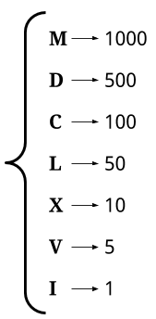

Now, recall that each symbol adds its own value, except for when a smaller valued symbol is before a larger valued symbol. In those cases, instead of adding both symbols to the total, we need to subtract the large from the small, adding that instead.

Therefore, the simplest algorithm is to use a pointer to scan through the string, at each step deciding whether to add the current symbol and go forward 1 place, or add the difference of the next 2 symbols and go forward 2 places. Here is this algorithm in pseudocode.

|  |
| --- |
| total = 0  i = 0  while i < s.length:  if at least 2 symbols remaining AND value of s[i] < value of s[i + 1]:  total = total + (value of s[i + 1]) - (value of s[i])  i = i + 2  else:  total = total + (value of s[i])  i = i + 1  return total |

Here is an animation of the above algorithm.

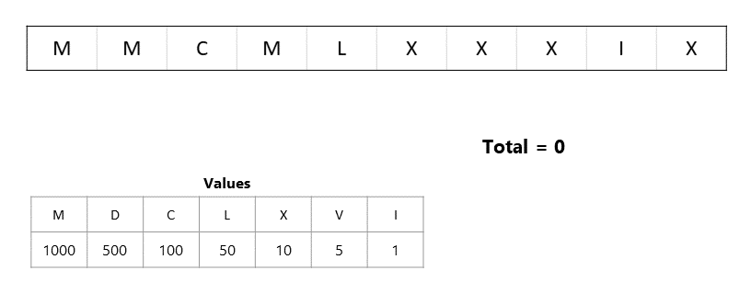

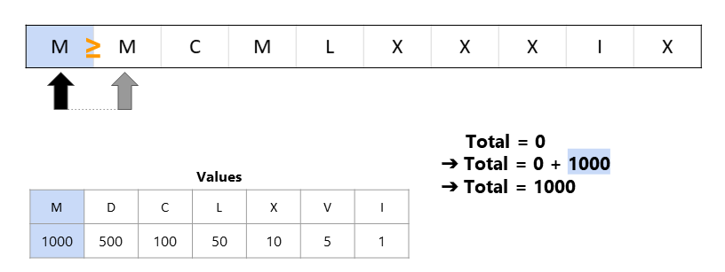

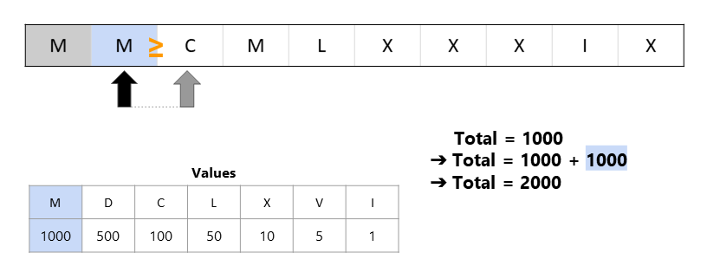

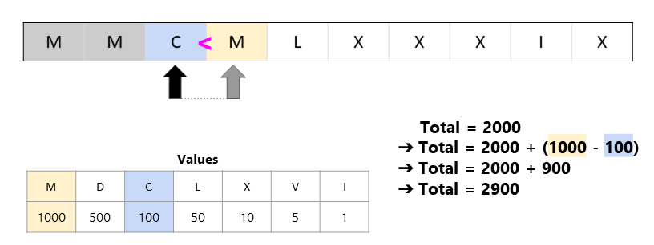

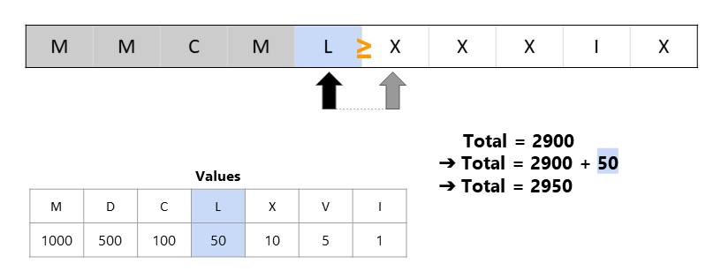

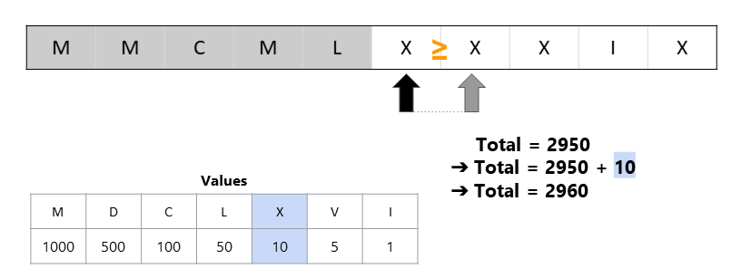

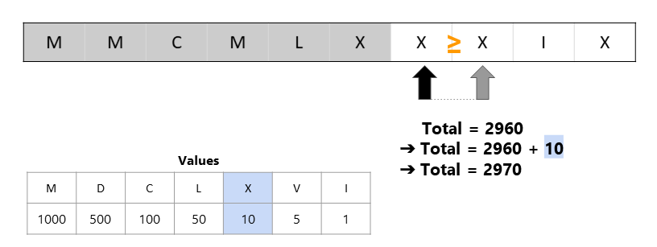

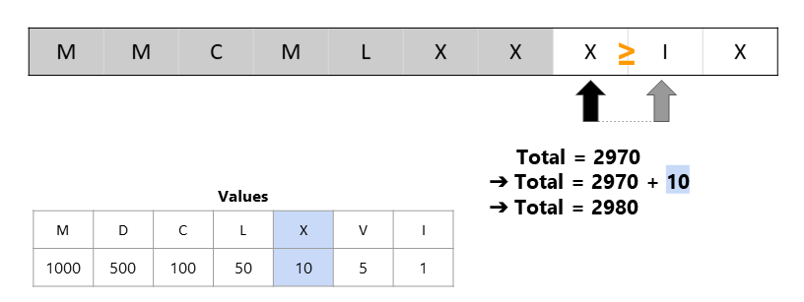

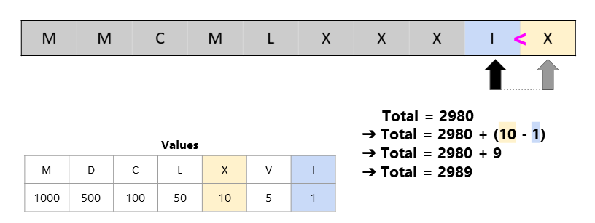

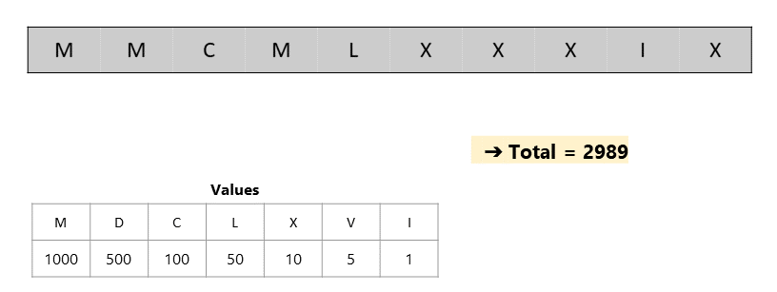

Recall that the *input is always valid*. This means that we don't need to worry about being given inputs such as ICD.

|  |
| --- |
| class Solution {    static Map<String, Integer> values = new HashMap<>();    static {  values.put("M", 1000);  values.put("D", 500);  values.put("C", 100);  values.put("L", 50);  values.put("X", 10);  values.put("V", 5);  values.put("I", 1);  }  public int romanToInt(String s) {    int sum = 0;  int i = 0;  while (i < s.length()) {  String currentSymbol = s.substring(i, i + 1);  int currentValue = values.get(currentSymbol);  int nextValue = 0;  if (i + 1 < s.length()) {  String nextSymbol = s.substring(i + 1, i + 2);  nextValue = values.get(nextSymbol);  }    if (currentValue < nextValue) {  sum += (nextValue - currentValue);  i += 2;  }  else {  sum += currentValue;  i += 1;  }    }  return sum;  }  } |

**Complexity Analysis**

Let n*n* be the length of the input string (the total number of symbols in it).

* Time complexity : *O*(1).

As there is a finite set of roman numerals, the maximum number possible number can be 3999, which in roman numerals is MMMCMXCIX. As such the time complexity is *O*(1).

If roman numerals had an arbitrary number of symbols, then the time complexity would be proportional to the length of the input, i.e. *O*(*n*). This is assuming that looking up the value of each symbol is *O*(1).

* Space complexity : *O*(1).

Because only a constant number of single-value variables are used, the space complexity is *O*(1).

#### **Approach 2: Left-to-Right Pass Improved**

Instead of viewing a Roman Numeral as having 7 unique symbols, we could instead view it as having 13 unique symbols—some of length-1 and some of length-2.

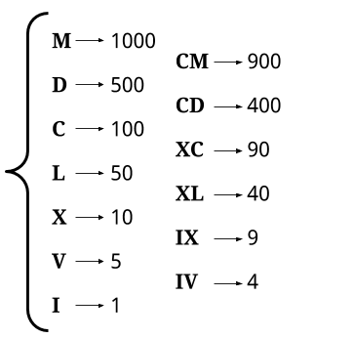

For example, here is the Roman Numeral MMCMLXXXIX broken into its symbols using this definition:



We can then look up the value of each symbol and add them together.



After making a Map of String -> Integer with the 13 "symbols", we need to work our way down the string in the same way as before (we'll do left-to-right, however right-to-left will work okay too), firstly checking if we're at a length-2 symbol, and if not, then treating it as a length-1 symbol.

|  |
| --- |
| total = 0  i = 0  while i < s.length:  if at least 2 characters remaining and s.substing(i, i + 1) is in values:  total = total + (value of s.substring(i, i + 1))  i = i + 2  else:  total = total + (value of s[i])  i = i + 1  return total |

Here is an animation showing the algorithm.

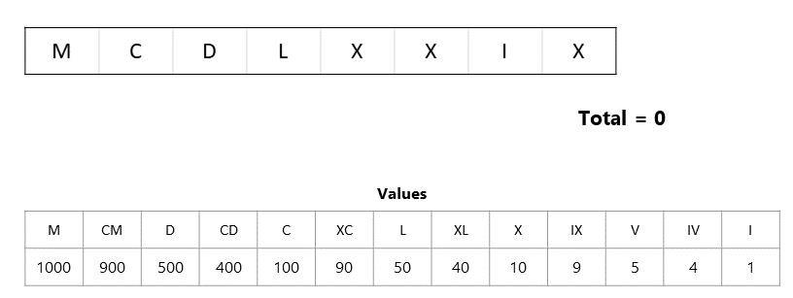

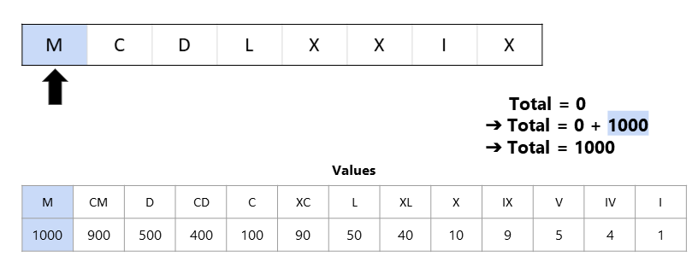

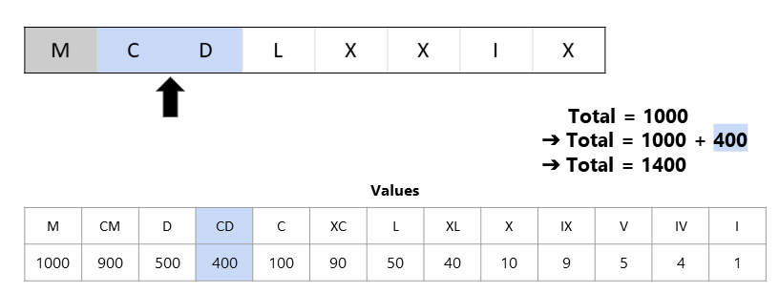

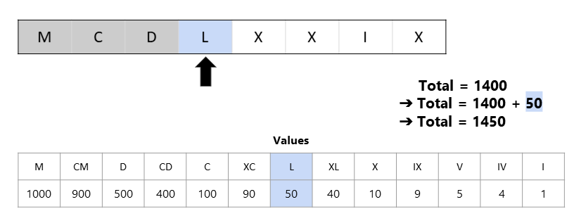

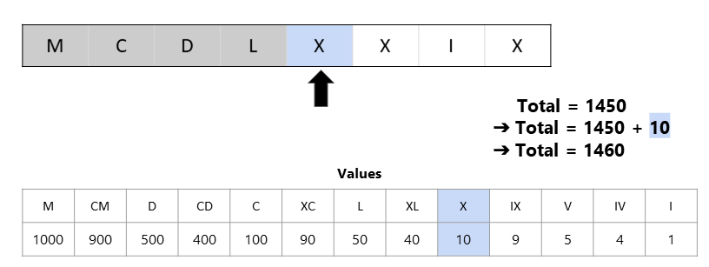

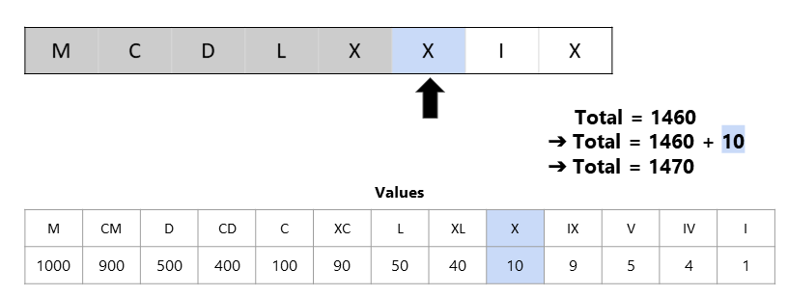

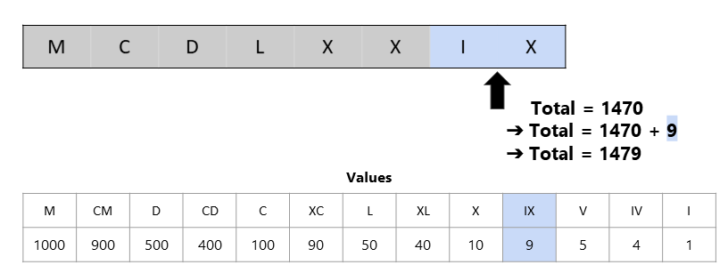

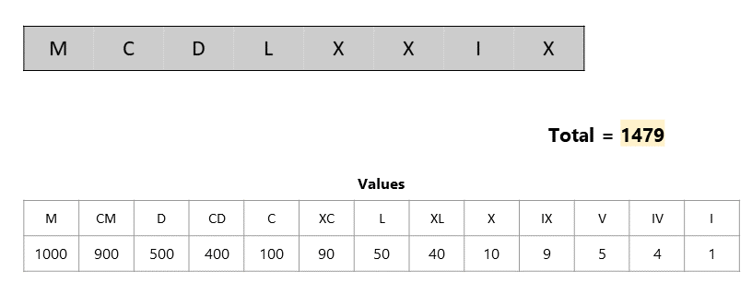

|  |
| --- |
| class Solution {    static Map<String, Integer> values = new HashMap<>();  static {  values.put("I", 1);  values.put("V", 5);  values.put("X", 10);  values.put("L", 50);  values.put("C", 100);  values.put("D", 500);  values.put("M", 1000);  values.put("IV", 4);  values.put("IX", 9);  values.put("XL", 40);  values.put("XC", 90);  values.put("CD", 400);  values.put("CM", 900);  }  public int romanToInt(String s) {    int sum = 0;  int i = 0;  while (i < s.length()) {  if (i < s.length() - 1) {  String doubleSymbol = s.substring(i, i + 2);  // Check if this is the length-2 symbol case.  if (values.containsKey(doubleSymbol)) {  sum += values.get(doubleSymbol);  i += 2;  continue;  }  }  // Otherwise, it must be the length-1 symbol case.  String singleSymbol = s.substring(i, i + 1);  sum += values.get(singleSymbol);  i += 1;  }  return sum;  }  } |

**Complexity Analysis**

* Time complexity : *O*(1).

Same as Approach 1.

* Space complexity : *O*(1).

Same as Approach 1.

#### **Approach 3: Right-to-Left Pass**

**Intuition**

This approach is a more elegant variant of Approach 1. Just to be clear though, Approach 1 and Approach 2 are probably sufficient for an interview. This approach is still well worth understanding though.

In the "subtraction" cases, such as XC, we've been updating our running sum as follows:

sum += value(C) - value(X)

However, notice that this is mathematically equivalent to the following:

sum += value(C)

sum -= value(X)

Utilizing this means that we can process one symbol each time we go around the main loop. We still need to determine whether or not our current symbol should be added or subtracted by looking at the neighbour though.

In Approach 1, we had to be careful when inspecting the next symbol to not go over the end of the string. This check wasn't difficult to do, but it increased the code complexity a bit, and it turns out we can avoid it with this approach!

Observe the following:

1. Without looking at the next symbol, we don't know whether or not the left-most symbol should be added or subtracted.
2. The right-most symbol is always added. It is either by itself, or the additive part of a pair.

So, what we can do is initialise sum to be the value of the right-most (last) symbol. Then, we work backwards through the string, starting from the second-to-last-symbol. We check the symbol after (i + 1) to determine whether the current symbol should be "added" or "subtracted".

last = s.length - 1

total = value(last)

`

for i from last - 1 down to 0:

if value(s[i]) < value(s[i+1]):

total -= value(s[i])

else:

total += value(s[i])

return sum

Because we're starting at the second-to-last-index, we know that index i + 1 always exists. We no longer need to handle its potential non-existence as a special case, and additionally we're able to (cleanly) use a for loop, as we're always moving along by 1 index at at time, unlike before where it could have been 1 or 2.

Here is an animation of the above approach.

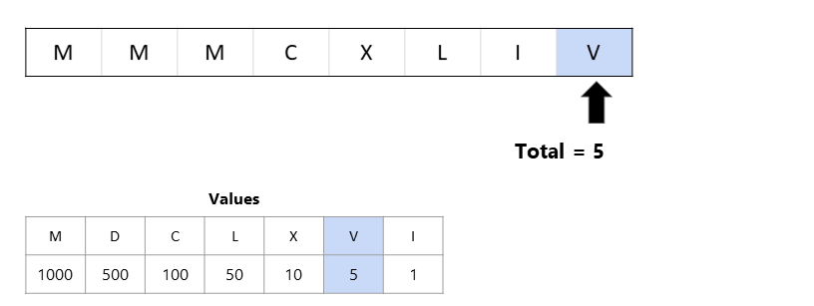

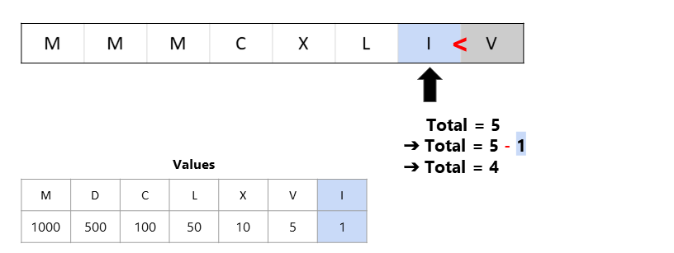

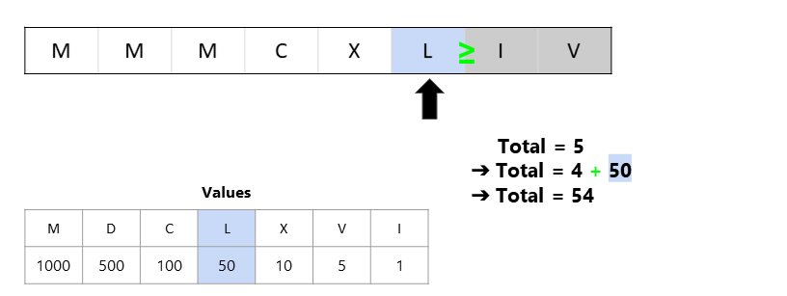

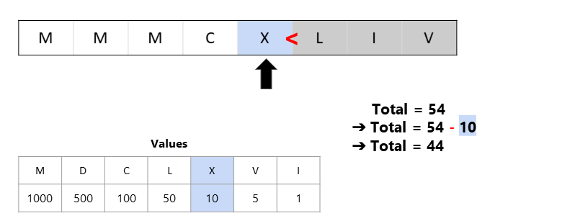

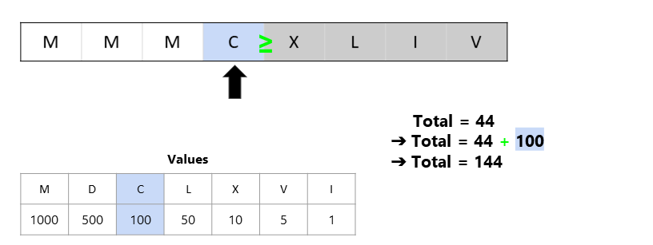

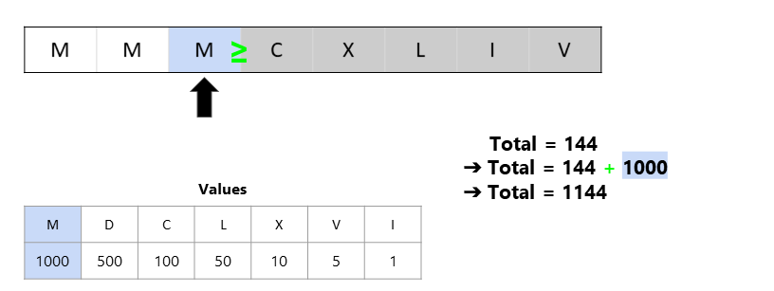

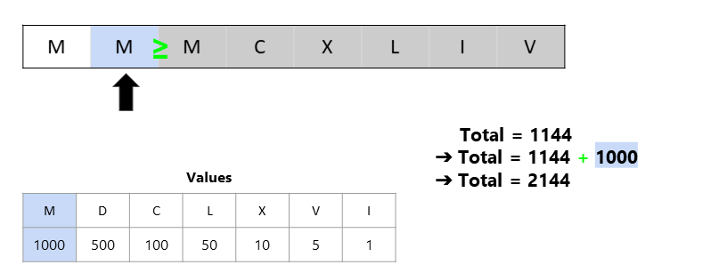

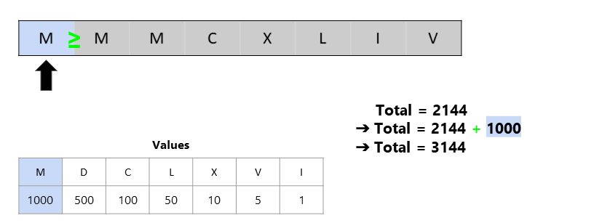

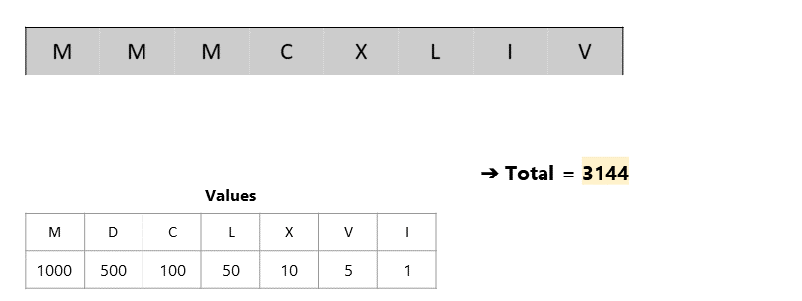

|  |
| --- |
| class Solution {    static Map<String, Integer> values = new HashMap<>();    static {  values.put("M", 1000);  values.put("D", 500);  values.put("C", 100);  values.put("L", 50);  values.put("X", 10);  values.put("V", 5);  values.put("I", 1);  }  public int romanToInt(String s) {    String lastSymbol = s.substring(s.length() - 1);  int lastValue = values.get(lastSymbol);  int total = lastValue;  for (int i = s.length() - 2; i >= 0; i--) {  String currentSymbol = s.substring(i, i + 1);  int currentValue = values.get(currentSymbol);  if (currentValue < lastValue) {  total -= currentValue;  } else {  total += currentValue;  }  lastValue = currentValue;  }  return total;  }  } |

**Complexity Analysis**

* Time complexity : *O*(1).

Same as Approach 1.

* Space complexity : *O*(1).

Same as Approach 1.

## Others

Here are some other questions that do not fit in other categories.

We recommend: Number of 1 Bits and Valid Parentheses.

 Number of 1 Bits

 Hamming Distance

 Reverse Bits

 Pascal's Triangle

 Valid Parentheses

 Missing Number

**Number of 1 Bits**

Write a function that takes an unsigned integer and returns the number of '1' bits it has (also known as the [Hamming weight](http://en.wikipedia.org/wiki/Hamming_weight)).

**Note:**

* Note that in some languages such as Java, there is no unsigned integer type. In this case, the input will be given as a signed integer type. It should not affect your implementation, as the integer's internal binary representation is the same, whether it is signed or unsigned.
* In Java, the compiler represents the signed integers using [2's complement notation](https://en.wikipedia.org/wiki/Two%27s_complement). Therefore, in **Example 3**, the input represents the signed integer. -3.

**Example 1:**

**Input:** n = 00000000000000000000000000001011

**Output:** 3

**Explanation:** The input binary string **00000000000000000000000000001011** has a total of three '1' bits.

**Example 2:**

**Input:** n = 00000000000000000000000010000000

**Output:** 1

**Explanation:** The input binary string **00000000000000000000000010000000** has a total of one '1' bit.

**Example 3:**

**Input:** n = 11111111111111111111111111111101

**Output:** 31

**Explanation:** The input binary string **11111111111111111111111111111101** has a total of thirty one '1' bits.

**Constraints:**

* The input must be a **binary string** of length 32

**Follow up:** If this function is called many times, how would you optimize it?

## Solution

#### **Approach #1 (Loop and Flip) [Accepted]**

\*\* Algorithm\*\*

The solution is straight-forward. We check each of the 32 bits of the number. If the bit is 1, we add one to the number of 1-bits.

We can check the *ith* bit of a number using a bit mask. We start with a mask *m*=1, because the binary representation of 1 is,

00000000000000000000000000000001 Clearly, a logical AND between any number and the mask 1 gives us the least significant bit of this number. To check the next bit, we shift the mask to the left by one.

00000000000000000000000000000010

And so on.

**Java**

public int hammingWeight(int n) {

int bits = 0;

int mask = 1;

for (int i = 0; i < 32; i++) {

if ((n & mask) != 0) {

bits++;

}

mask <<= 1;

}

return bits;

}

**Complexity Analysis**

The run time depends on the number of bits in *n*. Because *n* in this piece of code is a 32-bit integer, the time complexity is *O*(1).

The space complexity is *O*(1), since no additional space is allocated.

#### **Approach #2 (Bit Manipulation Trick) [Accepted]**

**Algorithm**

We can make the previous algorithm simpler and a little faster. Instead of checking every bit of the number, we repeatedly flip the least-significant 1-bit of the number to 0, and add 1 to the sum. As soon as the number becomes 0, we know that it does not have any more 1-bits, and we return the sum.

The key idea here is to realize that for any number *n*, doing a bit-wise AND of *n* and *n*−1 flips the least-significant 1-bit in *n* to 0. Why? Consider the binary representations of *n* and *n*−1.

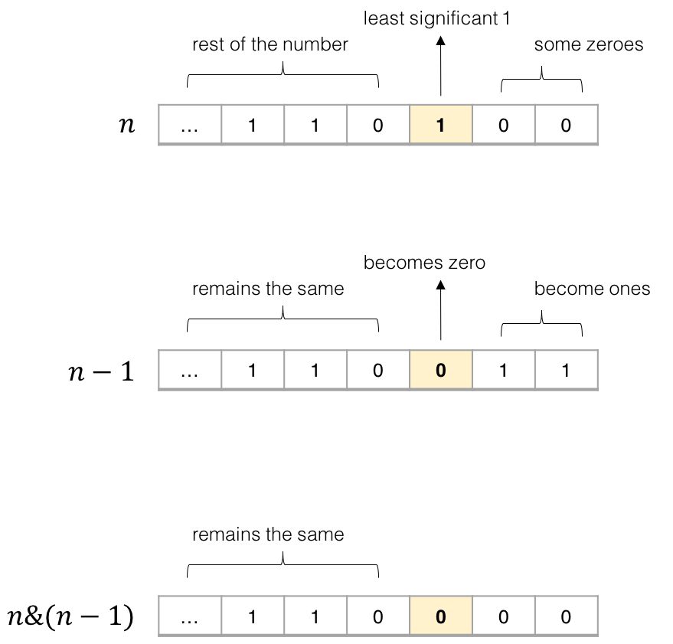

Figure 1. AND-ing *n* and *n−1* flips the least-significant *1*-bit to 0.

In the binary representation, the least significant 1-bit in *n* always corresponds to a 0-bit in *n*−1. Therefore, anding the two numbers *n* and *n*−1 always flips the least significant 1-bit in *n* to 0, and keeps all other bits the same.

Using this trick, the code becomes very simple.

**Java**

public int hammingWeight(int n) {

int sum = 0;

while (n != 0) {

sum++;

n &= (n - 1);

}

return sum;

}

**Complexity Analysis**

The run time depends on the number of 1-bits in *n*. In the worst case, all bits in *n* are 1-bits. In case of a 32-bit integer, the run time is *O*(1).

The space complexity is *O*(1), since no additional space is allocated.

**Hamming Distance**

The [Hamming distance](https://en.wikipedia.org/wiki/Hamming_distance) between two integers is the number of positions at which the corresponding bits are different.

Given two integers x and y, calculate the Hamming distance.

**Note:**  
0 ≤ x, y < 231.

**Example:**

**Input:** x = 1, y = 4

**Output:** 2

**Explanation:**

1 (0 0 0 1)

4 (0 1 0 0)

↑ ↑

The above arrows point to positions where the corresponding bits are different.

## Solution

#### **Intuition**

[Hamming distance](https://en.wikipedia.org/wiki/Hamming_distance) is an interesting metric that is widely applied in several domains, e.g. in coding theory for error detection, in information theory for quantifying the difference between strings.

The Hamming distance between two **integer** numbers is the number of positions at which the corresponding bits are different.

Given the above definition, it might remind one of the bit operation called [XOR](https://en.wikipedia.org/wiki/Bitwise_operation#XOR) which outputs 1 if and only if the input bits are different.



As a result, in order to measure the hamming distance between x and y, we can first do x XOR y operation, then we simply count the number of bit 1 in the result of XOR operation.

We now convert the original problem into a bit-counting problem. There are several ways to count the bits though, as we will discuss in the following sections.

#### **Approach 1: Built-in BitCounting Functions**

**Intuition**

First of all, let us talk of the elephant in the room. As one can imagine, we have various built-in functions that could count the bit 1 for us, in all (or at least most of) programming languages. So if this is the task that one is asked in a project, then one should probably just go for it, rather than reinventing the wheel. We given two examples in the following.

Now, since this is a LeetCode problem, some of you would argue that using the built-in function is like "implementing a LinkedList with LinkedList", which we fully second as well. So no worry, we will see later some fun hand-crafted algorithms for bit counting.

**Algorithm**

|  |
| --- |
| class Solution {  public int hammingDistance(int x, int y) {  return Integer.bitCount(x ^ y);  }  } |

**Complexity Analysis**

* Time Complexity: O(1)
  + There are two operations in the algorithm. First, we do the XOR operation which takes a constant time.
  + Then, we call the built-in bitCount function. In the worst scenario, the function would take O(*k*) time where *k* is the number of bits for an integer number. Since the Integer type is of fixed size in both Python and Java, the overall time complexity of the algorithm becomes constant, regardless the input numbers.
* Space Complexity: O(1), a temporary memory of constant size is consumed, to hold the result of XOR operation.
  + We assume that the built-in function also takes a constant space.

#### **Approach 2: Bit Shift**

**Intuition**

In order to count the number of bit 1, we could shift each of the bit to either the leftmost or the rightmost position and then check if the bit is one or not.

More precisely, we should do the [logical shift](https://en.wikipedia.org/wiki/Bitwise_operation#Logical_shift) where zeros are shifted in to replace the discarded bits.

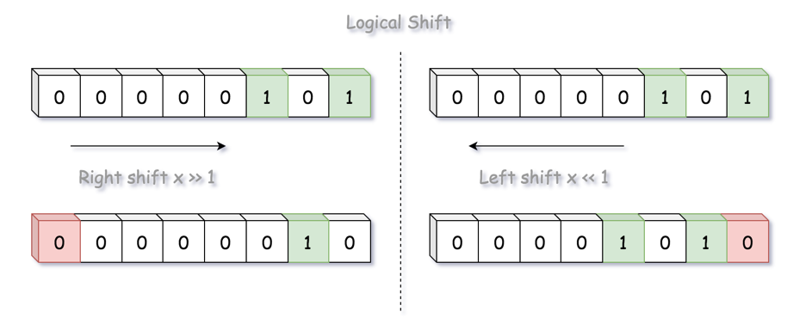

Here we adopt the right shift operation, where each bit would has its turn to be shifted to the rightmost position. Once shifted, we then check if the rightmost bit is one, which we can use either the modulo operation (i.e. i % 2) or the bit AND operation (i.e. i & 1). Both operations would ***mask out*** the rest of the bits other than the rightmost bit.

**Algorithm**

|  |
| --- |
| class Solution {  public int hammingDistance(int x, int y) {  int xor = x ^ y;  int distance = 0;  while (xor != 0) {  if (xor % 2 == 1)  distance += 1;  xor = xor >> 1;  }  return distance;  }  } |

**Complexity Analysis**

* Time Complexity: O(1), since the Integer is of fixed size in Python and Java, the algorithm takes a constant time. For an Integer of 32 bit, the algorithm would take at most 32 iterations.
* Space Complexity: O(1), a constant size of memory is used, regardless the input.

#### **Approach 3: Brian Kernighan's Algorithm**

**Intuition**

In the above approach, one might wonder that "rather than shifting the bits one by one, is there a faster way to count the bits of one ?". And the answer is yes.

If we is asked to count the bits of one, as humans, rather than mechanically examining each bit, we could ***skip*** the bits of zero in between the bits of one, e.g. 10001000.

In the above example, after encountering the first bit of one at the rightmost position, it would be more efficient if we just jump at the next bit of one, skipping all the zeros in between.

This is the basic idea of the [Brian Kernighan's bit counting algorithm](http://graphics.stanford.edu/~seander/bithacks.html#CountBitsSetKernighan), which applies some smart bit and arithmetic operations to ***clear*** the rightmost bit of one. Here is the secret recipe.

When we do AND bit operation between number and number-1, the rightmost bit of one in the original number would be cleared.

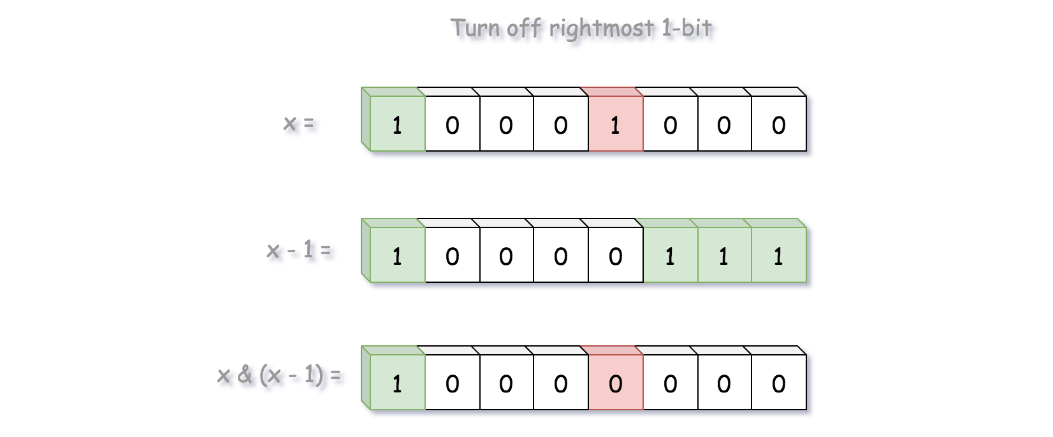

Based on the above idea, we then can count the bits of one for the input of 10001000 in 2 iterations, rather than 8.

**Algorithm**

|  |
| --- |
| class Solution {  public int hammingDistance(int x, int y) {  int xor = x ^ y;  int distance = 0;  while (xor != 0) {  distance += 1;  // remove the rightmost bit of '1'  xor = xor & (xor - 1);  }  return distance;  }  } |

Note, according to the online book of [Bit Twiddling Hacks](http://graphics.stanford.edu/~seander/bithacks.html#CountBitsSetKernighan), the algorithm was published as an exercise in 1988, in the book of the C Programming Language 2nd Ed. (by **Brian W. Kernighan** and Dennis M. Ritchie), though on April 19, 2006 Donald Knuth pointed out that this method "was first published by Peter Wegner in CACM 3 (1960), 322. (Also discovered independently by Derrick Lehmer and published in 1964 in a book edited by Beckenbach.)". By the way, one can find many other tricks about bit operations in the aforementioned book.

**Complexity Analysis**

* Time Complexity: O(1).
  + Similar as the approach of bit shift, since the size (i.e. bit number) of integer number is fixed, we have a constant time complexity.
  + However, this algorithm would require less iterations than the bit shift approach, as we have discussed in the intuition.
* Space Complexity: O(1), a constant size of memory is used, regardless the input.

**Reverse Bits**

Reverse bits of a given 32 bits unsigned integer.

**Note:**

* Note that in some languages such as Java, there is no unsigned integer type. In this case, both input and output will be given as a signed integer type. They should not affect your implementation, as the integer's internal binary representation is the same, whether it is signed or unsigned.
* In Java, the compiler represents the signed integers using [2's complement notation](https://en.wikipedia.org/wiki/Two%27s_complement). Therefore, in **Example 2** above, the input represents the signed integer -3 and the output represents the signed integer -1073741825.

**Follow up**:

If this function is called many times, how would you optimize it?

**Example 1:**

**Input:** n = 00000010100101000001111010011100

**Output:** 964176192 (00111001011110000010100101000000)

**Explanation:** The input binary string **00000010100101000001111010011100** represents the unsigned integer 43261596, so return 964176192 which its binary representation is **00111001011110000010100101000000**.

**Example 2:**

**Input:** n = 11111111111111111111111111111101

**Output:** 3221225471 (10111111111111111111111111111111)

**Explanation:** The input binary string **11111111111111111111111111111101** represents the unsigned integer 4294967293, so return 3221225471 which its binary representation is **10111111111111111111111111111111**.

**Constraints:**

* The input must be a **binary string** of length 32

## Solution

#### **Approach 1: Bit by Bit**

**Intuition**

Though the question is not difficult, it often serves as a warm-up question to kick off the interview. The point is to test one's basic knowledge on data type and bit operations.

As one of the most intuitive solutions that one could come up during an interview, one could reverse the bits **one by one**.

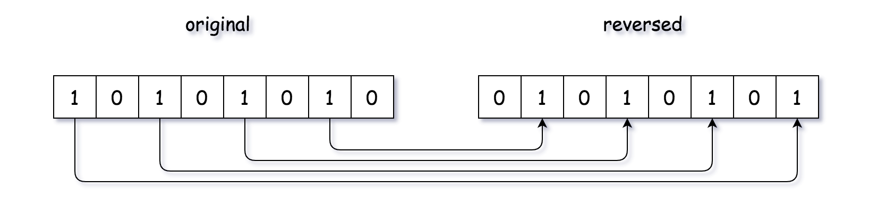

As easy as it sounds, the above intuition could lead to quite some variants of implementation. For instance, to retrieve the right-most bit in an integer n, one could either apply the modulo operation (i.e. n % 2) or the bit AND operation (i.e. n & 1). Another example would be that in order to combine the results of reversed bits (e.g. 2^a, 2^b2*a*,2*b*), one could either use the addition operation (i.e. 2^a + 2^b2*a*+2*b*) or again the bit OR operation (i.e. 2^a | 2^b2*a*∣2*b*).

**Algorithm**

Here we show on example of implementation based on the above intuition.

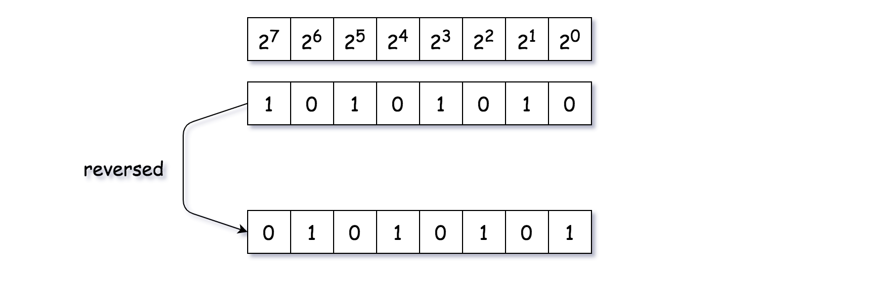

The key idea is that for a bit that is situated at the index i, after the reversion, its position should be 31-i (note: the index starts from zero).

* We iterate through the bit string of the input integer, from right to left (i.e. n = n >> 1). To retrieve the right-most bit of an integer, we apply the bit AND operation (n & 1).
* For each bit, we reverse it to the correct position (i.e. (n & 1) << power). Then we accumulate this reversed bit to the final result.
* When there is no more bits of one left (i.e. n == 0), we terminate the iteration.

|  |
| --- |
| class Solution {  public:  uint32\_t reverseBits(uint32\_t n) {  uint32\_t ret = 0, power = 31;  while (n != 0) {  ret += (n & 1) << power;  n = n >> 1;  power -= 1;  }  return ret;  }  }; |

**Complexity**

* Time Complexity: O(1). Though we have a loop in the algorithm, the number of iteration is fixed regardless the input, since the integer is of fixed-size (32-bits) in our problem.
* Space Complexity: O(1), since the consumption of memory is constant regardless the input.

#### **Approach 2: Byte by Byte with Memoization**

**Intuition**

Someone might argument it might be more efficient to reverse the bits, **per byte**, which is an unit of 8 bits. Though it is not necessarily true in our case, since the input is of fixed-size 32-bit integer, it could become more advantageous when dealing with the input of long bit stream.

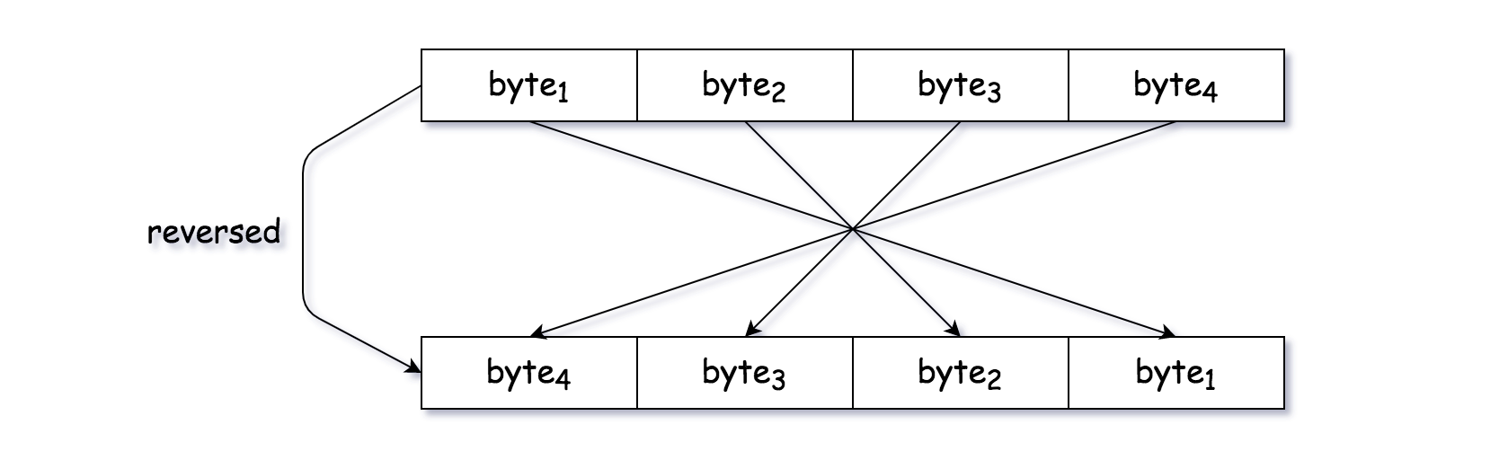

Another implicit advantage of using **byte** as the unit of iteration is that we could apply the technique of [**memoization**](https://leetcode.com/explore/learn/card/recursion-i/255/recursion-memoization/), which caches the previously calculated values to avoid the re-calculation.

The application of memoization can be considered as a response to the **follow-up** question posed in the description of the problem, which is stated as following:

If this function is called many times, how would you optimize it?

To reverse bits for a byte, one could apply the same algorithm as we show in the above approach. Here we would like to show a different algorithm which is solely based on the arithmetic and bit operations without resorting to any loop statement, as following:

def reverseByte(byte):

return (byte \* 0x0202020202 & 0x010884422010) % 1023

The algorithm is documented as ["reverse the bits in a byte with 3 operations"](http://graphics.stanford.edu/~seander/bithacks.html#ReverseByteWith64BitsDiv) on the online book called **Bit Twiddling Hacks** by Sean Eron Anderson, where one can find more details.

**Algorithm**

* We iterate over the bytes of an integer. To retrieve the right-most byte in an integer, again we apply the bit AND operation (i.e. n & 0xff) with the bit mask of 11111111.
* For each byte, first we reverse the bits within the byte, via a function called reverseByte(byte). Then we shift the reversed bits to their final positions.
* With the function reverseByte(byte), we apply the technique of memoization, which caches the result of the function and returns the result directly for the future invocations of the same input.

Note that, one could opt for a smaller unit rather than byte, e.g. a unit of 4 bits, which would require a bit more calculation in exchange of less space for cache. It goes without saying that, the technique of memoization is a trade-off between the space and the computation.

|  |
| --- |
| class Solution {  public:  uint32\_t reverseByte(uint32\_t byte, map<uint32\_t, uint32\_t> cache) {  if (cache.find(byte) != cache.end()) {  return cache[byte];  }  uint32\_t value = (byte \* 0x0202020202 & 0x010884422010) % 1023;  cache.emplace(byte, value);  return value;  }  uint32\_t reverseBits(uint32\_t n) {  uint32\_t ret = 0, power = 24;  map<uint32\_t, uint32\_t> cache;  while (n != 0) {  ret += reverseByte(n & 0xff, cache) << power;  n = n >> 8;  power -= 8;  }  return ret;  }  }; |

**Complexity**

* Time Complexity: O(1). Though we have a loop in the algorithm, the number of iteration is fixed regardless the input, since the integer is of fixed-size (32-bits) in our problem.
* Space Complexity: O(1). Again, though we used a cache keep the results of reversed bytes, the total number of items in the cache is bounded to 2^8 = 256.

#### **Approach 3: Mask and Shift**

**Intuition**

We have shown in Approach #2 an example on how to reverse the bits in a byte without resorting to the loop statement. During the interview, one might be asked to reverse the entire 32 bits without using loop. Here we propose one solution that utilizes only the bit operations.

The idea can be considered as a strategy of **divide and conquer**, where we divide the original 32-bits into blocks with fewer bits via **bit masking**, then we reverse each block via **bit shifting**, and at the end we merge the result of each block to obtain the final result.

In the following graph, we demonstrate how to reverse two bits with the above-mentioned idea. As one can see, the idea could be applied to **blocks** of bits.

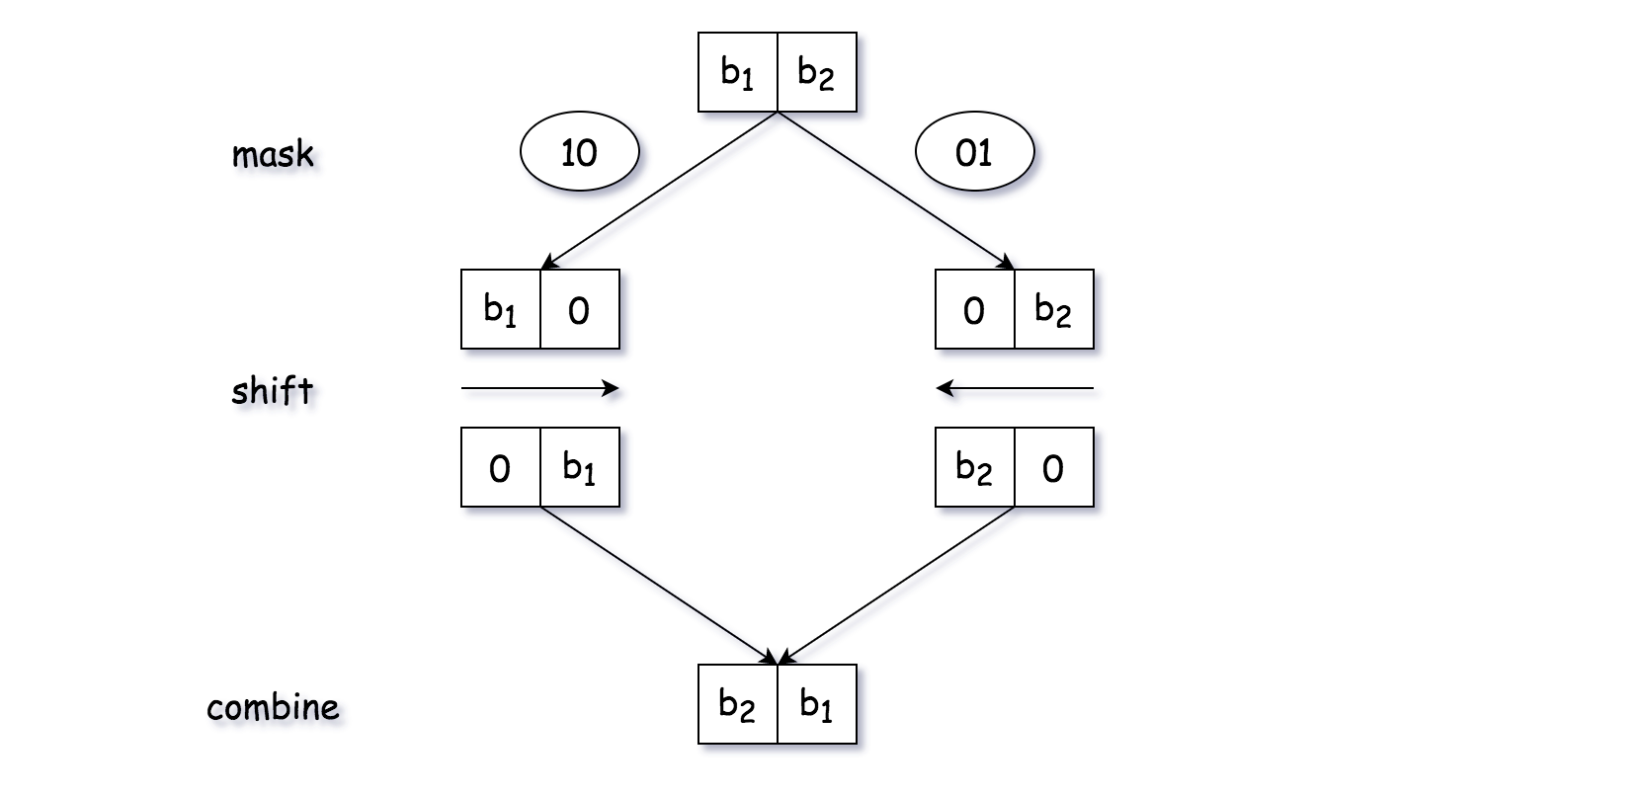

**Algorithm**

We can implement the algorithm in the following steps:

* 1). First, we break the original 32-bit into 2 blocks of 16 bits, and switch them.
* 2). We then break the 16-bits block into 2 blocks of 8 bits. Similarly, we switch the position of the 8-bits blocks
* 3). We then continue to break the blocks into smaller blocks, until we reach the level with the block of 1 bit.
* 4). At each of the above steps, we merge the intermediate results into a single integer which serves as the input for the next step.

The credit of this solution goes to @tworuler and @bhch3n for their [post and comment](https://leetcode.com/problems/reverse-bits/discuss/54741/O(1)-bit-operation-C%2B%2B-solution-(8ms)) in the discussion forum.

|  |
| --- |
| class Solution {  public:  uint32\_t reverseBits(uint32\_t n) {  n = (n >> 16) | (n << 16);  n = ((n & 0xff00ff00) >> 8) | ((n & 0x00ff00ff) << 8);  n = ((n & 0xf0f0f0f0) >> 4) | ((n & 0x0f0f0f0f) << 4);  n = ((n & 0xcccccccc) >> 2) | ((n & 0x33333333) << 2);  n = ((n & 0xaaaaaaaa) >> 1) | ((n & 0x55555555) << 1);  return n;  }  }; |

**Complexity**

* Time Complexity: O(1), no loop is used in the algorithm.
* Space Complexity: O(1). Actually, we did not even create any new variable in the function.

**Pascal's Triangle**

Given a non-negative integer *numRows*, generate the first *numRows* of Pascal's triangle.

  
In Pascal's triangle, each number is the sum of the two numbers directly above it.

**Example:**

**Input:** 5

**Output:**

[

[1],

[1,1],

[1,2,1],

[1,3,3,1],

[1,4,6,4,1]

]

**Valid Parentheses**

Given a string s containing just the characters '(', ')', '{', '}', '[' and ']', determine if the input string is valid.

An input string is valid if:

1. Open brackets must be closed by the same type of brackets.
2. Open brackets must be closed in the correct order.

**Example 1:**

**Input:** s = "()"

**Output:** true

**Example 2:**

**Input:** s = "()[]{}"

**Output:** true

**Example 3:**

**Input:** s = "(]"

**Output:** false

**Example 4:**

**Input:** s = "([)]"

**Output:** false

**Example 5:**

**Input:** s = "{[]}"

**Output:** true

**Constraints:**

* 1 <= s.length <= 104
* s consists of parentheses only '()[]{}'.

 Hide Hint #1

An interesting property about a valid parenthesis expression is that a sub-expression of a valid expression should also be a valid expression. (Not every sub-expression) e.g.

{ { } [ ] [ [ [ ] ] ] } is VALID expression

[ [ [ ] ] ] is VALID sub-expression

{ } [ ] is VALID sub-expression

Can we exploit this recursive structure somehow?

   Hide Hint #2

What if whenever we encounter a matching pair of parenthesis in the expression, we simply remove it from the expression? This would keep on shortening the expression. e.g.

{ { ( { } ) } }

|\_|

{ { ( ) } }

|\_\_\_\_\_\_|

{ { } }

|\_\_\_\_\_\_\_\_\_\_|

{ }

|\_\_\_\_\_\_\_\_\_\_\_\_\_\_\_\_|

VALID EXPRESSION!

   Hide Hint #3

The **stack** data structure can come in handy here in representing this recursive structure of the problem. We can't really process this from the inside out because we don't have an idea about the overall structure. But, the stack can help us process this recursively i.e. from outside to inwards.

**Missing Number**

Given an array nums containing n distinct numbers in the range [0, n], return *the only number in the range that is missing from the array.*

**Follow up:** Could you implement a solution using only O(1) extra space complexity and O(n) runtime complexity?

**Example 1:**

**Input:** nums = [3,0,1]

**Output:** 2

**Explanation:** n = 3 since there are 3 numbers, so all numbers are in the range [0,3]. 2 is the missing number in the range since it does not appear in nums.

**Example 2:**

**Input:** nums = [0,1]

**Output:** 2

**Explanation:** n = 2 since there are 2 numbers, so all numbers are in the range [0,2]. 2 is the missing number in the range since it does not appear in nums.

**Example 3:**

**Input:** nums = [9,6,4,2,3,5,7,0,1]

**Output:** 8

**Explanation:** n = 9 since there are 9 numbers, so all numbers are in the range [0,9]. 8 is the missing number in the range since it does not appear in nums.

**Example 4:**

**Input:** nums = [0]

**Output:** 1

**Explanation:** n = 1 since there is 1 number, so all numbers are in the range [0,1]. 1 is the missing number in the range since it does not appear in nums.

**Constraints:**

* n == nums.length
* 1 <= n <= 104
* 0 <= nums[i] <= n
* All the numbers of nums are **unique**.

#### **Approach #1 Sorting [Accepted]**

**Intuition**

If nums were in order, it would be easy to see which number is missing.

**Algorithm**

First, we sort nums. Then, we check the two special cases that can be handled in constant time - ensuring that 0 is at the beginning and that n*n* is at the end. Given that those assumptions hold, the missing number must somewhere between (but not including) 0 and n*n*. To find it, we ensure that the number we expect to be at each index is indeed there. Because we handled the edge cases, this is simply the previous number plus 1. Thus, as soon as we find an unexpected number, we can simply return the expected number.

|  |
| --- |
| class Solution {  public int missingNumber(int[] nums) {  Arrays.sort(nums);  // Ensure that n is at the last index  if (nums[nums.length-1] != nums.length) {  return nums.length;  }  // Ensure that 0 is at the first index  else if (nums[0] != 0) {  return 0;  }  // If we get here, then the missing number is on the range (0, n)  for (int i = 1; i < nums.length; i++) {  int expectedNum = nums[i-1] + 1;  if (nums[i] != expectedNum) {  return expectedNum;  }  }  // Array was not missing any numbers  return -1;  }  } |

**Complexity Analysis**

* Time complexity : O(*nlgn*)

The only elements of the algorithm that have asymptotically nonconstant time complexity are the main for loop (which runs in O(*n*) time), and the sort invocation (which runs in O(*nlgn*) time for Python and Java). Therefore, the runtime is dominated by sort, and the entire runtime is O(*nlgn*).

* Space complexity : O(1) (or O(*n*))

In the sample code, we sorted nums in place, allowing us to avoid allocating additional space. If modifying nums is forbidden, we can allocate an O(*n*) size copy and sort that instead.

#### **Approach #2 HashSet [Accepted]**

**Intuition**

A brute force method for solving this problem would be to simply check for the presence of each number that we expect to be present. The naive implementation might use a linear scan of the array to check for containment, but we can use a HashSet to get constant time containment queries and overall linear runtime.

**Algorithm**

This algorithm is almost identical to the brute force approach, except we first insert each element of nums into a set, allowing us to later query for containment in O(1) time.

|  |
| --- |
| class Solution {  public int missingNumber(int[] nums) {  Set<Integer> numSet = new HashSet<Integer>();  for (int num : nums) numSet.add(num);  int expectedNumCount = nums.length + 1;  for (int number = 0; number < expectedNumCount; number++) {  if (!numSet.contains(number)) {  return number;  }  }  return -1;  }  } |

**Complexity Analysis**

* Time complexity : O(*n*)

Because the set allows for O(1) containment queries, the main loop runs in O(*n*) time. Creating num\_set costs O(*n*) time, as each set insertion runs in amortized O(1) time, so the overall runtime is O(*n*+*n*)=O(*n*).

* Space complexity : O(*n*)

nums contains n-1*n*−1 distinct elements, so it costs O(*n*) space to store a set containing all of them.

#### **Approach #3 Bit Manipulation [Accepted]**

**Intuition**

We can harness the fact that XOR is its own inverse to find the missing element in linear time.

**Algorithm**

Because we know that nums contains *n* numbers and that it is missing exactly one number on the range [0..*n*−1], we know that *n* definitely replaces the missing number in nums. Therefore, if we initialize an integer to *n* and XOR it with every index and value, we will be left with the missing number. Consider the following example (the values have been sorted for intuitive convenience, but need not be):

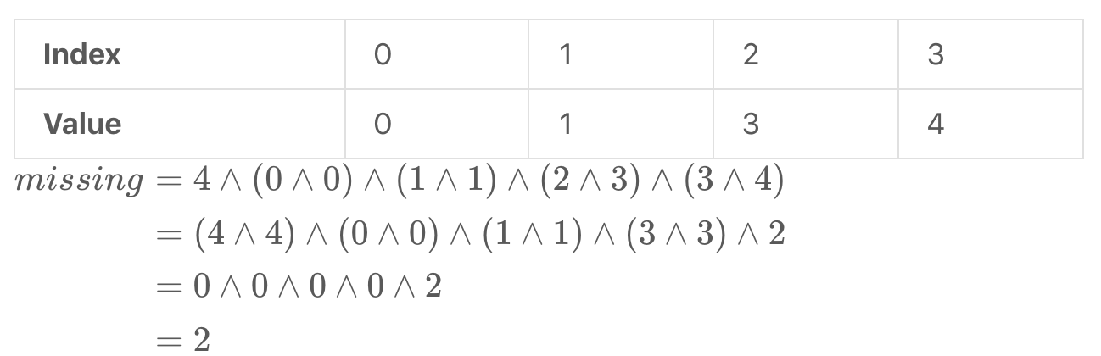

|  |
| --- |
| class Solution {  public int missingNumber(int[] nums) {  int missing = nums.length;  for (int i = 0; i < nums.length; i++) {  missing ^= i ^ nums[i];  }  return missing;  }  } |

**Complexity Analysis**

* Time complexity : O(*n*)

Assuming that XOR is a constant-time operation, this algorithm does constant work on *n* iterations, so the runtime is overall linear.

* Space complexity : O(1)

This algorithm allocates only constant additional space.

#### **Approach #4 Gauss' Formula [Accepted]**

**Intuition**

One of the most well-known stories in mathematics is of a young Gauss, forced to find the sum of the first 100 natural numbers by a lazy teacher. Rather than add the numbers by hand, he deduced a [closed-form expression](https://brilliant.org/wiki/sum-of-n-n2-or-n3/) for the sum, or so the story goes. You can see the formula below:

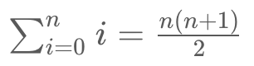

**Algorithm**

We can compute the sum of nums in linear time, and by Gauss' formula, we can compute the sum of the first n*n* natural numbers in constant time. Therefore, the number that is missing is simply the result of Gauss' formula minus the sum of nums, as nums consists of the first n*n* natural numbers minus some number.

|  |
| --- |
| class Solution {  public int missingNumber(int[] nums) {  int expectedSum = nums.length\*(nums.length + 1)/2;  int actualSum = 0;  for (int num : nums) actualSum += num;  return expectedSum - actualSum;  }  } |

**Complexity Analysis**

* Time complexity : O(*n*)

Although Gauss' formula can be computed in O(1) time, summing nums costs us O(*n*) time, so the algorithm is overall linear. Because we have no information about which number is missing, an adversary could always design an input for which any algorithm that examines fewer than n*n* numbers fails. Therefore, this solution is asymptotically optimal.

* Space complexity : O(1)

This approach only pushes a few integers around, so it has constant memory usage.